**Open Source Knowledge Enrichment User Manual**

v.20190905.001



POC: The Laboratory for Analytic Sciences (LAS) OSKE Team

Email: [las-openke@googlegroups.com](mailto:las-openke@googlegroups.com)

Table of Contents

Document Version History 3

Table of Acronyms 4

Table of Figures 5

Project Overview 8

OSKE Components 10

Retrieval Infrastructure (Core Components) 10

Source Handlers 10

Document Handler 11

Annotators 12

OSKE Application (Analysis Components) 12

Domain Discovery 13

Job Control & Tuning 13

Search, Filter, Analysis, & Data Export 14

Data Storage Components 15

External Components 15

Web Retrieval Caveats and Guidance 16

OSKE GUI Reference 17

Domain Summary 18

Dashboard 19

Navigational Elements 20

Main Menu Bar 22

Project Summary Pane 22

Discovery Session Summary Pane 22

News Summary Pane 24

Search Alerts Summary Pane 26

Concepts Summary Pane 26

Help and Training Pane 28

Plan 29

Projects Pane 29

View/Edit Existing Projects 29

Editing/Deleting a Project 30

Setting the Current Project 30

Toggling a Project as Active/Inactive 31

Initiating a New Project 31

Discover 32

Discovery Session Summary Interface Overview 33

View/Edit Existing Discovery Sessions 34

Initiating a New Discovery Session 35

Related Google Searches 36

Creating a Job or Search Alert from Discovery Session 36

Submitting a New Search 38

Foreign Language Query 38

Search Results Interface Overview 39

Manage 48

Manage Menu Options 48

Concepts Overview (i.e., PESTLE-S) 49

Document Buckets Overview 51

Document Indexes Overview 55

Holdings Search Overview 57

Search Alerts Overview 61

Structural Extraction Overview 63

Jobs Overview 68

Job History 72

Most Recent Visited Pages 73

Add a New Job 74

Advanced Collector View Overview 77

Analyze 86

Analyze Overview 87

View/Edit a Different Analysis Visualization 90

Document 96

Document Overview 96

View/Edit an Existing Scratchpad 97

Initiating a New Scratchpad 98

Analysis Tools Overview 101

Elasticsearch 101

Kibana 101

Voyant Word Cloud 101

Appendix 102

Collector Job Examples 102

OSKE Job Configuration Parameters 103

JSON Output Example 109

# Document Version History

|  |  |  |  |
| --- | --- | --- | --- |
| **Date** | **Version ID** | **Remarks** | **Author(s)** |
| 5/28/2019 | 20190528.001 | Formatting and text updates; finalization for release | John S., Peter M., Robert B. |
| 9/5/2019 | 20190905.001 | Minor edits and screenshot replacements for GUI changes | John S., Peter M., Robert B. |

# Table of Acronyms

|  |  |
| --- | --- |
| **Acronym** | **Definition** |
| API | Application Programming Interface; set of subroutine definitions, communication protocols, and tools for building software. |
| CRON | Software utility; time-based job scheduler in Unix-like computer operating systems. |
| HDFS | Hadoop Distributed File System; distributed file system designed to run on commodity hardware. |
| JSON | JavaScript Object Notation; open-standard file format that uses human-readable text to transmit data objects consisting of attribute–value pairs and array data types. |
| LDA | Latent Dirichlet Allocation; a generative statistical model that allows sets of observations to be explained by unobserved groups that explain why some parts of the data are similar. |
| PAI | Publicly Available Information; according to 17 CFR 160.3, PAI is defined as “any information that you reasonably believe is lawfully made available to the general public from: Federal, state or local government records; Widely distributed media; or, Disclosures to the general public that are required to be made by federal, state or local law. |
| PESTLE-S | Political, Economic, Socio-Cultural, Technological, Legal, Environmental, and Security/Military; extension of PEST analysis that describes a framework of macro-environmental factors used in the environmental scanning component of strategic management. |
| REGEX | Regular Expression; sequence of characters that define a search pattern. |
| REST | Representational State Transfer; software architectural style that defines a set of constraints to be used for creating Web services. |

# Table of Figures

Figure 1: OSKE Framework Schematic 9

Figure 2: OSKE Workflow 17

Figure 3: OSKE Simplified Organizational Hierarchy 17

Figure 4: OSKE Domain Summary Page 18

Figure 5: OSKE Logo Linked to Domain Summary 19

Figure 6: OSKE Dashboard Page 19

Figure 7: Navigational Awareness for Current Domain, Project, and Scratchpad 20

Figure 8: Current User Information; Link to Collector Home and Feedback 20

Figure 9: Feedback Submission Form 21

Figure 10: OSKE Collector Home View Interface 21

Figure 11: Main OSKE Menu Bar Options 22

Figure 12: Project Summary Pane Example 22

Figure 13: Discovery Session Summary Pane Example 23

Figure 14: Quick Start Discovery Session Example 23

Figure 15: Discovery Session Results View Example 24

Figure 16: News Summary Pane Example 25

Figure 17: News Summary Configuration Pane Example 26

Figure 18: Search Alerts Summary Pane Example 26

Figure 19: Concepts Summary Pane Example 27

Figure 20: Example of Drill-Down into Concepts 27

Figure 21: Example of PESTLE-S Criteria used to Filter Search using Shift-Click from Chart 28

Figure 22: Examples of Additional Features for Concept Pane 28

Figure 23: Help and Training Pane Example 29

Figure 24: OSKE Plan Interface, Displaying Example of Creating New Project 29

Figure 25: Project Details Pane with Selection Example 30

Figure 26: Project Detail Action Buttons 30

Figure 27: Session Name Example for Current Project 31

Figure 28: Example of All Projects Selection Displaying Inactive Project 31

Figure 29: Example of Active Projects Only Selection Hiding Inactive Project 31

Figure 30: New Project Detail Form 32

Figure 31: Domain Discovery Session Summary Interface 33

Figure 32: View and Search Options for Filtering Table Results 33

Figure 33: Example of Keyword Filter in Search Box 34

Figure 34: Default Creation of Discovery Session from Key Questions Captured in Plan Section 34

Figure 35: Navigating from a Session Listing Returns Session History 35

Figure 36: Start New Session and Domain Home Buttons 35

Figure 37: Blank Discovery Session Query Form Interface 35

Figure 38: Discovery Session Query Form Options 36

Figure 39: Related Google Search Suggestions Example 36

Figure 40: Job Creation from Discovery Session 37

Figure 41: Search Alert Creation from Discovery Session 38

Figure 42: Submitting a New Search 38

Figure 43: Foreign Language Search Example 39

Figure 44: Search Results Example 39

Figure 45: Search History Example 40

Figure 46: Progress Feedback Section of Results Pane 40

Figure 47: Results Retrieval Error Example 40

Figure 48: Search Results Options 41

Figure 49: Export Results Dialog Box Options 41

Figure 50: Export Alert Dialog Box 42

Figure 51: Export Email Alert Example 42

Figure 52: Example Result Statistics Output File 42

Figure 53: Example List View for Results 43

Figure 54: Example Index View for Results 43

Figure 55: Menu Options for Results 44

Figure 56: Example of Position Indicators across Subsequent Searches 44

Figure 57: Inline Text Summarization Slider Example 47

Figure 58: Sample DBPedia Entry 47

Figure 59: Topic Modeling Pane Example 48

Figure 60: Manage Menu Options 49

Figure 61: OSKE Concepts Interface 50

Figure 62: Manually Adding Data Dictionary Category Entry Example 50

Figure 63: Data Dictionary Entity Addition Example 51

Figure 64: Example CSV File Export and File Structure Required for Import 51

Figure 65: Concepts Tester Dialog 51

Figure 66: Document Buckets Interface 52

Figure 67: Creating a New Document Bucket Form 53

Figure 68: Add to Bucket Drop-Down Menu Example 54

Figure 69: Project Details Example with Key Questions and Associated Bucket Tags 54

Figure 70: Show Documents Pane within the Document Buckets Interface 55

Figure 71: Document Indexes Interface Example 56

Figure 72: Document Index Interface Example 56

Figure 73: Data Set Index Summary Options Example 57

Figure 74: Document Index Results Example 57

Figure 75: Holdings Search Interface with Expanded Filters Portion 58

Figure 76: Add Concept Filter Dialog; Shift-Click on "legal” Creates Filtered Search 59

Figure 77: Search Holding Example with Filters Employed (2,386 to 95 results) 60

Figure 78: Holdings Search Results Interface 60

Figure 79: Create Document Index Dialog 61

Figure 80: Document Index Creation Completion Dialog 61

Figure 81: Search Alerts Interface 62

Figure 82: Create Search Alert Dialog 62

Figure 83: Structural Extraction Interface 63

Figure 84: Reuters Story Example for Structural Extraction 64

Figure 85: Page Source Information Example 64

Figure 86: Craigslist Listing Example for Structural Extraction 65

Figure 87: Page Source Information Example 65

Figure 88: Page Source CSS Selector Example 66

Figure 89: Jobs Interface 69

Figure 90: Job Entry Example 69

Figure 91: Manage Jobs Navigation Options 70

Figure 92: Edit Jobs Form Example 71

Figure 93: Edit Jobs Form Options 72

Figure 94: Job History Interface Example 73

Figure 95: Job History Filter Options 73

Figure 96: Most Recent Visited Pages Example 73

Figure 97: Stored Copy (Left) Compared to Live Version (Right) 74

Figure 98: Visited Pages Filter Options 74

Figure 99: Manage Jobs Interface; Add Job Button 74

Figure 100: Add New Job Interface 75

Figure 101: Add Job Form Action Buttons 76

Figure 102: Job Creation Process Schematic Diagram 77

Figure 103: Advanced Collector View Interface Example 78

Figure 104: Stored Copy (Left) Compared to Live Version (Right) 79

Figure 105: Visited Pages Interface Example 80

Figure 106: Stored Copy (Left) Compared to Live Version (Right) 80

Figure 107: Visited Pages Filter Options 81

Figure 108: File Upload Interface Example 81

Figure 109: Source Handler Listing 82

Figure 110: Source Handler Parameters Example (for DuckDuckGo Handler) 82

Figure 111: Document Handler Listing 84

Figure 112: Annotators Listing 85

Figure 113: OSKE Analyze Page Interface Example 87

Figure 114: Example of Modified Statistics in Tables Using Timeline Slider 88

Figure 115: Filter Dialog within Analyze Interface 89

Figure 116: Example of Frequencies Interface 91

Figure 117: Example of Geospatial Interface 92

Figure 118: Example of Individual Result in Geospatial Interface 92

Figure 119: Example of Heatmap Interface 93

Figure 120: Heatmap Options Menu 94

Figure 121: Example of Heatmap Timeline Interface 95

Figure 122: Heatmap Timeline Options Menu 95

Figure 123: Example of Choropleth Interface 96

Figure 124: OSKE Document Page Interface 96

Figure 125: OSKE Scratchpad Details Example 97

Figure 126: Setting the Current Scratchpad Procedure 98

Figure 127: Example of All Scratchpads Selection, Displaying Inactive Scratchpad 98

Figure 128: Example of Active Scratchpads Only Selection, Hiding Inactive Scratchpad 98

Figure 129: OSKE Scratchpad Entry Form Example 99

Figure 130: Scratchpad Text Editor Options Menu 99

Figure 131: Example Notification Alert of Successful Save 99

Figure 132: Scratchpad Menu Options 99

Figure 133: Copy to Scratchpad Feature Example 100

# Project Overview

The Open Source Knowledge Enrichment (OSKE/OpenKE[1]) framework was developed by the Laboratory of Analytic Science (LAS) in partnership with North Carolina State University (NCSU) to support the research of open source tradecraft and technology. In the context of OSKE, “open source” is defined as publicly available information (PAI) that can be openly retrieved from the Internet. OSKE supports prototype development, technology research, tradecraft development, and evaluation of tools that support analysis of open source data. The framework also provides a platform for creating textual Big Data sets on focused topics.

The OSKE framework is comprised of four main functional parts: Retrieval Infrastructure, OSKE Application, Data Storage Components, and External Components (see Figure 1 below for graphical representation). Each component will be further defined in subsequent sections.

The functional parts of the OSKE framework include:

* Retrieval Infrastructure (also referred to as Core Components)
  + Source Handlers
  + Document Handlers
  + Annotators & Concept Tags
* OSKE Application (also referred to as Analysis Components)
  + Discovery (Domain & Concept)
  + Retrieval Job Management
  + Search, Filter, Analysis, & Data Export
  + Planning & Documentation
  + Analysis
* Data Storage Components
  + Indexing & Visualization (Elasticsearch and Kibana)
  + Hadoop Distributed File System (HDFS)
  + Filesystem
* External Components
  + Voyant Text Analysis Tool
  + Instrumentation Event

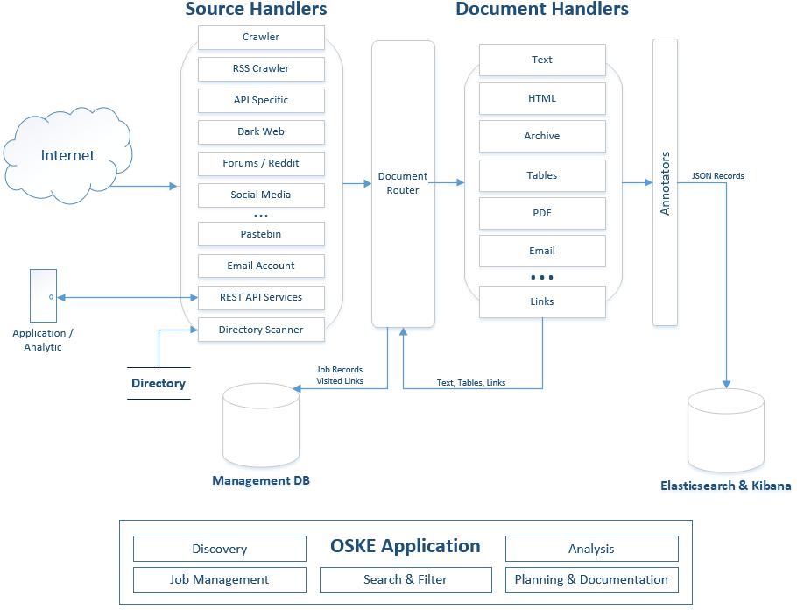

*Figure 1: OSKE Framework Schematic*

# OSKE Components

The following section provides more detail on the functional parts, what each does, and how they work together within the OSKE framework. This overview is meant to provide a high-level introduction to the system while more detail on capabilities and functionality will be provided in the specific graphical user interface (GUI) sections that follow.

## Retrieval Infrastructure (Core Components)

OSKE’s Retrieval Infrastructure includes the Source Handlers, the Document Handlers, and the Annotators & Concept Tagging as shown in the upper half of Figure 1. These form the core processing pipeline. Every web document that is retrieved by OSKE - and every document that is uploaded to OSKE - will be processed through these components. Processing through these components is initiated either by the Job Control & Tuning or Domain & Concept Discovery Components. The resulting page objects produced by the Retrieval Infrastructure will be stored in the Data Storage Components. The most current capabilities of the Retrieval Infrastructure can be found in the OSKE GUI under the Manage phase and in the Source and Document Handler interface (see Manage section).

### Source Handlers

The first stage of the core processing pipeline are the Source Handlers. These components retrieve data from the Internet through a variety of different sources using techniques that include web requests, application programming interface (API) calls, and uploaded files. The system provides over 20 different source handlers to attempt to provide a more efficient retrieval of data sources and make use of the structure and metadata of the data source when possible.

The current set of the more generic source handlers include:

* Directorywatcher - for file uploads directly into OSKE
* Email - for imap server accounts
* Feed - for RSS and ATOM news feeds
* Web - for typical web pages
* Weblist - for typical web pages, but allows for a list of starting URLs

There are also a number of source handlers that leverage search APIs and allow for queries of search terms, including:

* DuckDuckGo - privacy-focused[2] search providing generic results (not user-focused)
* Federated - includes DuckDuckGo and Google APIs
* Federated Academic - includes Google Scholar and Microsoft Academic APIs
* Google - the well-known Google search through the exposed API
* Google Scholar- the Google academic literature search API
* Microsoft Academic - the Microsoft academic literature search API
* PasteBin- searches a PasteBin search aggregation API
* Qwant - privacy-focused search providing generic results (France-based)

*Note: PasteBin-type websites allow users to store plain text files that are then retrievable by others who know the specific URL; many of these sites have made available search engines on their sites to bring back posted content. As an example of nefarious use, hackers used pastebin.com to communicate how to download the Sony Hack files through Torrent.*

There are also source handlers that were developed to leverage the structure of web forums (e.g., topic, thread, user) and store that associated structure as metadata in the page objects, including:

* Forum - web crawling for more generic implementations of a bulletin board
* Vbulletin - web crawling for vBulletin implementation of a bulletin board

OSKE also has several disabled (by default) darkweb-associated source handlers that leverage proxy services to reach “non-surface web” sources.

The Source Handler also begins to build the page objects which will, ultimately, be populated by all three Core Components and stored after each page is completely processed. The Source Handler always runs first; however, the other handlers may run in different orders and multiple times as the page data is processed into the base text.

### Document Handler

The next stage of the core processing pipeline is the Document Handler. This component takes the data from the Source Handler and attempts to extract the raw text content. This component is able to extract embedded files, outlinks, and text out of many formats. It will also run iteratively on page objects to remove multiple layers (e.g., a gzip of spreadsheets and presentations) in order to extract the underlying text.

The extraction format capabilities include:

* HyperText Markup Language (HTML) - text extraction performed with Apache Tiki[3] and BoilerPipe[4]
* XML and related formats (XML)
* Microsoft Office and OpenDocument Format (Word, Excel, PowerPoint)
* Portable Document Formats (PDF)
* Electronic Publication Format (EPUB digital books)
* Rich Text Format (RTF)
* Compression and packaging formats (ar, arj, cpio, dump, tar, 7z, and zip)
* Text Formats (various encoding formats)
* Audio, Image, and Video Formats (extracts files, but no content processing)

The resulting text data and metadata extracted from the initial page by the Document Handler execution is also added into the page object started by the Source Handler. The details on the page object are covered later in this document.

### Annotators

The next stage of the core processing pipeline is the Annotator. There are several annotators that will run during processing. Each of these annotators can add additional metadata to the page objects. One of the annotators implements Concept Tagging; this takes the OSKE concept dictionary - which includes a catalogue of generic and user-defined regular expressions - and “tags” matching dictionary terms within the extracted text of the pages. All of the resulting matches are annotated (with the matched name and location) within the page object. Concept Tagging, therefore, allows objects to be easily sorted through based on these tags.

Annotators currently implemented include:

* Concepts - annotates all concept dictionary matches within page text and adds those concept names and locations to the page object
* Data Header - annotates a LAS enterprise data header to the page object
* DBpedia - annotates matching entries within [DBpedia](https://wiki.dbpedia.org/) ([https://wiki.dbpedia.org](https://wiki.dbpedia.org/))
* Geo Tag Annotator - annotates named entity matches within page text (using Claven service) and adds matched names and geo-coordinates to the page object
* HTML Annotators - annotates HTML elements found in page text to the page object (including the following: Meta Tags, Outlinks, Title, and Referrer)
* Language - annotates the language extracted from html
* Microformat - extracts [microformat data](http://microformats.org) ([http://microformats.org](http://microformats.org/)) from html content
* Named Entity Extraction (spaCy and Stanford) - annotates named entity matches with spaCy and Stanford natural language processing (NLP) services
* Open Graph - annotates any open graph structure found in the HTML of a retrieved page; used by Facebook to link pages into their site
* Provenance- annotates information on how, when, and from where the page was retrieved
* Published Date - compares some common fields to try to determine content publish date
* Structured Data - adds any additional structured data extracted from page content
* Temporal - adds time annotations found within text
* tikaMetaData - adds tika output as additional metadata

The goal of the Annotators is to enrich the open source data. The expectation is that this added information and text content can be leveraged during development of advanced analytics on the collections of stored or exported page objects (outside the OSKE framework).

## OSKE Application (Analysis Components)

The Analysis Components provide a web-based GUI into OSKE. This allows for the following open source capabilities:

* Discovery of resources for the domain of interest
* Analysis and tuning of the data retrieval process
* Querying into the stored data
* Filtering of stored data
* Exporting of stored data sets
* Basic analysis and analytics of retrieved data

The OSKE Analysis Components include: Domain & Concept Discovery, Job Control & Tuning, and Search, Filter, Analysis, & Data Export and are individually described in more detail below.

### Domain Discovery

The Domain Discovery capability is introduced to the users within the OSKE interface in the Discover phase (covered in detail in the Discover section).

The goal of this component is to provide a way to start to “discover” what resources are available for a topic of interest.

*Note: Within the scope of this document, the terms “topic of interest” and “domain” are synonymous.*

Informally referred to as the “sandbox,” data retrieved through these components is stored with explicit markings that identify the data as being retrieved through this Discovery capability. This allows the data to be easily purged later if it is not useful or appropriate. This Domain & Concept Discovery component leverages the Retrieval Infrastructure as well as some additional capabilities, such as topic modeling and keyword extraction.

It is expected that users would normally start their work to understand a new topic of interest (or domain) and begin to answer analytical questions in Domain Discovery. This component will help users find out more about a specific domain and then select resources to set up periodic retrieval jobs to retrieve these resources and bring data into OSKE for analysis. To do this, the Discover interface within the OSKE GUI provides users with a way to query different search provider's APIs (as implemented in the Source Handler) and compare the results. Additionally, topic modeling can be used to identify additional searches within the returned results.

This workflow is expected to be an iterative process. The Discover interface also provides a mechanism to create an index of search results to help identify common terms and phrases within the results. This index uses keyword and keyphrase extraction techniques; it also provides a view of the OSKE concept dictionary annotation results. Finally, when resources do look promising, the Discover interface provides the capability to populate a template configuration for a crawling job.

### Job Control & Tuning

The Job Control & Tuning capability is exposed to the users within the OSKE platform in the Manage Jobs, Job History, Visited Pages, and Upload Files interfaces (see the Manage section for further details). As with Domain Discovery, this component also leverages the Core Components; however, unlike Domain Discovery, Job Control & Tuning runs based on a system scheduler clock. Although user interactions are not directly driving the process, the user can still monitor and tune the processing.

There are two main goals that this component accomplishes. First, OSKE executes the resource retrieval as retrieval jobs and then stores the resulting pages objects (each with annotated metadata) in the Data Storage components. Second, this component allows the user to set up these retrieval jobs (in the Manage Jobs interface) and analyze and/or adjust these jobs through the other menus (Job History and Visited Pages). Additionally, the user can add files directly to OSKE through the Upload Files interface. Through this menu, individual files will process through the Retrieval Infrastructure just as retrieval jobs do.

The user can create a number of retrieval job configurations; this allows for highly-customized and tuned open source data retrieval. Each job is configured to run at user-defined time intervals (CRON-style to allow for monthly, weekly, daily, or hourly hourly). When the scheduled time is reached, the OSKE server will use the job-specific configuration parameters to execute the web retrieval. Each web retrieval will leverage one of the Source Handlers to retrieve resources, such as: web pages, RSS feeds (based on an initial OSKE job configuration “seed” URL), and web searches (using one of several implemented search engines providers) to access content, including text and additional hyperlinks (along with the hypertext markup and JavaScript) associated with each page. The hypertext is parsed to attempt to remove the layers of formatting from each page and ultimately get to the unstructured text within it and store this information in OSKE Storage Components.

The pages, along with additional metadata, are stored in JavaScript Object Notation (JSON) format. Based on the job configuration, hyperlinks found in the content may then be used to start additional page retrievals. The OSKE job configuration allow for options, such as: limiting to a specific domain; controlling extent of retrievals; limiting size of individual page retrieval; limiting number of pages in a retrieval; and, adding a delay between subsequent page retrievals within an OSKE job. The OSKE job configuration also includes the option of using simple regular expression (REGEX) statements to determine relevance of individual pages, and it has the ability to extract only specific text based on job-configuration parameters.

### Search, Filter, Analysis, & Data Export

The Search, Filter, Analysis, and Data Export capability is introduced to the users within the OSKE User Interface in the search forms and results panes (see various Search sections below for more details). This allows the user to search through page objects. This menu provides a simple interface into the ElasticSearch (the page object data store), which allows for keyword, phrase, or REGEX queries as well as filtering of the retrieved page objects.

There are two main goals of this component. The first goal is to verify that the correct (accurate and relevant) data is being retrieved in the Job Control & Tuning stage. Using this component and the Job Control & Tuning stage, the data retrieval process can be adjusted to maximize the value of retrieved data. The second goal of this component is to provide data analysis capabilities. The search results feature includes the ability to view extracted text, outlinks, annotations, and metadata. Additionally, it offers basic analytics like text summarization, word clouds, keyword/keyphrase views, and Google analytics (info, linkto, and related). Users can also place results into document buckets (i.e., collections) for future reference. Through these buckets, users can quickly access documents related to a particular topic. The complete functionality for these capabilities is exposed in the Document Buckets interface.

## Data Storage Components

The Data Storage Components include ElasticSearch[5] (with Kibana[6] for visualization), Hadoop Distributed File System[7] (HDFS), and the local filesystem. These provide data stores for the entire collection of OSKE retrieved page objects as well as the raw (original) page retrieval objects. OSKE uses ElasticSearch within the Search, Filter, Analysis, & Data Export Component; however, these data stores also provide mechanisms for external processes to access these, potentially, rich data sets. Specifically, ElasticSearch allows for direct queries through a Representational State Transfer (REST) interface, and HDFS can be mounted by external processes. Both of these techniques allow for development and use of analytics outside of the OSKE systems: including those typically used in “big data” infrastructures, such as Map-reduce and Spark. The stored page objects include the extracted text, but also metadata and retrieval details for the page. This includes information such as: date/time of page retrieval, details of the job that produced the page, and any annotations as described above. ElasticSearch also has the Kibana visualization plug-in, which provides another interface into the stored page objects for analysis as well as visualizations.

## External Components

Several external components have been loosely integrated with OSKE. These components can access OSKE data (via export, data storage, or messaging) to allow for development and testing of new open source analysis capabilities. Currently, the open source Voyant[8] text analytic tool is available to use with OSKE exported documents. The activity, both of the system itself and of users, within the OSKE framework is instrumented with these events being stored in their own ElasticSearch database. These events can then be analyzed for a variety of reasons to include system performance, common analytic workflows, and feature use with the system. These instrumented events, which included processing details as well as User GUI interaction, are stored in an Instrumentation Event database. Additionally, knowledge graph implementations are being experimented with. Finally, OSKE provides a data export capability (see details later in this guide), which allows for external analytic development (with tools such as Apache Zeppelin[9] and Jupyter Notebooks[10]). By using these external tools, analysts can develop and experiment with their own analytics on the data collected through OSKE.

# Web Retrieval Caveats and Guidance

OSKE supports research of PAI on the Internet. Data must be openly available, users must adhere to legal agreements on the web pages, and any registration must be using the person’s true identity. Queries into the data should also be for specific and justifiable research purposes.

The Web Robots Exclusion Protocol provides one way to ensure OSKE is adhering to website owner guidelines when retrieving web pages. Most websites will have a file at the root level named “robots.txt” which stipulates content owner’s rules for where web crawlers are allowed and disallowed. When OSKE jobs are written, the “respectRobotsText” rule should be set to true (by default). Some interesting reading on legal aspects of robots.txt can be found at<http://www.robotstxt.org/faq/legal.html>.

When setting up retrieval jobs, it should be noted that the web retrievals will be originating from the domain where OSKE was installed and any web site administrator will be able to see this. Retrieval jobs should not be set up if the fact that particular domain is crawling a site should not be publicly known. Most websites will have a Terms of Service section. It is important to understand the implications of any de facto agreement that comes from retrieving and using web pages.

Finally, retrieval jobs must be configured properly to ensure that “runaway crawl” situations don’t happen. Configuration rules are available to limit items such as: website depth, domains, maximum number of pages, and speed of page access. The retrievals need to be reviewed before they are implemented, and this is handled by an “adjudicator” process implemented within the Manage Jobs interface in the OSKE platform.

# OSKE GUI Reference

This section will provide the user familiarity with the main functional components, analytic workflow, concepts, and features of the OSKE platform. Additionally, this section will attempt to walk the user through sample scenarios (if applicable) within the application interface.  
  
The OSKE interface is built around a simplified workflow design, separating the major components and analytic features into suggested analytic tasks that can be accomplished in any order. The implied order in Figure 2, however, walks a novice user through a common research path. The user first organizes their thoughts and key research questions into a *Plan*; conducts initial research against those questions in a *Discover* phase through open source retrieval and storage; begins to *Analyze* materials retrieved to make initial judgements and revise planning and discovery approaches; starts to build and *Manage* recurring retrieval strategies to bring in new material over time; and, highlight and *Document* findings in completion of analytic task. Although represented in a cyclical fashion below for simplification, each step of the process can inform the other, depending on the analytic task at hand; users can freely jump between each as their experience dictates.

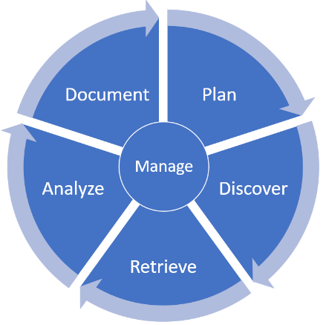

*Figure 2: OSKE Workflow*

OSKE also uses a simple system hierarchy and file structure within its interface to help users organize (and research) in an easily understood and managed manner. The hierarchy can be graphically represented as in Figure 3.

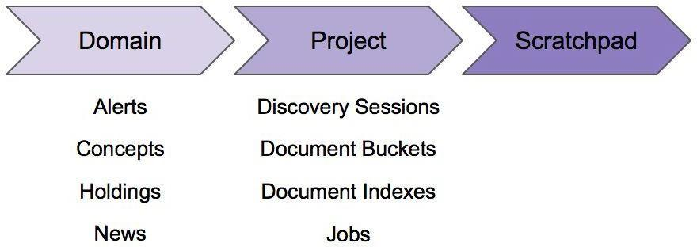

*Figure 3: OSKE Simplified Organizational Hierarchy*

Conceptually, users can think of the hierarchy as follows:

* Domain - highest-level of grouping of users and research around a general topic (e.g., the category of Emerging Technologies; elements such as alerts, PESTLE-S/concepts (to be covered later), holdings (retrieved and stored materials), and news feeds are examples that apply to the broadest level
* Project - within a domain, users can set up individual projects (under the Plan phase) to focus research against specific topics within the domain (e.g., Drones - a specific yet multi-faceted emerging technology); users can have multiple projects under the domain; elements such as discovery sessions, document buckets, document indexes, and recurring jobs are examples that apply to a more specific project-level task
* Scratchpad - within a project, users can utilize the scratchpad feature to document findings specific to that project; the notes therein should reflect materials that prove/refute the hypothesis and research questions specific to that project

## Domain Summary

Upon successful login to the OSKE platform, the user will be presented with the Domain Summary page.

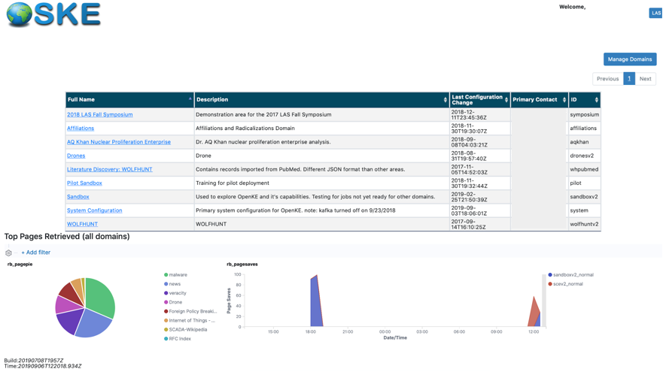

*Figure 4: OSKE Domain Summary Page*

The Domain Summary page will list all available domains the user is authorized to access. To enter any domain, the user simply clicks on the corresponding hyperlinked *Full Name* field (e.g., affiliations, sandboxv2). A *Description* field for each domain is provided to offer insight into the scope of the respective research project. A *Primary Point of Contact (POC)* for each domain is also provided for reference should users have questions pertaining to that research topic and/or to request access.

Additionally, the user is presented with a graphical representation (utilizing ElasticSearch and Kibana) of the most recent pages that have been stored within the last 12 hours for any recurring retrieval jobs that have been set up.

*Note: This visualization may or may not be present - it is configurable and must be implemented in Kibana and applied to OSKE’s configuration.*

Additionally, users with authorization to manage the OSKE framework will see an additional button on the upper right corner to Manage Domain. The Administrator’s Guide covers this functionality.

Users can navigate back to the Domain Summary page at any time by clicking on the OSKE logo (see Figure 5 below) at the top left-hand side of every page.



*Figure 5: OSKE Logo Linked to Domain Summary*

## Dashboard

After clicking on and entering a specific Domain(e.g., sandboxv2), the user will first be presented with the Dashboard page.

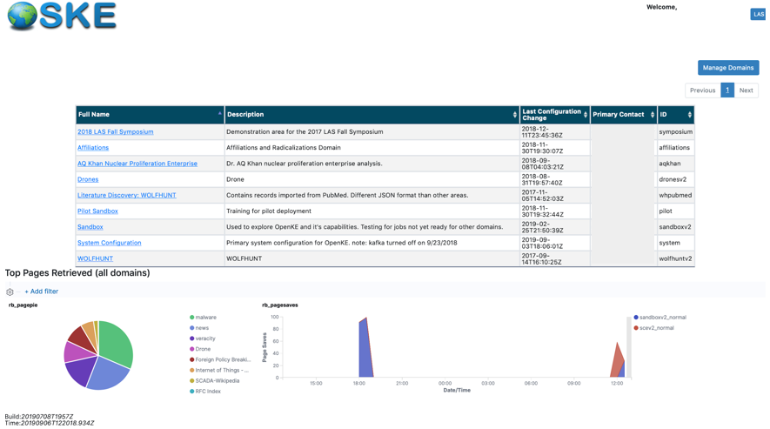

*Figure 6: OSKE Dashboard Page*

The Dashboard page is comprised of several sections, including navigation elements, main menu bar/tabs, and summary panes for Projects, Discovery Sessions, News, Search Alerts, Concepts, and Help sections.  
  
*Note: The Dashboard page is tailored to each individual Domain, and will only present items from users within that respective Domain.*

### Navigational Elements

Along the top left of the Dashboard page (and carried across all pages of OSKE), users can access the Domain Summary page by clicking on the OSKE logo (see Figure 5).

Additionally, in the top middle of the navigation section, users are provided information on the current Domain, Project, and Scratchpad they are working within during their session (see Figure 7). Each label includes a hyperlink to the respective section.  
  
*Note: Upon initial entry into the Domain, the user will need to select/assign the Project and Scratchpad they wish to work within for that session. Prior to selection, the user will see “Unassigned” next to each. Users simply click the hyperlinked text for “Unassigned” to be presented with the selection dialog.*

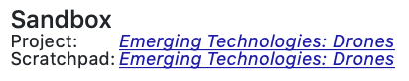

*Figure 7: Navigational Awareness for Current Domain, Project, and Scratchpad*

On the top right-hand side of each page (see Figure 8), the user is presented with information on the current user as well as links to the Collector Home view and a Feedback submission form.



*Figure 8: Current User Information; Link to Collector Home and Feedback*

The Feedback submission form (see Figure 9) can be used to report bugs; request feature enhancements/improvements; request support; and/or, provide the support team[11] with any information to facilitate building a better user experience. Upon clicking submit, the support team will receive an email with the user’s entry. This “support team” is defined within OSKE’s configuration. Refer to the Administrator’s Guide for further details.

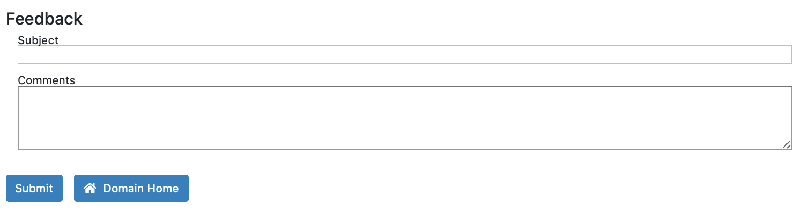

*Figure 9: Feedback Submission Form*

The Collector Home view (see Figure 10) is a legacy interface for the OSKE platform that provides a more collector-centric view of the inner-workings of OSKE features and components. The biggest difference is in the way the navigation is handled, as seen in the layout of the left-hand side menu vice the Plan/Discover/Analyze/Manage/Document approach. The Collector Home view exposes more of the job creation and management interfaces on the home page. Users can switch between the views by clicking the respective *“Switch to…”* links in the top right-hand side section.

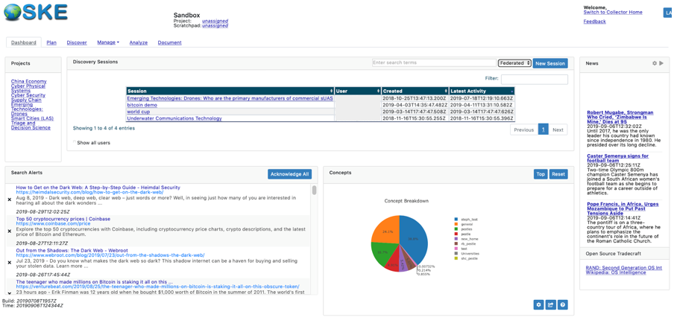

*Figure 10: OSKE Collector Home View Interface*

General statistics can be found on the lower left corner of the Collector Home page. This shows the total number of web retrieval jobs run to date, number of currently running jobs, number of pages visited, pages stored, and size of stored pages to date. Of note is that a Domain has a limited number of “job threads” available to service data retrievals at any given time. These “jobs” are configured in the Job Control & Tuning component and specifically under the “Manage Jobs” interface (see Manage section). These details can be helpful when monitoring and tuning jobs.

### Main Menu Bar

The Main Menu Bar (see Figure 11) allows users to jump between the Dashboard, Plan, Discover, Analyze, Manage, and Document portions of the OSKE platform. Each link will take the user to the respective section (each detailed in subsequent sections below).  
  


*Figure 11: Main OSKE Menu Bar Options*

### Project Summary Pane

The Project Summary section of the Dashboard presents the user with the currently available Projects within that Domain. Users can click on the respective project to be taken to the corresponding Plan entry. If there are no current entries available, the user will see *“No active projects”* in the display. To start a new project, the user can click on Plan within the Main Menu

Bar/Tabs to begin a new project. That project, once saved, will be reflected in the Project Summary pane (see Figure 12) on the Dashboard for quick access.

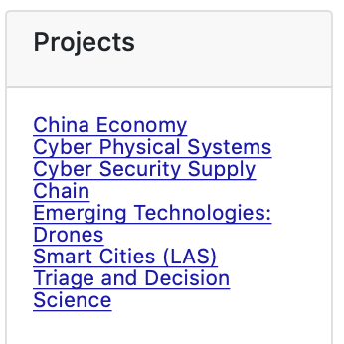

*Figure 12: Project Summary Pane Example*

### Discovery Session Summary Pane

The Discovery Session Summary section of the Dashboard presents the user with a summarized listing of all existing Discovery Sessions within that Domain. The table (see Figure 13) includes sortable headers that can be toggled ascending/descending by clicking on the respective up/down arrow icons next to the field name. By default, the listing is ordered descending on the Latest Activity column, with the most recently accessed session at the top of the list.  
  
*Note: The listing in this pane will include Discovery Sessions for just the current user by default, but can be selected to show the Discovery Sessions for in that Domain.*

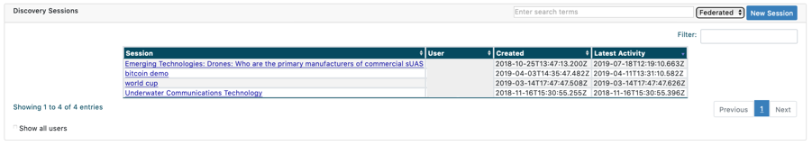

*Figure 13: Discovery Session Summary Pane Example*

Additionally, users can initiate a new discovery session through the Quick Start along the top of the pane by simply adding their search term(s), choosing a source handler, and clicking the New Session button.  
  
*Note: Exact phrases can also be searched within the Quick Search using double-quotes (e.g., “search phrase”).*

The available source handlers within the Quick Start (see Figure 14) are:

* Federated - default; includes Google and DuckDuckGo search engines
* Academic - includes Google Scholar and Microsoft Academic search engines
* Holdings - includes only information that has been previously retrieved and stored in OSKE through recurring retrieval jobs



*Figure 14: Quick Start Discovery Session Example*

Upon submitting the search, the user will be taken to the Discover section (see Figure 15) where the results will be displayed (see the Discover section below for more details on features available to the user).

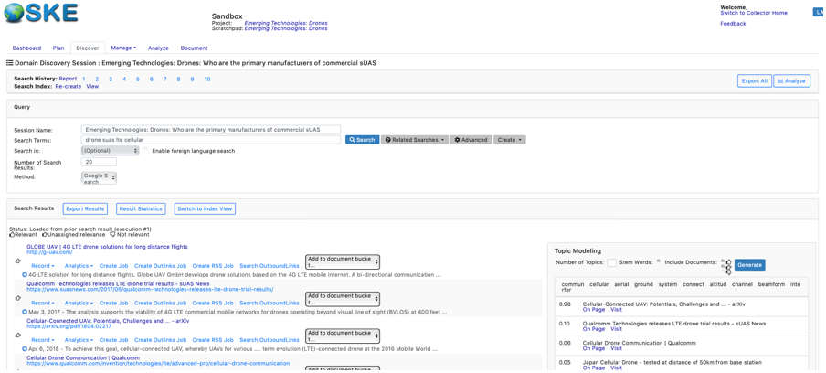

*Figure 15: Discovery Session Results View Example*

When using the Federated or Academic search handlers, as noted in the graphic above, the summary text for the results returned will be prepended with the search engine from where that result came (e.g., Google, DuckDuckGo for Federated; Google Scholar, Microsoft Academic for Academic).

### News Summary Pane

The News Summary section of the Dashboard provides the user high-level awareness of breaking news. The section currently shows breaking news highlights from several open source RSS feeds, including: NY Times, Fox News, Al Jazeera, and BBC. These feeds are cached every 10 minutes.

Current feeds include:

* <http://www.aljazeera.com/xml/rss/all.xml>
* <http://feeds.bbci.co.uk/news/world/rss.xml>
* <http://rss.nytimes.com/services/xml/rss/nyt/World.xml>
* <http://feeds.foxnews.com/foxnews/world>

The News pane can be set to automatically scroll through the available articles by clicking the Play/Pause icon (see Figure 16).

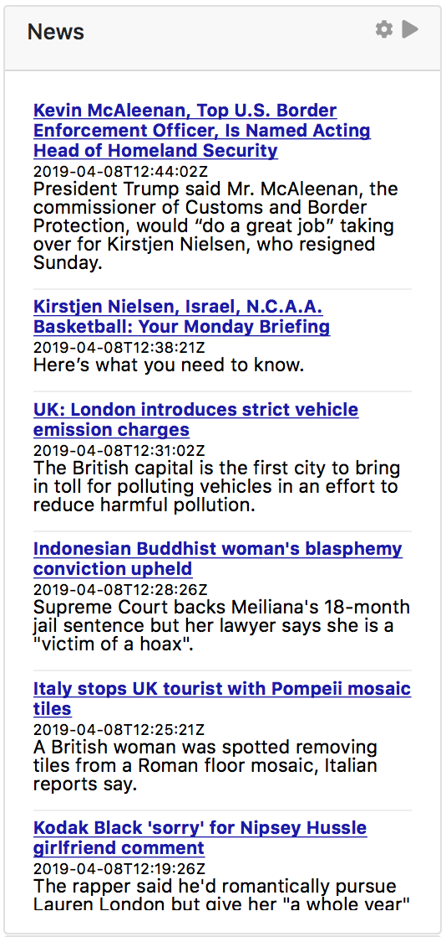

*Figure 16: News Summary Pane Example*

Additionally, users can customize their experience by clicking the gear icon to open the News Configuration dialog (see Figure 17), allowing for the addition or deletion of feeds as well as specific keywords to further tailor the results provided in the News Summary section. Users can add new RSS feeds by inputting a valid RSS URL address into the Feed URL text box and clicking the Add button. Users can also delete any feed(s) listed by clicking the ‘X’ icon to the right of the feed.

*Note: URLs must be valid RSS feeds. The addition of keywords will require the keyword to be present in the source document across all feeds, and cannot be applied directly to specific feeds. Users can leave this field blank to show all entries from the listed RSS feeds.*

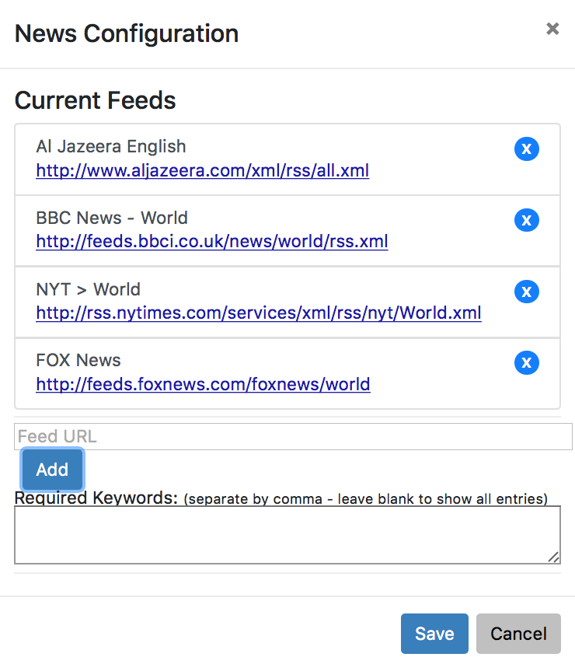

*Figure 17: News Summary Configuration Pane Example*

### Search Alerts Summary Pane

The Search Alerts Summary section of the Dashboard provides can be tailored by the user to provide indications and alerts of new open source materials available from recurring queries. This feature is similar to Google’s search alert feature, whereby the user sets up an alert based off their search term(s), sets up a frequency, and they are notified when new collection meeting that criteria is available. Users can acknowledge each entry by clicking the “X” next to the alert, or they can clear all alerts by clicking the Acknowledge All button. More detail on configuring search alerts can be found in the Manage section. The example below (in Figure 18) shows results from search alerts set on the terms “bitcoin” and “dark web”:

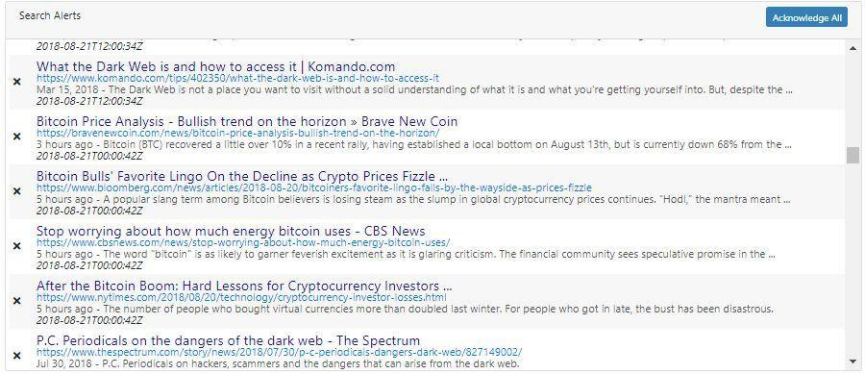

*Figure 18: Search Alerts Summary Pane Example*

### Concepts Summary Pane

The Concepts Summary section (see Figure 19) provides the user with a graphical representation of OSKE’s PESTLE-S concept implementation.

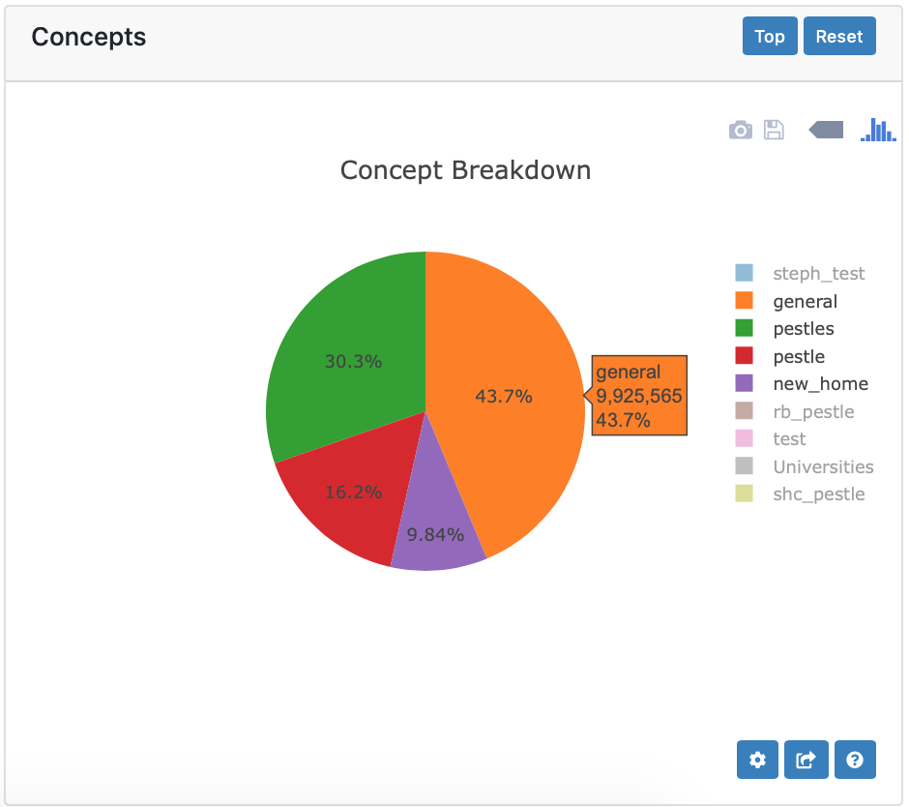

*Figure 19: Concepts Summary Pane Example*

Users can interact with the dynamic chart to drill-down into information that has been “tagged” with concepts from OSKE’s concept dictionaries (more details in the PESTLE-S section). As users hover over the chart, they will see the associated count and overall percentage of times a concept from within OSKE’s holdings (within that domain) was noted. Clicking on the chart wedges will drill-down from more general to specific terms (see Figure 20).

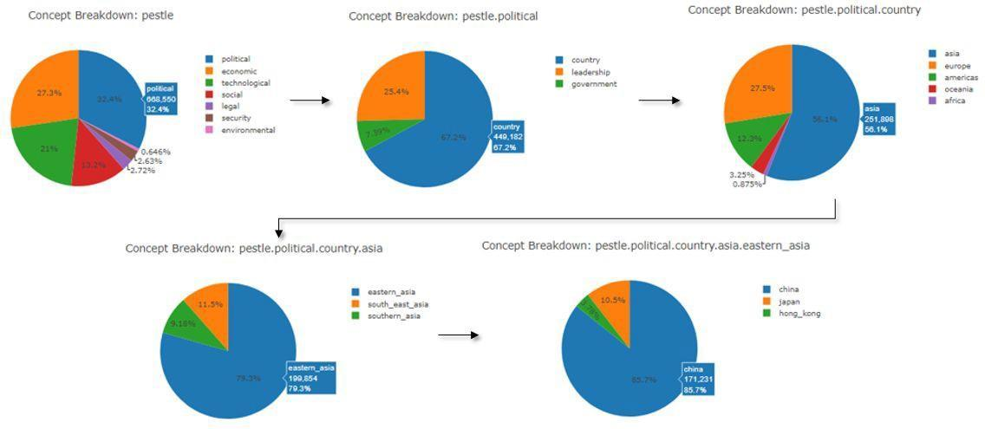

*Figure 20: Example of Drill-Down into Concepts*

Users can also initiate a search of OSKE’s holdings within the respective domain using specific PESTLE-S concepts directly from the graph by using a Shift-Click on specific wedges of the chart. By using a Shift-Click on a chart wedge, the user is simply applying a filter within a search to show all materials in the OSKE holdings for that domain that were “tagged” with the concept on ingest. In Figure 21 below, the filter was on the “pestle.political” concept, which would include any sub-concepts under that hierarchy.

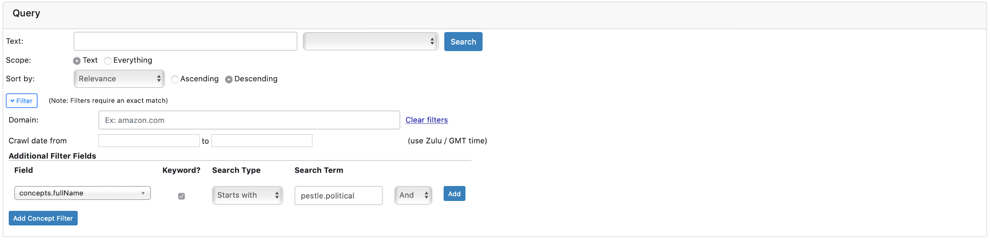

*Figure 21: Example of PESTLE-S Criteria used to Filter Search using Shift-Click from Chart*

Users can also toggle specific dictionaries and/or concepts on/off by clicking on the appropriate label in the legend of the Concepts Summary pane. To return the chart back to default, users can Reset or return to the Top of the PESTLE-S hierarchy by clicking the appropriate button at the top of the Concepts Summary pane.

Users can also interact with the chart through additional features (see Figure 22) noted beneath the graph, including restricting the statistics shown by set date/time criteria (settings icon); copying the graph to the current Scratchpad (copy icon); or, getting more information from a Help pop-up dialog (help icon).

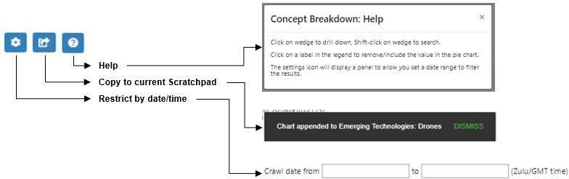

*Figure 22: Examples of Additional Features for Concept Pane*

### Help and Training Pane

The Help and Training section presents the user with reference materials and training on various OSKE components and open source tradecraft.   
  
*Note: This section can be configured by the administrator to reflect internal or external training materials and guides.* *Figure 23* *below depicts an example of what that section may look like to the user.*

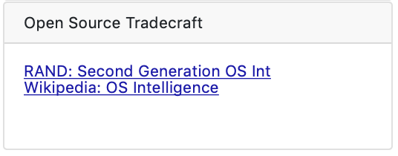

*Figure 23: Help and Training Pane Example*

## Plan

Outside of the initial Dashboard page, which provides a high-level overview of all activity within a specific Domain, the suggested OSKE workflow, typically, begins with the Plan page (see Figure 24). The Plan page provides the user an opportunity to brainstorm and document their research goals and engage in pre-query development of key research questions, hypotheses, and question decomposition techniques. The Plan page is comprised of a Projects and Project Details pane.

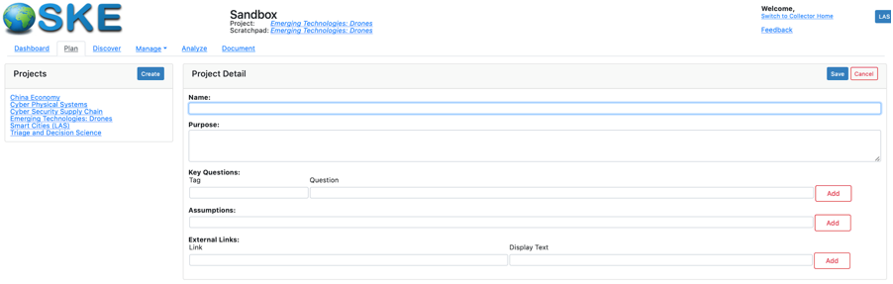

*Figure 24: OSKE Plan Interface, Displaying Example of Creating New Project*

### Projects Pane

The Plan page displays all current projects within the respective domain within the Project pane. If there are no existing projects available, the user will see *“No active projects”* in the display.

Likewise, if no existing projects are available and/or selected, the user will see *“No project is currently selected or set as active”* in the Project Details pane.

*Note: All users within the domain can view/edit any project. There are currently no project-level restrictions in place.*

### View/Edit Existing Projects

To view/edit the details of an existing project, the user can click on the name of the project. Upon clicking on the name of the project, a Project Detail pane will appear with the relevant details (see Figure 25).

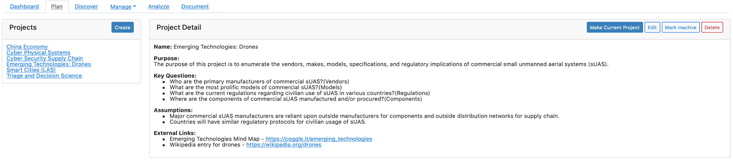

*Figure 25: Project Details Pane with Selection Example*

From an existing Project Detail pane, using the appropriate action buttons (see Figure 26), the user can set the selected project as their current project; initiate an edit of the project details; mark the project as inactive/complete; or, delete the project entirely.



*Figure 26: Project Detail Action Buttons*

### Editing/Deleting a Project

To edit an existing project, the user can either click the Edit action button or click within the text of the plan within the Project Detail pane. Doing so will make the text fields editable. Upon making changes, the user clicks the Save button to save changes. The Cancel button will discard all changes without saving and present the user with the last saved version of the text. The user can also choose to delete the project, using the respective action button.  
  
*Note: There is no undo button for any edit or deletion. All users within the domain can view/edit/delete any project listed.*

### Setting the Current Project

Marking a project as the current project will set subsequent Session Names within the Discover section with the project Name given (see Figure 27 for example of having the Emerging Technologies: Drone project set as current project). This Session Name can still be edited by the user; but, it attempts to keep the user informed of the research topic at hand should they jump around between topics.

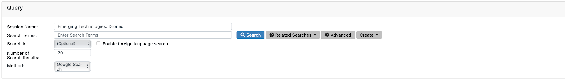

*Figure 27: Session Name Example for Current Project*

### Toggling a Project as Active/Inactive

Users can also toggle a project as Active/Inactive, using the respective toggle button, should they complete a research project or need to place one on hold. This option allows a user to archive the project details for future use and offers the ability to remove older projects from the active project directory. When a project is set to inactive, a new button is included in the Project pane that toggles between *All Projects* and *Active Projects Only*. When All Projects is selected, any inactive project(s) will be shown in italics (see “testingmysmartcities” project in the Figures 28 and 29 below for example of an inactive project). When Active Projects Only is selected, any inactive project(s) will be hidden for view.

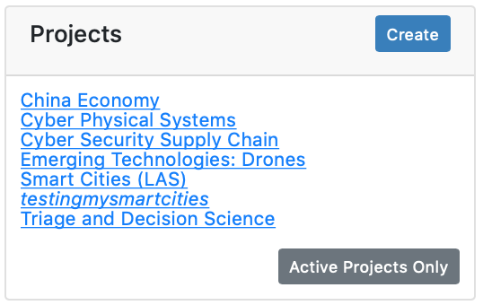

*Figure 28: Example of All Projects Selection Displaying Inactive Project*

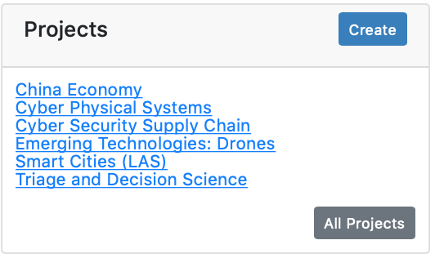

*Figure 29: Example of Active Projects Only Selection Hiding Inactive Project*

### Initiating a New Project

To initiate a new project, the user can click on the Create button in the Project pane. The user can then input relevant details concerning their new research project in the Project Detail form (see Figure 30). Once complete, the user clicks the Save button to save changes and add the project to the Projects pane. The Cancel button will discard all changes without saving and present the user with a new blank project plan form.

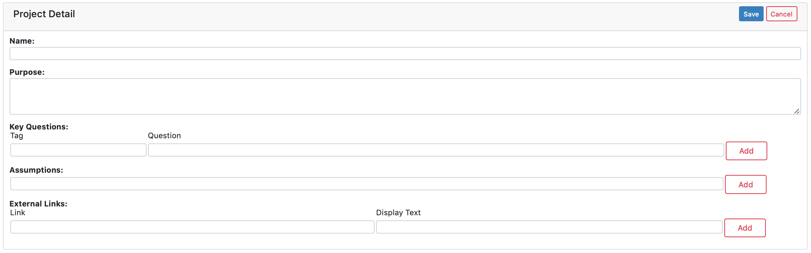

*Figure 30: New Project Detail Form*

Currently, the project plan form allows the user to document the Name, Purpose, Key Questions, Assumptions, and any external links associated with the research at hand.

Descriptions for each element include:

* Name - specific name for the research project (e.g., Emerging Technologies, Drones) which will be appended to discovery sessions to delineate searches
* Purpose - overall description of research project (i.e., why are you conducting the research)
* Key Questions - descriptive questions to be answered through research; a tag can also be used designate document buckets (collections) to store references addressing the research question
* Assumptions - descriptive statements that define pre-existing bias or beliefs, either to be proven true/false or to caveat research approach
* External Links - URLs for any external references, mind maps, or relevant sources

## Discover

Moving from planning research to conducting initial research queries, the suggested OSKE workflow takes the user into the Discover phase. Within the Discover phase, the user iterates through searches to make judgements on the value and veracity of data sources and begin to retrieve material that addresses stated analytic tasks and/or key research questions identified. The Discover page provides the user an initial starting point for searching the Internet and making sense of results. The Discover page defaults to the Domain Discovery Session Summary page (see Figure 31).

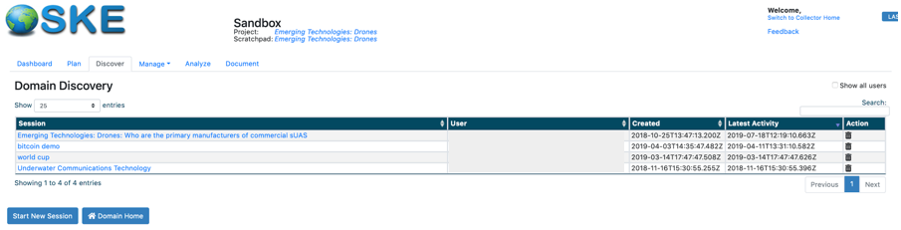

*Figure 31: Domain Discovery Session Summary Interface*

### Discovery Session Summary Interface Overview

The Domain Discovery Session Summary section presents the user with a listing of all existing Discovery Sessions within that respective Domain. The table includes sortable headers that can be toggled ascending/descending by clicking on the respective up/down arrow icons next to the field name. By default, the listing is ordered descending on the Latest Activity column, with the most recently accessed session at the top of the list.   
  
*Note: The listing in this pane will include Discovery Sessions for all users authorized within that Domain.*

The user can also toggle the number of results shown in the table, using the available View drop-down menu (see Figure 32), from 25 (default) to 10, 50, 100, or All. Additionally, the user can apply a filter to the table (see Figure 33), using the available Search text box, to limit results to certain users, keywords, or dates. The example provided shows results filtered on the word “drone” in the search box.  
  
*Note: The Search text box is free-form and exact match. It will dynamically update as the user types. To remove filter, simply delete text from the text box.*

**

*Figure 32: View and Search Options for Filtering Table Results*

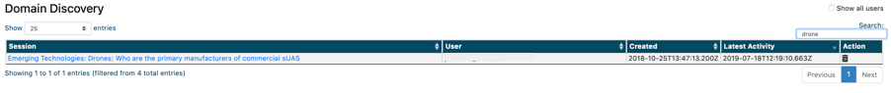

*Figure 33: Example of Keyword Filter in Search Box*

### View/Edit Existing Discovery Sessions

Each session name in the Session column is a hyperlink to the search history for that particular user search session. If there are no existing sessions available, the user will see *“No sessions available”* in the display. By default, any key questions that have been entered by the user into a plan (see Plan section) will create a corresponding Discovery Session entry (see Figure 34). This behavior is intended to help users bin their research into sessions that focus on specific aspects of their analytic tasks and questions. See the “Emerging Technologies: Drones” example below:

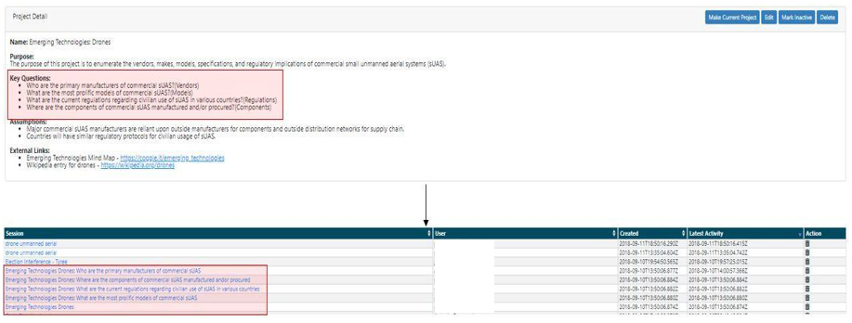

*Figure 34: Default Creation of Discovery Session from Key Questions Captured in Plan Section*

When clicking on the session name, the user will be taken to the session history for that search (see Figure 35). From there, the user can reload the results by clicking on the numbered links next to the Search History label; create a report to export search statistics by clicking on the Report link next to the Search History label; or, create a new search index view from all sessions by clicking on the Create link next to the Search Index label (see detail later in section).   
  
*Note: All users within the domain can access any session. No project-level restrictions exist.*

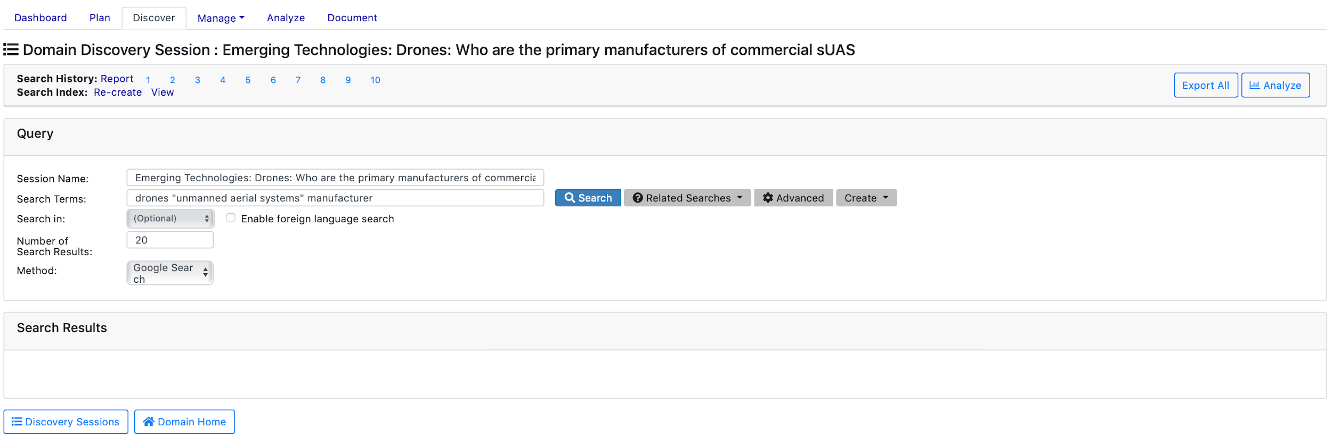

*Figure 35: Navigating from a Session Listing Returns Session History*

### Initiating a New Discovery Session

To initiate a new discovery session, the user can click on the Start New Session button below the session listing table (see Figure 36). Clicking this button will direct the user to a blank Discovery Session interface. The user can then input relevant details concerning their new search. The Domain Home button will return the user back to the Dashboard page.



*Figure 36: Start New Session and Domain Home Buttons*

When creating new a new session, a blank Discovery Session Query form will be presented to the user (see Figure 37).

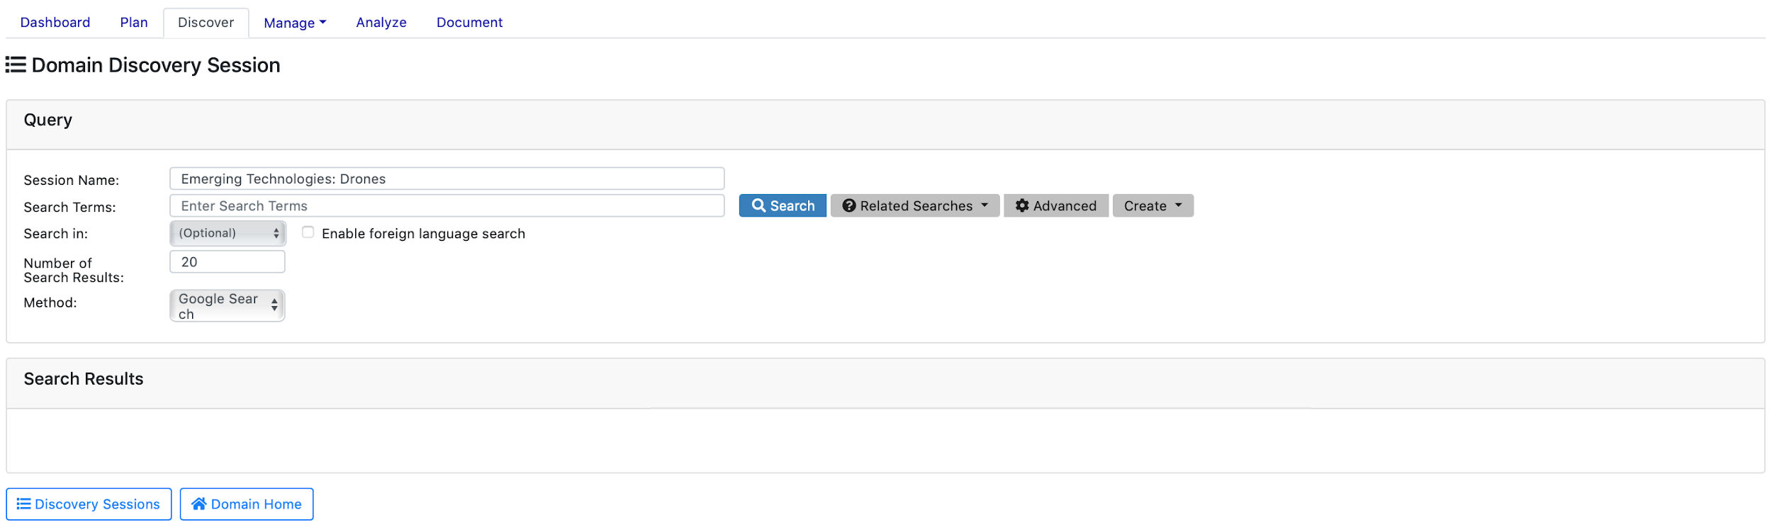

*Figure 37: Blank Discovery Session Query Form Interface*

The Discovery Sessions button will return the user back to the Domain Discovery Session Summary page. The Domain Home button will return the user back to the Dashboard page.

The query form is comprised of several user-input elements required to run a search, including:

* Session Name - descriptive name for discovery session, usually tied back to the research question at hand
* Search Terms - listing of search terms and/or keyphrases (delimited by quotes) to be queried; boolean operators permitted; standard Google search logic applies
* Search In - provides foreign language translation and query capabilities; toggling “Enable foreign language search” option on will enable drop-down selection menu of available translation languages; defaults to off (for more information on foreign language queries, see Foreign Language Query section)
* Number of Search Results - denotes the number of results to be retrieved from the selected method(s); defaults to top 20 results
* Method - denotes the source handler to be used in the query; defaults to Google (for more information on available search handlers, see Source Handler section)

Once a user inputs the required elements above, they have several options to consider prior to submitting (see Figure 38). They can run the search; check Google recommendations for related search terms; or, create a recurring retrieval job (to be covered in the Manage section) or search alert (displayed on the Dashboard page).

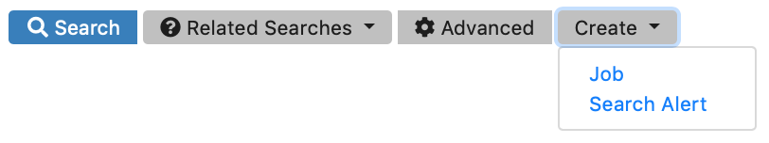

*Figure 38: Discovery Session Query Form Options*

### Related Google Searches

Skipping over Search for a moment, the Related Google Searches button pulls in Google’s recommender service to provide additional keywords to consider adding prior to submitting, similar to suggestions provided when typing search terms into google.com (see Figure 39). The user can click on any keyword returned to automatically add the term(s) to the query form.

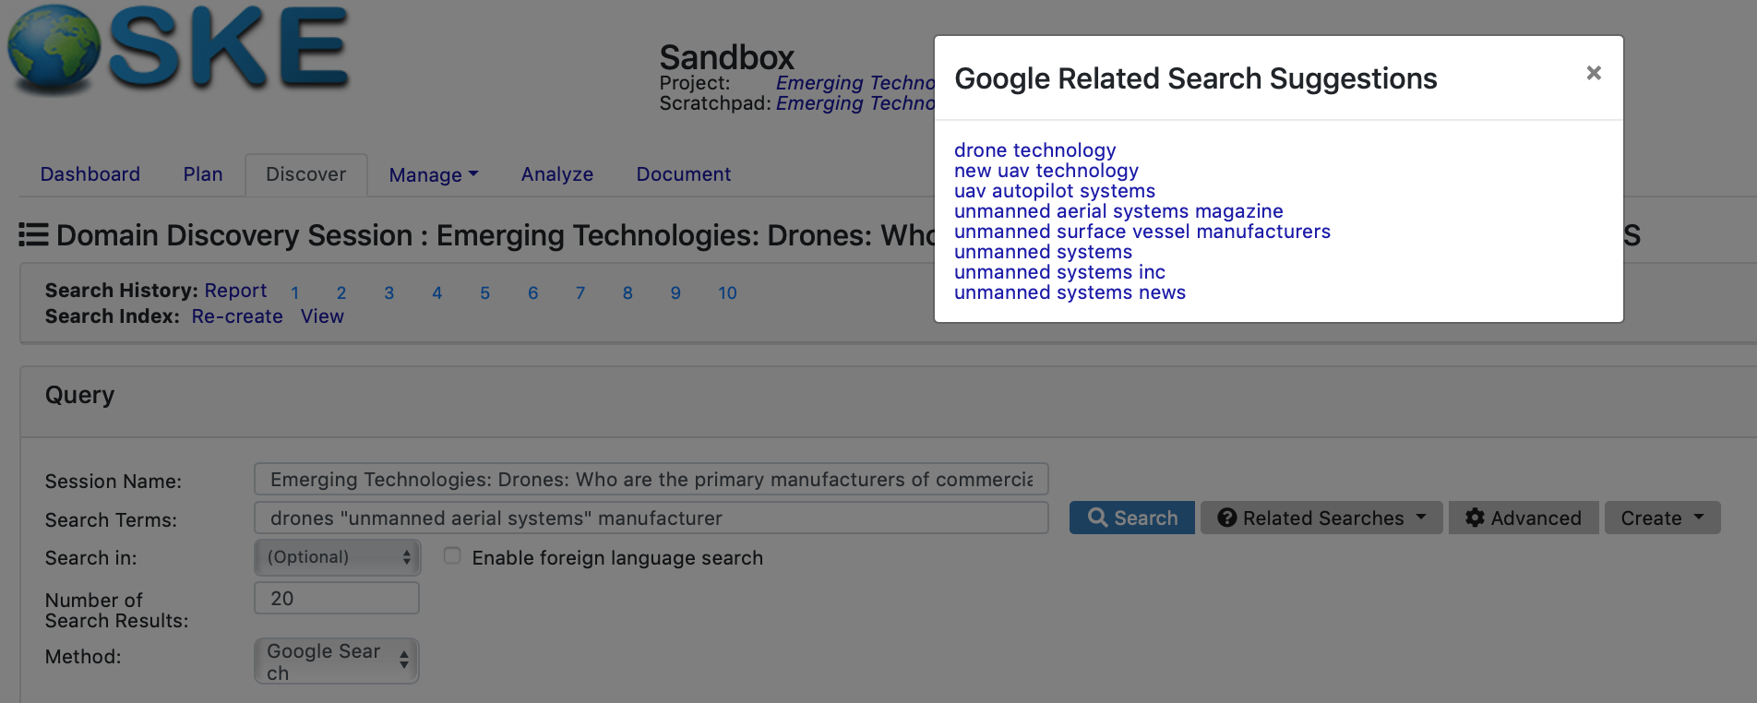

*Figure 39: Related Google Search Suggestions Example*

### Creating a Job or Search Alert from Discovery Session

Clicking on the Create button, will provide the user with the option to save the search as a recurring Job (run at set intervals) or a Search Alert (notifying the user of any new results from a previous search).

For creating a job (more detail in the Manage section), the user will first be asked to input a Search Justification, which will be made available to OSKE’s administrators and query adjudicators. The user will then be asked if they would like to view the job and, if so, will be taken to the Manage page. This process is shown in Figure 40 below.   
  
*Note: Creating a job through the Discovery Session will place the job in Draft status. The user will have to review, make any edits, and click Submit if they wish to submit it for adjudication and approval.*

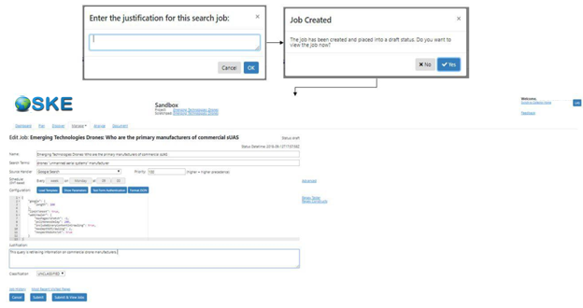

*Figure 40: Job Creation from Discovery Session*

For creating a search alert (more detail in the Manage section), the user will be presented with a dialog box to name and specify a search schedule for checking for new results. Users may also select to acknowledge all of the current results (i.e., they will not appear as “alerts” on the Domain Home Page. On clicking Create, the alert will be created. To view/edit the alert, the user can navigate to the Search Alerts summary under the Manage section. This process is shown in Figure 41 below.

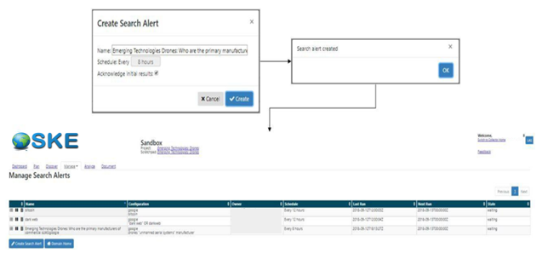

*Figure 41: Search Alert Creation from Discovery Session*

### Submitting a New Search

To submit a completed query form, the user will click the Search button (see Figure 42). While in the Domain Discovery Session, the query form will retain the search information from the last-run submission. The user can modify any/all fields in the form and re-submit.

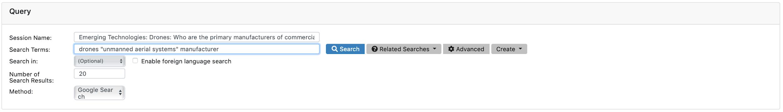

*Figure 42: Submitting a New Search*

### Foreign Language Query

OSKE allows users to search in multiple foreign languages through an integrated translation capability. To enable a foreign language search, which translates the current search terms in the Search Terms field, users can toggle on the Enable foreign language search radio button. By doing so, the terms listed in the Search Terms field will be translated to the chosen language (selected from within the drop-down listing) and displayed in a new Translated Terms field under the Search Terms field (see Figure 43 below). Once translated and displayed, the user can click the Search button to submit the search and view results.

If a user modifies the terms in the Search Term field, they can simply click the Translate Search Terms button (which appears when the Enable foreign language radio button is toggled on) to update the translated terms and then resubmit the search. Users can also enter their own foreign language terms directly into the field. This iterative process enables the same discovery approach with multiple foreign languages and different sets of terms.

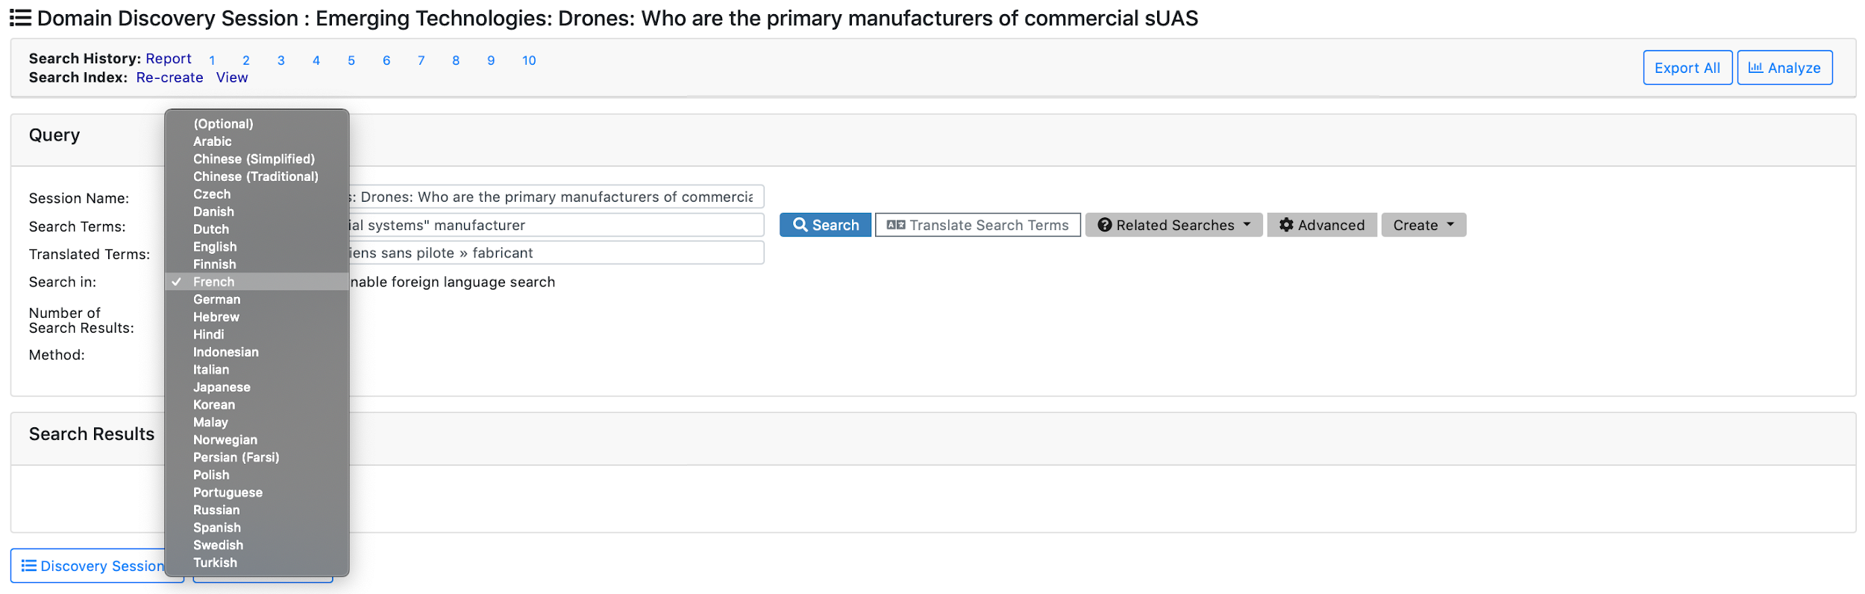

*Figure 43: Foreign Language Search Example*

### Search Results Interface Overview

Upon completing and submitting a new query form, the user will be provided with the results in the Search Results pane (see Figure 44).

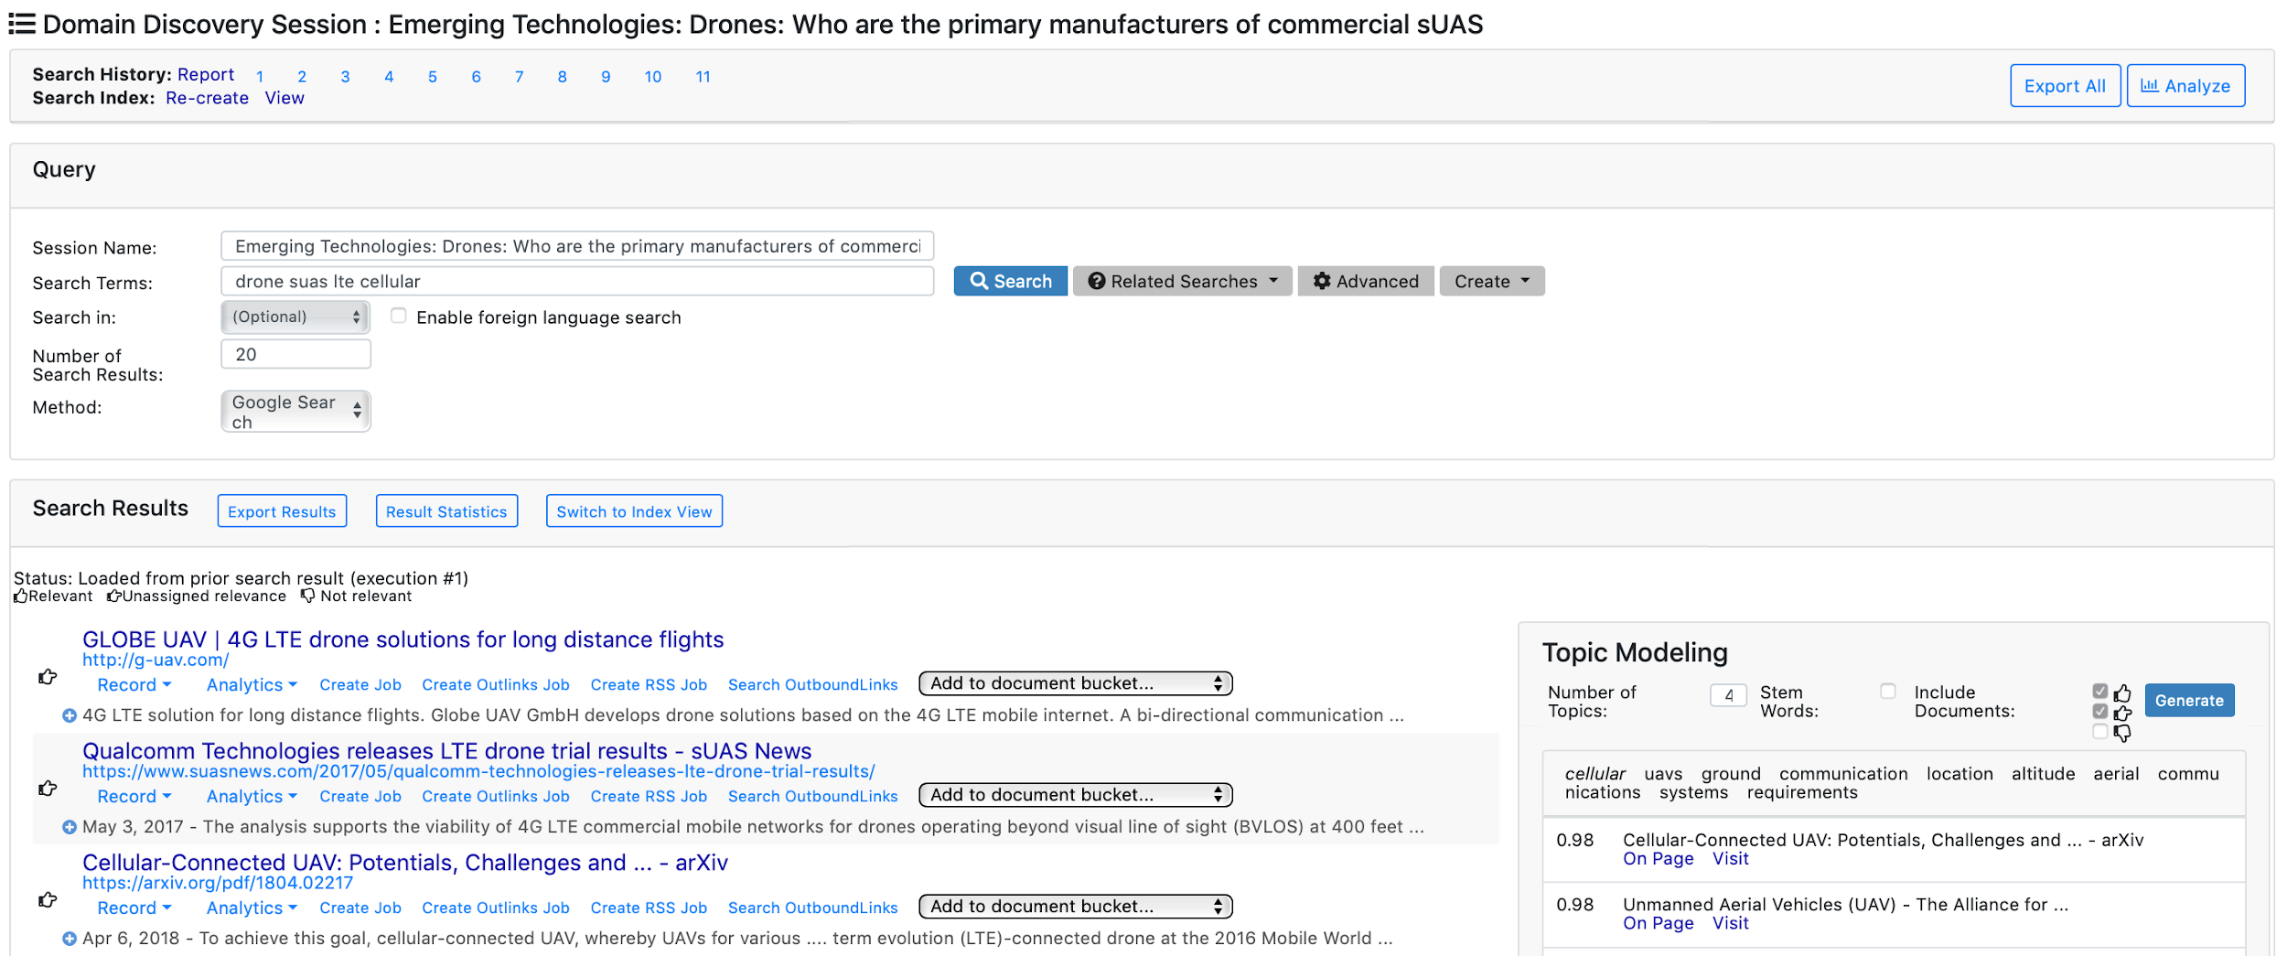

*Figure 44: Search Results Example*

*Note: Domain Discovery Sessions are expected to be iterative processes to refine searches, view resources, and, ultimately, find good candidate resources to create recurring retrieval jobs. These sessions also allow the user to become familiar with the current domain if needed. The Manage phase is meant to refine these jobs to make sure the most relevant data is being retrieved.*

The iterative process of refining searches will be tracked in Search History links that increment numerically with each new submission (see Figure 45). At any time, should the user realize that they strayed too far from their topic or forget how they got to the provided result set, they user can jump back to any point in their search history and re-submit.



*Figure 45: Search History Example*

The user can track the completion status of the search by examining the Progress Feedback section (see Figure 46). The progress feedback offers insight into completion status (e.g., crawling, complete, errored), elapsed query time (in milliseconds), the number of returned results, and any errors returned. This area also provides a legend for the user-defined Relevance determination feature, which allows users to mark individual results as Relevant, Unassigned, or Not Relevant. *Note: The Relevance determination only applies to and impacts Topic Modeling, at this point (see Topic Modeling section for more details). By default, all results will be set to unassigned. The relevance marker could be used to in the future to create machine learning classifiers to automatically determine which search results are relevant.*

**

*Figure 46: Progress Feedback Section of Results Pane*

Any errors incurred (and explanation of why, if available) will be shown for the individual results.   
  
*Note: Some errors are temporary or associated with network congestion during the time of query. If multiple errors are retrieved, users are encouraged to re-submit the search.*

**

*Figure 47: Results Retrieval Error Example*

#### Search Results Pane Viewing Options

From the Search Results pane, the user has the option to export the full result set; download result statistics; and, switch from a results listing view to an indexed view (see Figure 48).



*Figure 48: Search Results Options*

The Export Results option provides the user the opportunity to download the result set in a variety of formats for use in other applications (see Figure 49). Export options include:

* Destination - the location to which the user opts to save the exported file; options include download to a local drive (default), send to a filesystem directory, or send to Voyant
* Format - specifies the format of the exported file; options include full JSON array (default), JSON objects, limited comma-separated value (CSV) file, limited tab-delimited file, individual text only files, individual text expand files, and individual JSON record

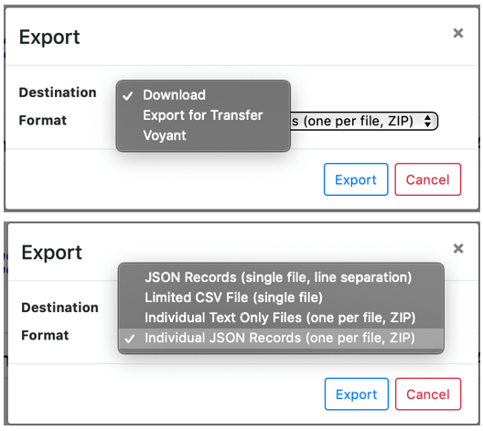

*Figure 49: Export Results Dialog Box Options*

The JSON options will either create a single JSON array with all page objects in a single file or one JSON will be created for each page. The Limited Comma Separated Variable (CSV) option will create a file that contains rows with the following elements: page ID, any page referrer, page mime type, crawled date/time, the domain, the url, and all of the extracted page text. The Individual Text Files Only will create a .tar file with files for each page that only contains the extracted text.

Upon clicking Export, the user will see an alert that the export was successfully submitted (see Figure 50).

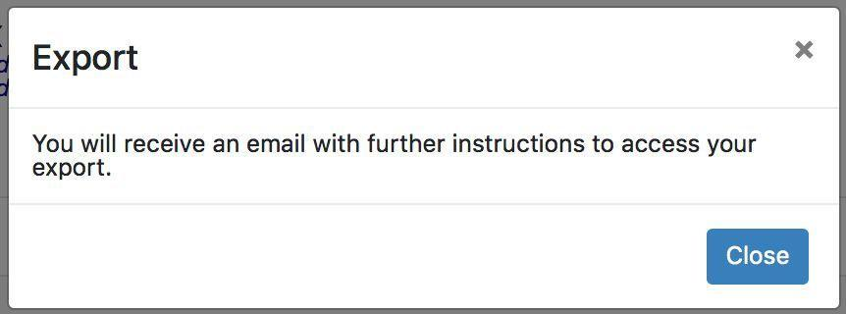

*Figure 50: Export Alert Dialog Box*

The user will then receive an email (see Figure 51) at their associated OSKE account with instructions to download or otherwise access the export.

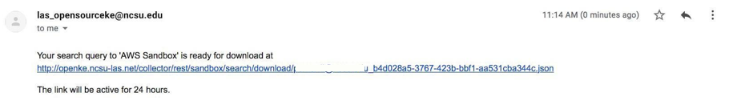

*Figure 51: Export Email Alert Example*

The user also has the option to download summary statistics for their results by clicking the Result Statistics link. The result statistics provide the user with a CSV file summary (see Figure 52) of their results, including the title of each returned result page, the URL, a brief description of the page, the publish date of the page, the position in the results order, the length of text, number of outgoing links, and number of matching OSKE concepts.

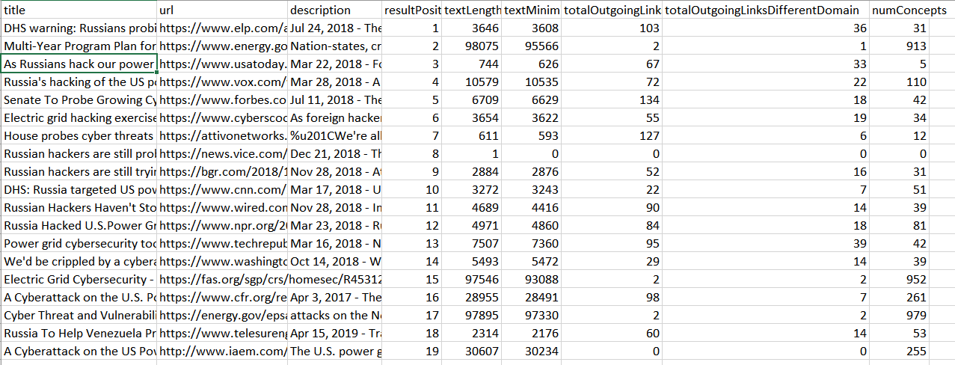

*Figure 52: Example Result Statistics Output File*

The Results pane displays results in the List view (i.e., Google-like listing of top *X* results) by default. However, OSKE also provides the user the option to view the results as a “back of book” index, which summarizes all results by frequency of keyphrases and displays the user with these keyphrases to order results alphabetically. This Index view is helpful in gaining a better understanding of prominent themes associated with the entirety of the result set (rather than clicking and reading each page individually in the list view). The user can toggle between each view by clicking the respective Switch to Index View or Switch to List View links.

Examples of each view are provided below in Figures 53 and 54:

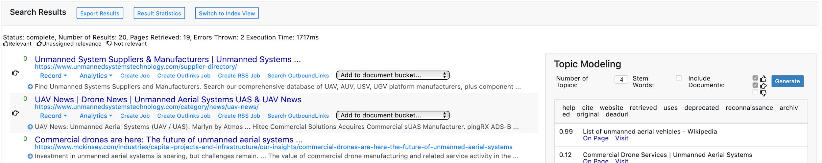

*Figure 53: Example List View for Results*

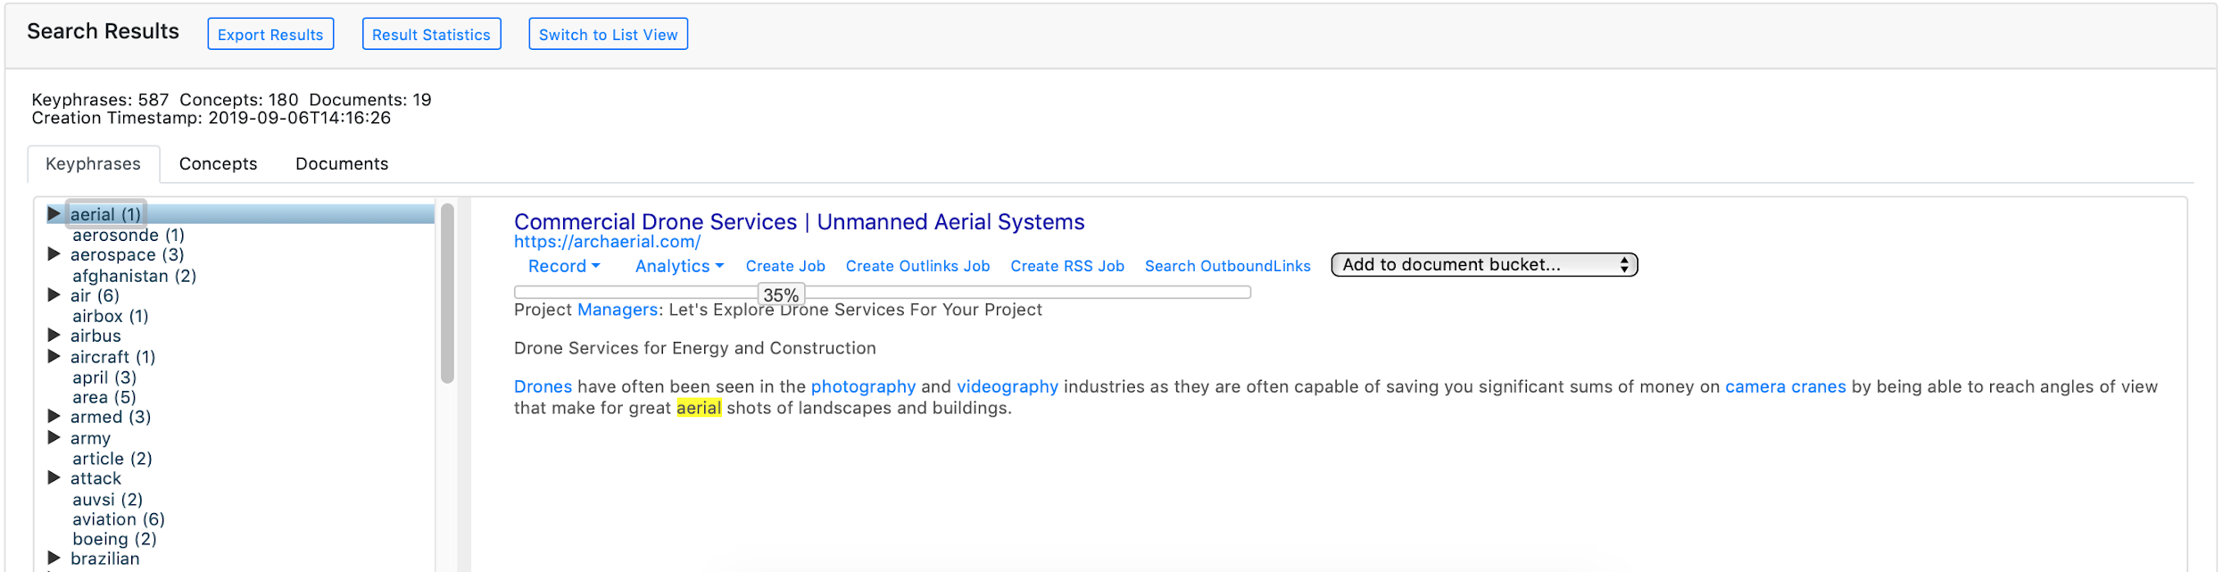

*Figure 54: Example Index View for Results*

#### Interacting with Results

When dealing with results in OSKE (in both index and list views), the user is presented with a multitude of options and analytics to help with initial sense-making. This section attempts to cover the major options available.   
  
*Note: Unless otherwise specified, the options and analytics covered here apply at the individual document level, not across the entire result set. Result-set level analytics are available in the Analytics tab, which can be filtered to individual Discovery Sessions.*

The menu under each result returned (see Figure 55) provides the user with document-level options, including a variety of record details; multiple analytics; ability to create a recurring job; ability to create a job based on outlinks extracted from the result; ability to create a job based on any RSS feeds noted in the result; and, ability to extract and submit a new search on the outlinks (without creating a new job).



*Figure 55: Menu Options for Results*

To the left of the result, the user can also determine the relevance of the record to their research by clicking on the hand icon. This Relevance determination feature is user-toggled with each click of the icon, from unassigned (default) to thumbs-up (meaning relevant) to thumb-down (not relevant) and back to unassigned.  
  
*Note: This relevance determination is currently only used in the Topic Modeling pane to either include/exclude certain records from that process. Future versions of OSKE could make further use of this feature for machine learning purposes.*

When conducting multiple searches within a Discovery Domain session, this area also provides the user with a visual cue on how returned results compare to the previous search. This feature is particularly helpful when switching source handlers to see how return results vary among search engines. In the Figure 56 below, you’ll see an example where the second result is new (compared to the last search in the history), while the first result was previously listed as the 9th result in the previous search (i.e., it moved up 9 spaces):

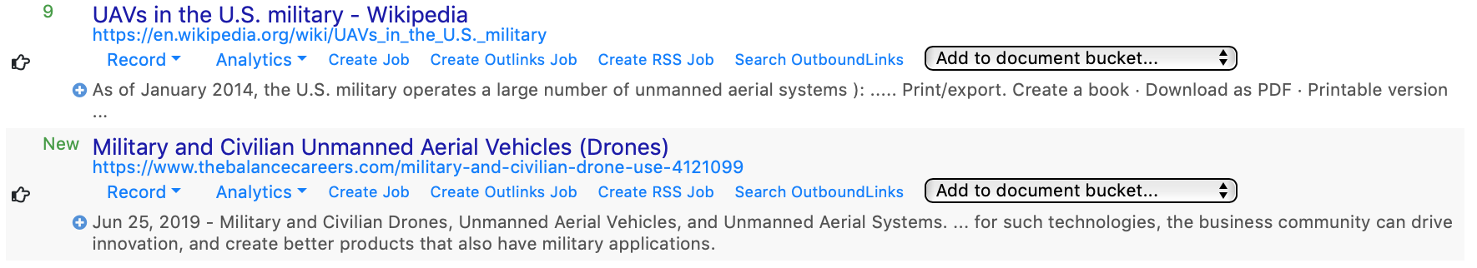

*Figure 56: Example of Position Indicators across Subsequent Searches*

#### Record Drop-down Menu Options

Within the Record options, the user has the ability to interact with and/or summarize various aspects of the individual record. By clicking on the Record link to the drop-down menu, the user is presented with the following options:

* Expand in New Window - expands the result view for the record in a new browser window
* Complete - opens the full JSON record for the result in a new browser window
* Complete (editor) - opens the full JSON record for the result in a new editor window
* Concepts - displays any PESTLE-S/concepts that were retrieved in the result
* Download Original - opens the original stored result, if included in holdings
* Geo Tags - displays any geographic place names and locations that were retrieved in the result; this feature uses Clavin ([https://clavin.bericotechnologies.com](https://clavin.bericotechnologies.com/)) for geotagging and OpenStreetMap ([https://www.openstreetmap.org](https://www.openstreetmap.org/)) for basemaps; provides the user with the option to view on map
* HTTP Headers - displays any HTTP header information extracted from the result
* Meta Data - provides meta-level data for the record
* Outlinks - provides a listing of all retrieved outlinks from the record
* Provenance - provides information on the collection instance of the record, such as the version of OSKE used
* Structured Data (schema.org) - Many web sites provide additional markup data, using a common format defined at http://schema.org) for other services within HTML tags. This features extracts that data and display it in a JSON-base format.
* Structural Extraction (via CSS and HTML tags) - provides structural extraction of record. The structural extraction components need to be pre-defined under the Manage tab.
* Text - shows the extracted text from the record

#### Analytics Drop-down Menu Options

Within the Analytics options, the user has the ability to apply defined analytics to individual records. By clicking on the Analytics link to the drop-down menu, the user is presented with the following options:

* Keyphrases - provides a listing of extracted keyphrases for the record, including relevance scoring
* Keywords - provides a listing of extracted keywords for the record, including relevance scoring
* Named Entities - provides a listing of any named entities extracted from the record, including names, persons, and organizations
* Overview Statistics - provides summary statistics for the record, to include number of concepts matched, number of outbound links, publication date, text length, number of geotags extracted, the record UUID, and URL; this information is also present in the Result Statistics output
* Relations - provides a listing of any extracted relations; uses Stanford’s NLP Open Information Extraction API (<https://nlp.stanford.edu/software/openie.html>); provides the user with the option to view as a graph
* Show Domain Whois - provides whois lookup information on URL
* Show Word Cloud - provides a graphic word cloud on the record; uses Voyant
* Summarize - provides ability to summarize text
* View Site’s robot.txt - shows robot.txt file for record, if one exists
* Info - provided by Google Based Analytics; conducts a info:URL Google search in a new browser window
* Link to - provided by Google Based Analytics; conducts a link:URL Google search in a new browser window; shows any pages linking to the URL
* Related - provided by Google Based Analytics; conducts a related:URL Google search in a new browser window

#### Inline Job/Search Creation Options

Following Record and Analytics options, the user has the ability to create various jobs and/or subsequent searches at the record level. In this section, the user can do the following:

* Create Job - initializes a new recurring job using the URL from the record; job will be presented in Draft status and Edit mode; the user will first be presented with a prompt to input a valid justification for the job; see Manage section below for the job creation process
* Create Outlinks Job - initializes a new recurring job using the outlinks URL(s) extracted from the record; job will be presented in Draft status and Edit mode; the user will first be presented with a prompt to input a valid justification for the job; see Manage section below for the job creation process
* Create RSS Job - initializes a new recurring job using any RSS feeds extracted from the source HTML page and/or domain - OSKE scans for RSS feeds in several common locations; the user will be able select a specific job to create an RSS based-job. Once the job has been created, it will be presented in Draft status and Edit mode; if no RSS feeds were noted, the user will be notified with an alert; see Manage section below for the job creation process

#### Inline Text Summarization Options

Below the Records, Analytics, and Job/Search Creation Options, each result provided contains summary text provided for that result by the respective search engine. If no text was provided by the search engine, OSKE will create a summary. The OSKE platform provides an inline text summarization feature (see Figure 57) to allow users the ability to quickly view the full text or any percentage of text for that result from the Results pane. Users can read the text for the various results without having to navigate to that URL and then back to the search results to see the next result.

The view the summary, the user clicks on the first line of the summary text (or the + icon) to expand the text and be presented with the Text Summarization slider bar (see below). The slider bar defaults to showing the most significant 10 percent of text, using a natural language processing algorithm, TextRank[12], which was adapted from Google’s PageRank algorithm, to summarize full text. This algorithm correlates word significance and sentence co-appearance to determine the most significant text, presenting the user with a quick manner to triage results. To see more, or less text, the user can move the position on the slider bar, as appropriate.

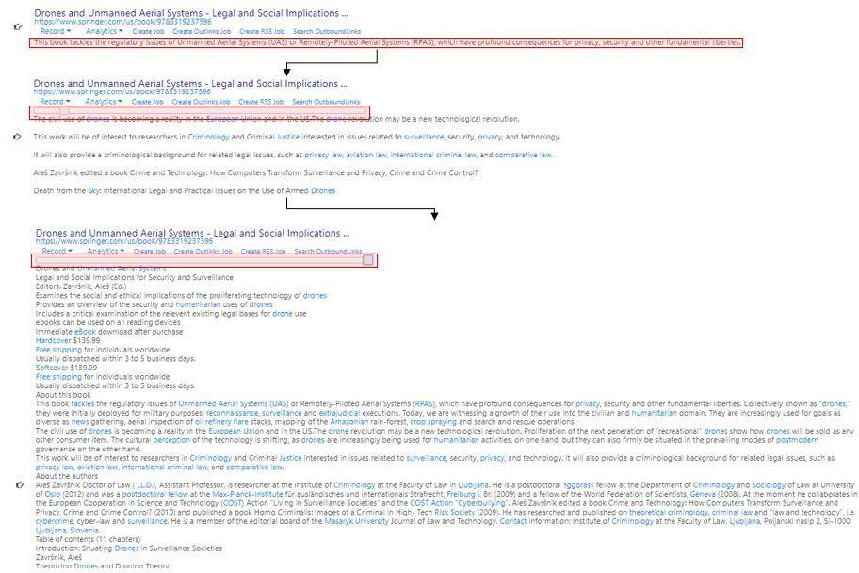

*Figure 57: Inline Text Summarization Slider Example*

Within the result summary, the OSKE platform also automatically includes annotations (i.e., hyperlinks) to any corresponding entries in [DBpedia](https://wiki.dbpedia.org) (<https://wiki.dbpedia.org/>), providing users with quick inline references to anything from common to more technical and/or obscure terms. This feature helps gain greater clarity into results, providing clarification of unfamiliar concepts or terms at the fingertips of the analyst where it matters most, while triaging the result. By clicking on a hyperlinked term in the text, the user will be presented with a new browser window with the corresponding DBpedia entry (as Figure 58 below for the Unmanned Aerial Systems link from above).



*Figure 58: Sample DBPedia Entry*

#### Topic Modeling Pane

Another sense-making feature offered within the OSKE platform offered through the Search Results pane is topic modeling. The Topic Modeling pane (see Figure 59) uses Latent Dirichlet Allocation ([LDA](https://en.wikipedia.org/wiki/Latent_Dirichlet_allocation)) to discover the abstract "topics" that occur in a collection of documents. Through the dialog, users can define the number of topic groupings to return; whether, or not, to use only the root stem of words or full word match (i.e., “drone” and “drones” or “dron” to capture both); and whether to use the relevance determination markings.

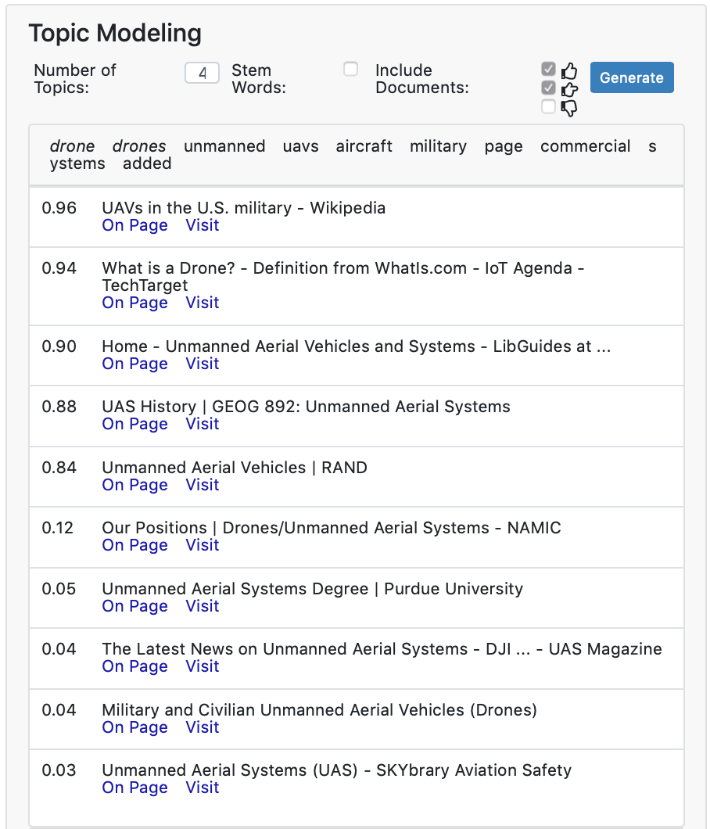

*Figure 59: Topic Modeling Pane Example*

## Manage

The Manage phase of the workflow allows the user to manage the various retrieval and storage features afforded by the OSKE platform; enabling a quick and organized manner to tune their research from one central place. The Manage phase is an integral part to longer-term research that requires the user to retrieve and store material over time.

### Manage Menu Options

Under the Manage menu (see Figure 60), the user is provided the ability to create/edit underlying concept dictionaries (i.e., PESTLE-S factors); create/edit document buckets to cite/store relevant source materials for quick retrieval/export; create/edit document indexes; conduct a search only against OSKE stored holdings; create/edit search alerts; import external materials to utilize OSKE’s structural extraction capabilities; and, create/edit recurring jobs.

This menu also offers the option of a legacy Advanced Collector View that is geared more towards those users that consistently build and monitor recurring jobs and require/desire easier access to underlying system health and maintenance features and metrics.   
  
*Note: This feature will not be covered in-depth in this manual. Many of the features remain the same across views; only the location of each in the interface is different.*

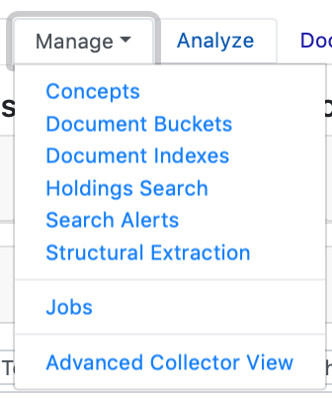

*Figure 60: Manage Menu Options*

### Concepts Overview (i.e., PESTLE-S)

The Concepts feature in the OSKE platform enables users to establish a “data dictionary” of relevant terms/concepts that apply to their domain of research. These concepts can then be used to annotate retrieved materials, allowing new search, discovery, and sense-making opportunities for the user. This data dictionary builds off the idea of PEST analysis (<https://en.wikipedia.org/wiki/PEST_analysis>), a framework commonly used in business and marketing to detail different macro-environmental factors to be taken into consideration for understanding market growth or decline, business position, potential and direction for operations. The OSKE platform extends this to PESTLE-S (political, economic, socio-cultural, technological, legal, environmental, and security/military). By considering all these factors, the user can begin to decompose their research questions (used in parallel with mind maps), providing additional opportunities to organize and summarize their holdings.

#### Concepts Interface

The Concepts page provides the user with the ability to create, view, edit, export, and import a data dictionary.  
  
*Note: Multiple data dictionaries can be uploaded and used for each domain.*The Concepts interface (see Figure 61) is comprised of three main portions, including multiple ways to input, edit, and/or export data dictionaries in the OSKE platform.

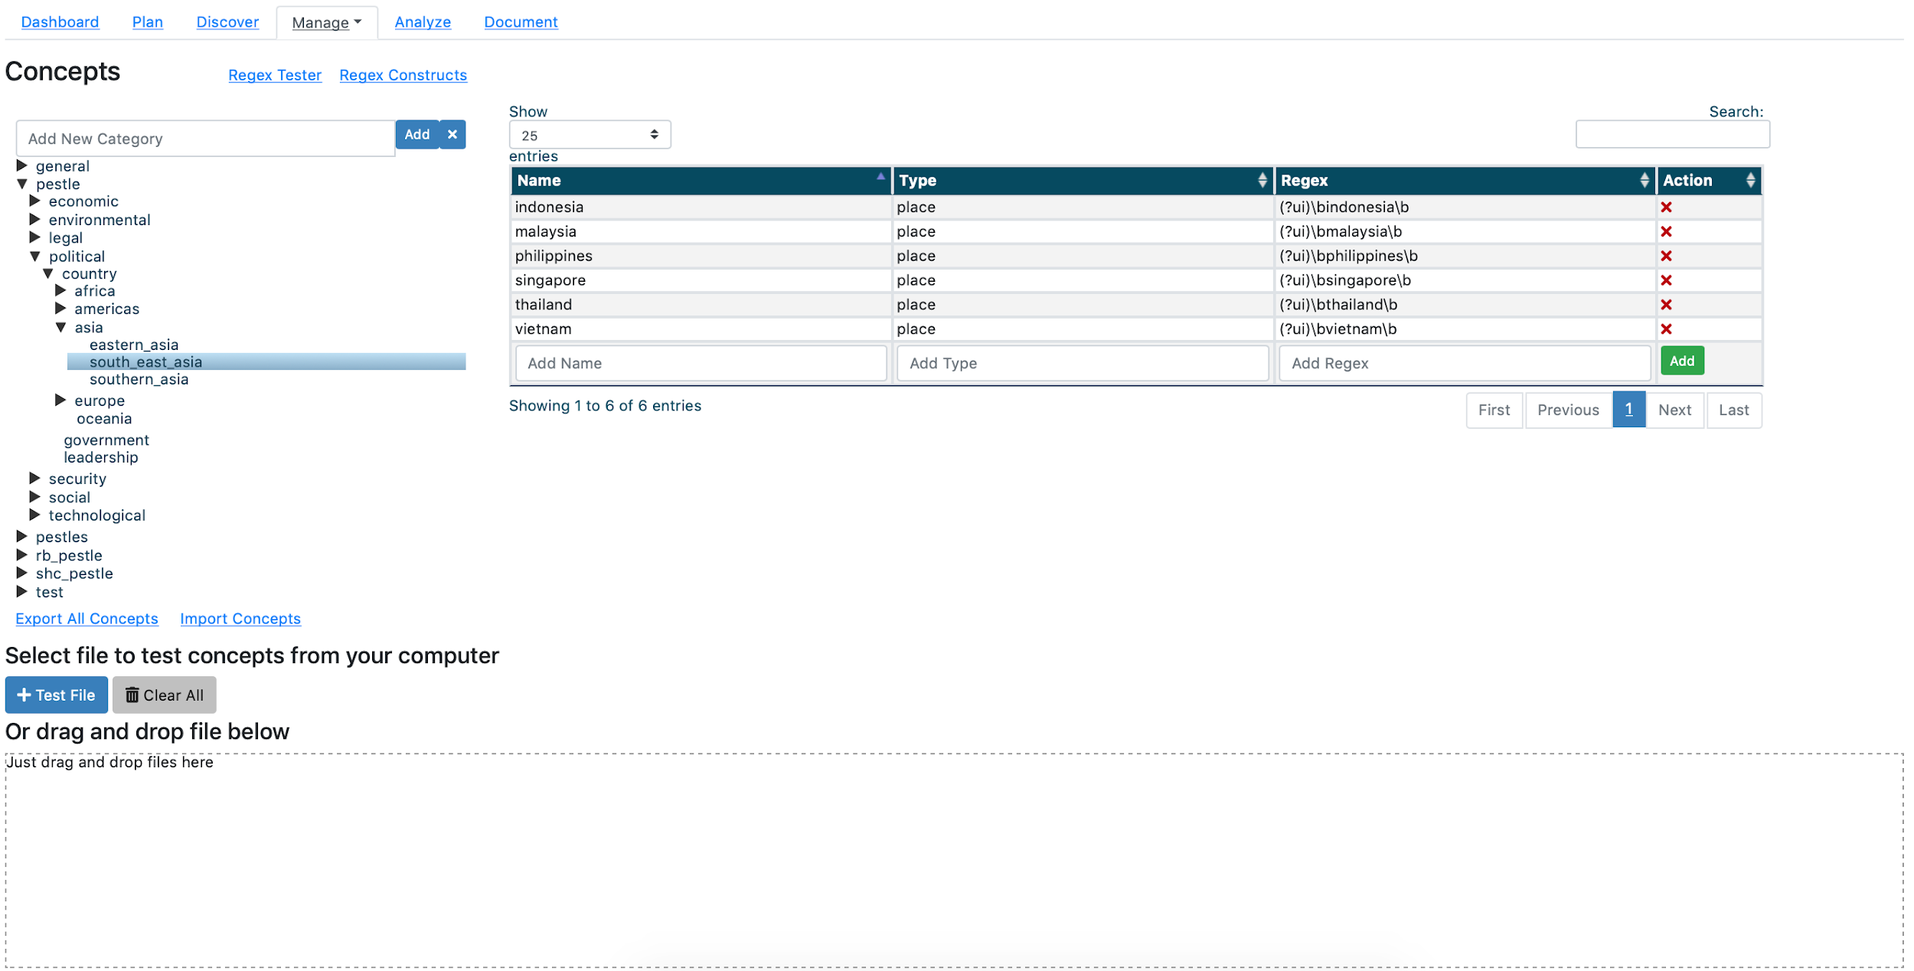

*Figure 61: OSKE Concepts Interface*

To edit an existing data dictionary, the user can manually add new categories through the input text box in the top portion of the dialog. For example, in Figure 62 below, the user would type in the new entry for the category in the text box, navigate through the existing hierarchy to the topic that entry would fall under, and hit the Add button.

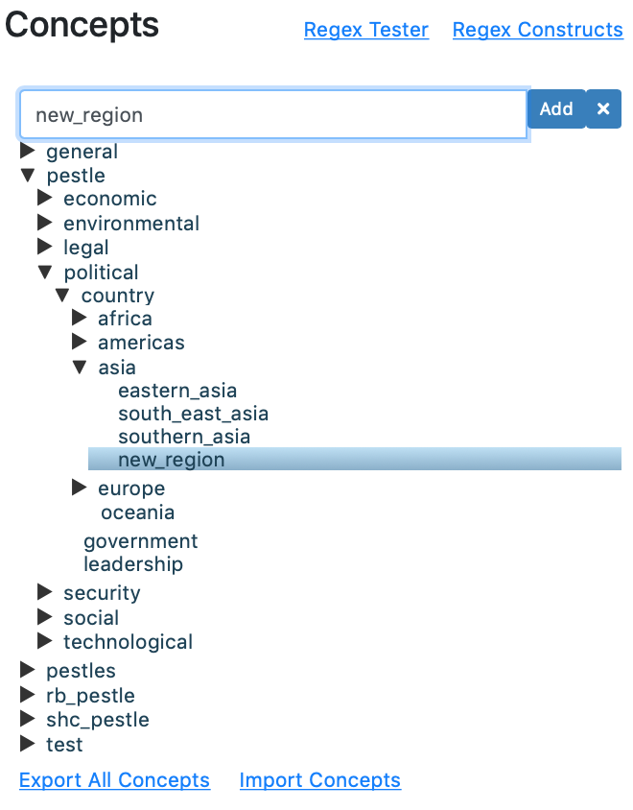

*Figure 62: Manually Adding Data Dictionary Category Entry Example*

To delete a category, the user would highlight the entry to be deleted, and click the Delete button (the *“X”* next to the Add button).   
  
*Note: The delete includes all nested categories under that element in the dictionary hierarchy. There is no undo feature. Additionally, any user in the domain can edit existing data dictionaries.*To add a new entity to a category in an existing data dictionary, the user would highlight the category that contains the new entity and then use the input text fields in the entities pane to the right of the hierarchy to add the item (see Figure 63). The user must input a Name, Type (e.g., Person, Place, Thing), and the term to be matched in the REGEX field.  
  
*Note: The text boxes are free-form text. The user does not need to use REGEX, if they only want to define simple keywords and keyphrases; the REGEX field can also support non-REGEX items. The system provides links to a REGEX Tester and Constructs should the user need them.*

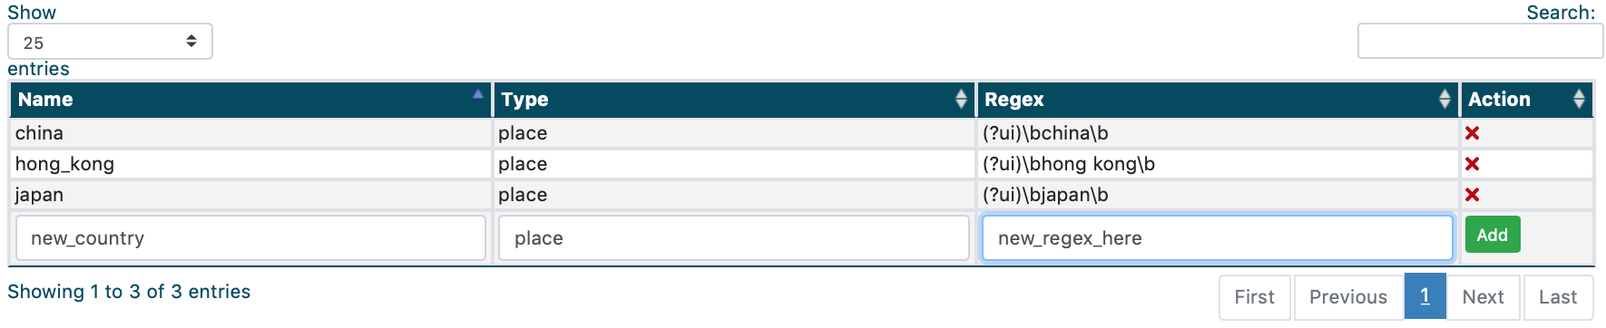

*Figure 63: Data Dictionary Entity Addition Example*

The user can export all data dictionaries or import new data dictionaries using the appropriate links. The export will provide the user with a download in comma separated values (CSV) text format (see Figure 64). The import will accept CSV files with header fields matching the Name, Type, and REGEX headers.

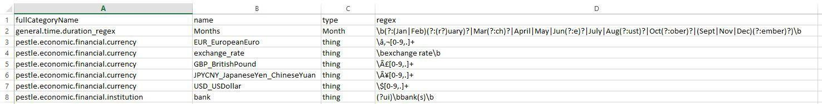

*Figure 64: Example CSV File Export and File Structure Required for Import*

Additionally, prior to importing a data dictionary, a user can test the format of their files using the test portion of the dialog. The user can either use the Test File button to navigate to a file on their computer, or drag-and-drop a file from their desktop/folder location to the interface (see Figure 65).

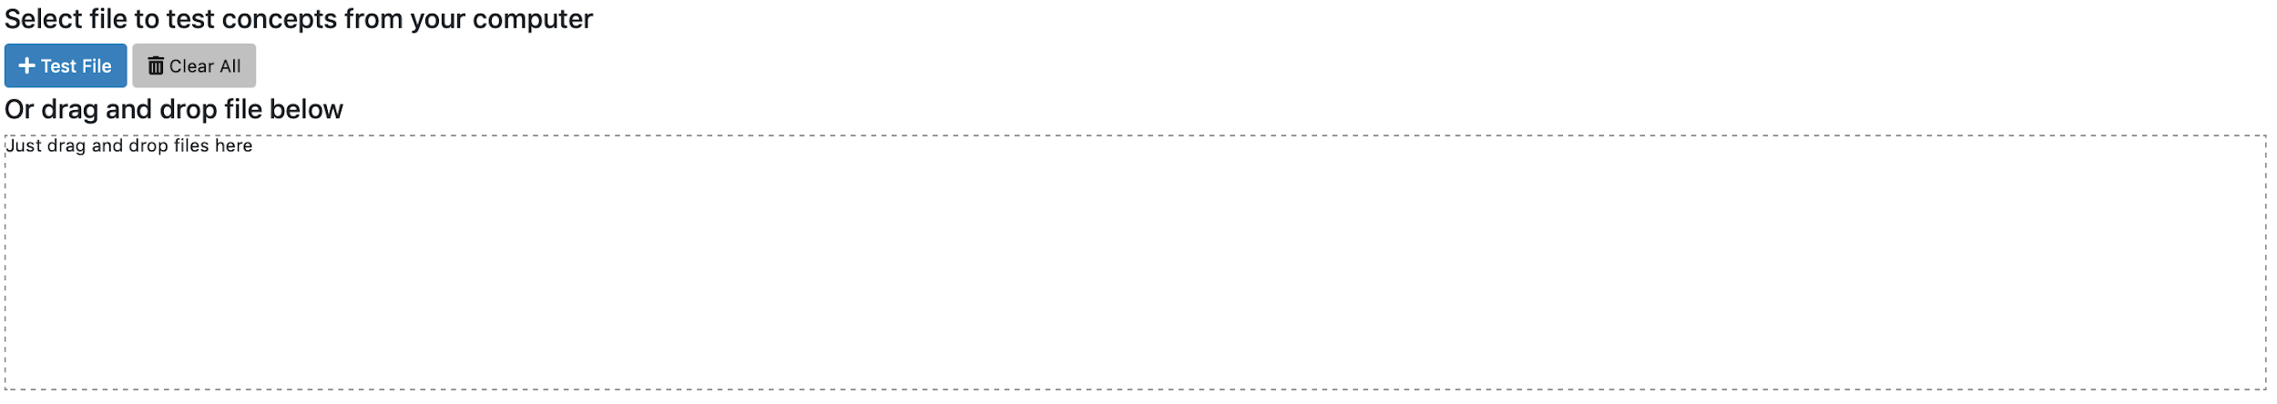

*Figure 65: Concepts Tester Dialog*

### Document Buckets Overview

The Document Buckets page provides the user with the ability to create, view, edit, and delete source citation “buckets”. The idea of document buckets within OSKE enables users to set up a folder, or “bucket,” to place citations of relevant materials retrieved through searches for reference/use later. Users can think of this feature as a running source reference list.

#### Document Buckets Interface

The Document Buckets page is comprised of the Document Buckets pane (see Figure 66).

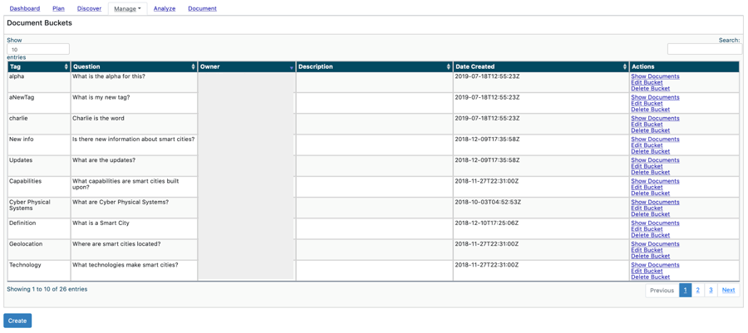

*Figure 66: Document Buckets Interface*

#### Viewing/Editing an Existing Document Bucket

Within the Document Buckets pane, the user will be presented with a table listing of existing document buckets. The listing will provide details on the tag associated with the bucket (used for selecting bucket from Results page); the question the bucket attempts to address (taken from the respective project details, if input); the corresponding owner’s email; a brief description of the bucket or project (user defined); the date the bucket was created; and, associated actions a user can take upon the bucket.  
  
*Note: Currently, any user authorized to the domain will be able to view, edit, and delete document buckets.*

The user can also toggle the number of results shown in the table, using the available View drop-down menu, from 10 (default) to 25, 50, 100, or All. Additionally, the user can apply a filter to the table, using the available Search text box, to limit results to certain users, keywords, or dates.   
  
*Note: The Search text box is free-form and exact match. It will dynamically update as the user types. To remove filter, simply delete text from the text box.*

Within the Actions options, a user can click the Show Documents link to view any references currently stored within the bucket. Clicking on the Edit Bucket link will present the user with an editable version of the Document Bucket form. After any changes are made, the user will click the Submit button on the form to save changes. Clicking on the Delete Bucket link will allow the user to delete the bucket entirely.   
  
*Note: There is no undo button for any edit or deletion. All users within the domain can view/edit/delete any bucket listed.*

#### Initiating a New Document Bucket

Users can create a new document bucket by clicking the Create button below the Document Buckets pane. Upon clicking the Create button, the user will be presented with New Document Bucket form to be completed (see Figure 67).

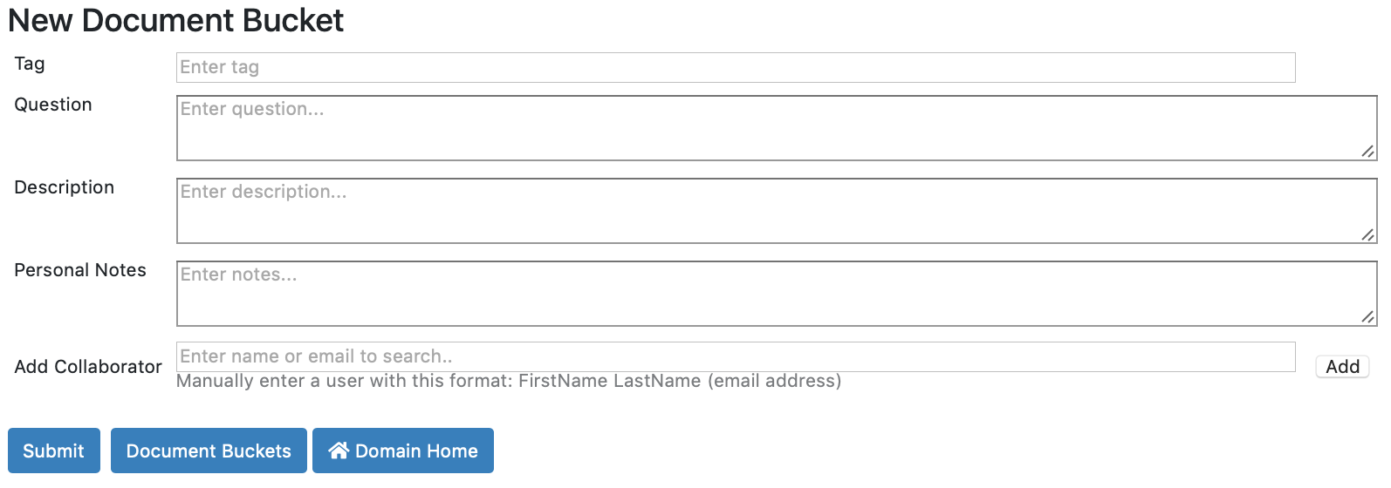

*Figure 67: Creating a New Document Bucket Form*

The Document Buckets form is comprised of the following elements:

* Tag - keyword or keyphrase for describing the intent of the storage bucket; this tag will be used to append to sources saved within the bucket as well as act as the label for selection with the “Add to Document Bucket” drop-down selection when interacting with results
* Question - key research question that references stored within the bucket will address
* Description - brief description of the project from which the question was drawn
* Personal Notes - brief description of any personal notes regarding the document bucket
* Classification - set field; not user-defined
* Add Collaborator - currently disabled, as all users in the domain can now view/edit buckets; when enabled, allowed for bucket-level permissions and specific collaborators to be assigned/added to the bucket with view/edit privileges; input must follow *FirstName LastName (email address)* format

#### Adding Documents to a Document Bucket

In order to add documents to a Document Bucket, the user can select the appropriate option from the drop-down menu in the results from a Holdings Search or a Domain Discovery Session.

From the Search Results pane of a Holdings Search, for any result that the user would like to add to a document bucket, the user will select the appropriate bucket from the *Add to document bucket…* drop-down menu option (see Figure 68). The user can also create a new Document Bucket from this menu, should an appropriate entry not exist in the listing. The user will be alerted that the document has been saved, and the name of the currently assigned Document Bucket will be displayed.

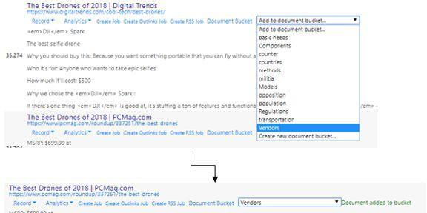

*Figure 68: Add to Bucket Drop-Down Menu Example*

Options within the drop-down menu will use the Tag as defined by the user within the Key Questions section of the Project details (see Project phase for details). For example, the Vendors tag shown in the example above was defined in the Project Details pane (under the Plan phase) as seen in Figure 69 below:

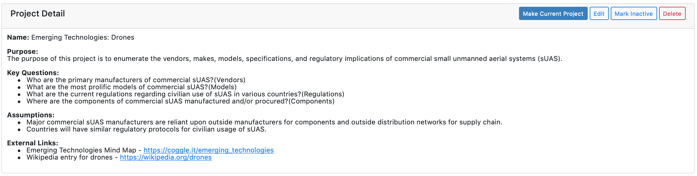

*Figure 69: Project Details Example with Key Questions and Associated Bucket Tags*

To show documents added into respective Document Buckets, from the Document Bucket page under the Manage menu, the user will be able to click the Show Documents link for the corresponding bucket and see the documents currently within the bucket (see Figure 70). Additionally, within that view of the results, the user can utilize all the Records and Analytics options available (see

Discover phase). From here, the user can remove documents from the bucket from this view, should they no longer want those documents included in the bucket.

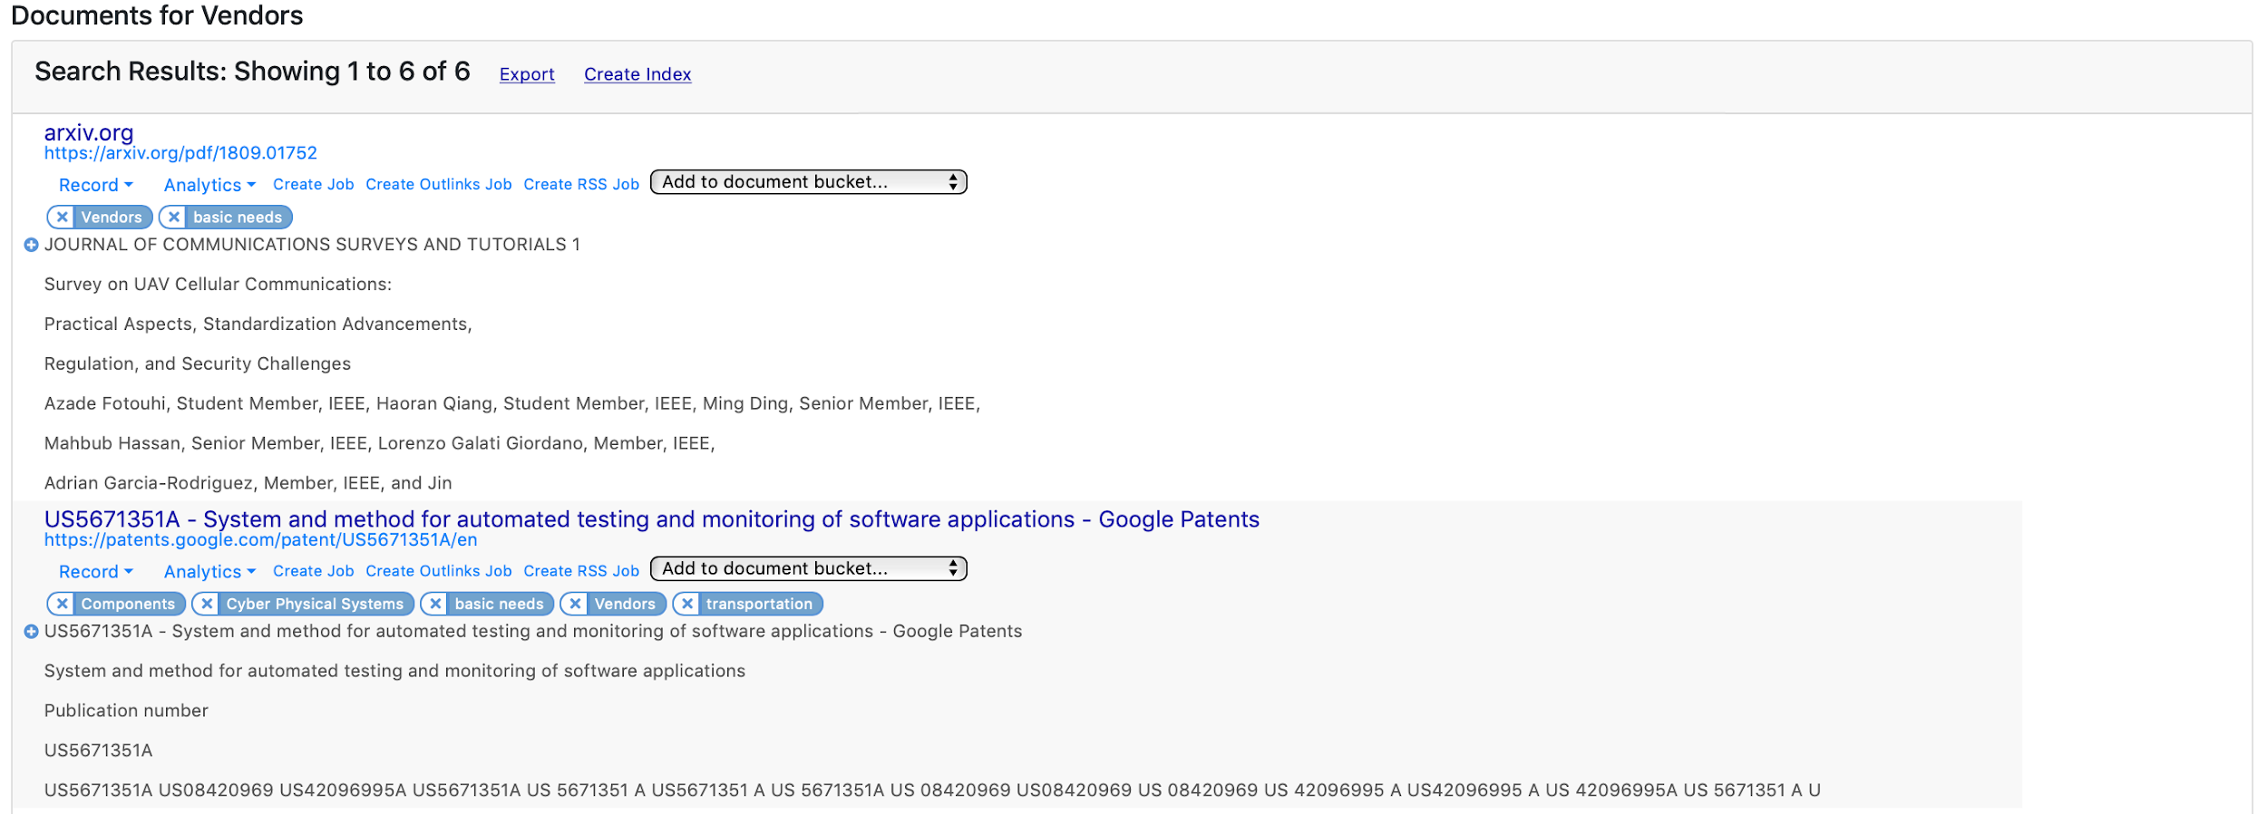

*Figure 70: Show Documents Pane within the Document Buckets Interface*

Lastly, the user can also export the results (see options covered under Search Results pane section) using the Export link or create a Document Index from this view using the Create Index link.

### Document Indexes Overview

The Document Indexes page provides the user the ability to create custom data sets and quickly analyze bulk results within those sets. Much like the Search Index results (covered in the Discover phase), the Document Index has the same functionality, but can contain results across multiple discovery sessions and/or projects. The document indexes are established through the Document Buckets (see previous section) and Search Holdings interfaces (see following section).

#### Document Indexes Interface

The Document Indexes interface displays a table listing of the existing indexes available to the user (see Figure 71). If no document indexes have been established, the user will see *“No document indexes available”* in the table. The table provides information on the Name, Date Created, Owner, and Number of Documents Contained for each index. In the left-hand columns of the table, the user can either view the index (clicking the magnifying glass icon) or delete the index (clicking the trash can icon).

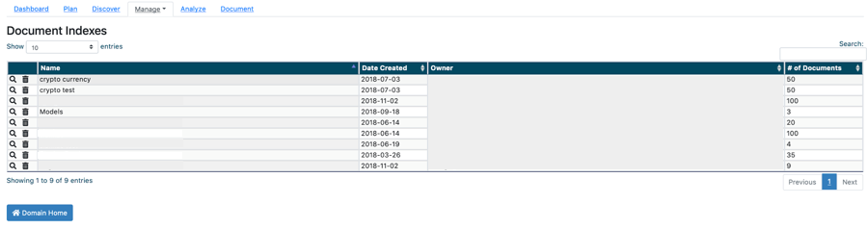

*Figure 71: Document Indexes Interface Example*

The user can also toggle the number of results shown in the table, using the available View drop-down menu, from 10 (default) to 25, 50, 100, or All. Additionally, the user can apply a filter to the table, using the available Search text box, to limit results to certain users, keywords, or dates.   
  
*Note: The Search text box is free-form and exact match. It will dynamically update as the user types. To remove filter, simply delete text from the text box.*

To view the index, the user clicks on the magnifying glass icon. Upon clicking the icon, the user will be presented with a new browser window containing the document index (see Figure 72).

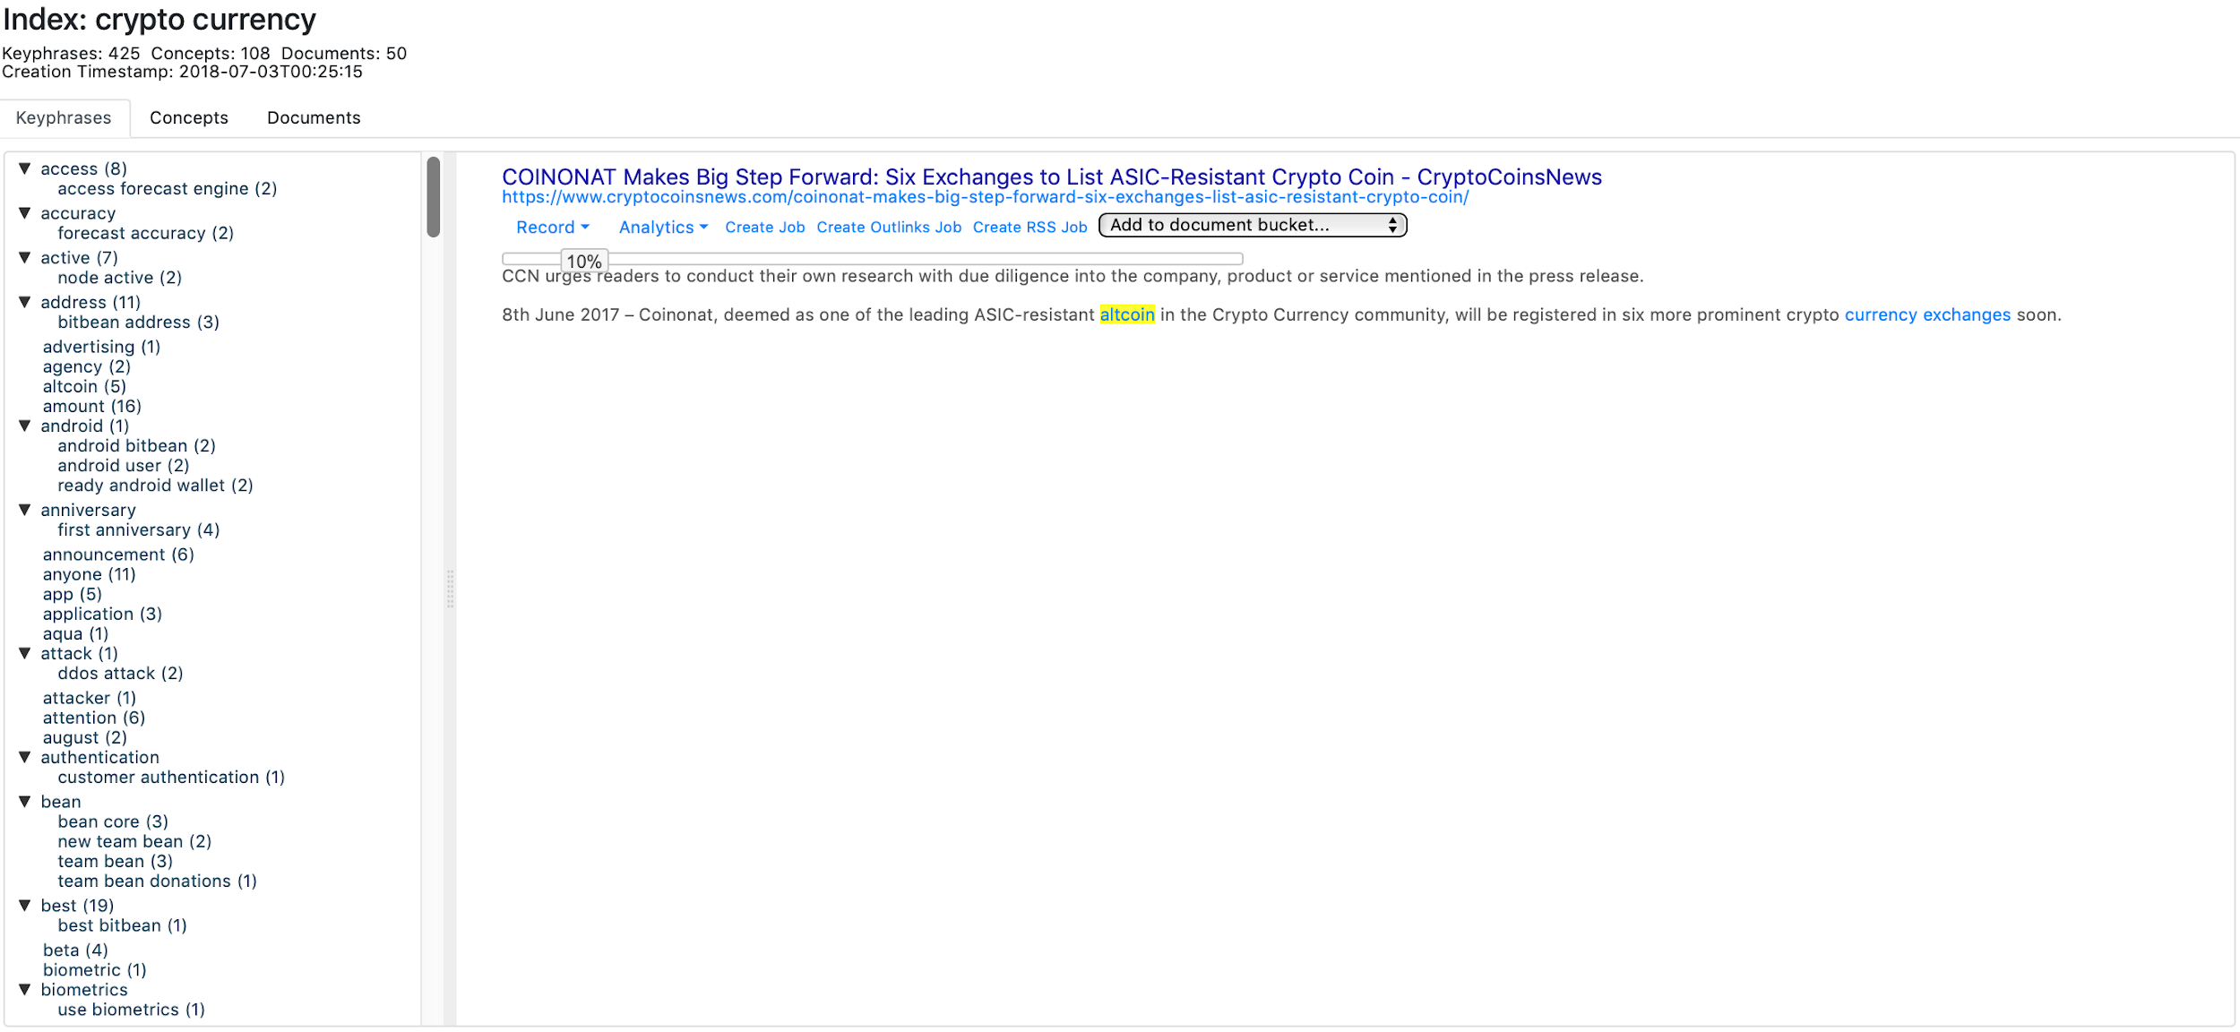

*Figure 72: Document Index Interface Example*

From the index view, the user can toggle between summarizing the data set by keyphrases, concepts, or documents (see Figure 73). The Keyphrases listing summarizes keyphrases across the entire data set and provides an alphabetized listing. The Concepts listing summarizes any concept tags that were noted across the entire data set and provides an alphabetized listing. The Documents listing provide an alphabetized listing of all document titles in the data set.

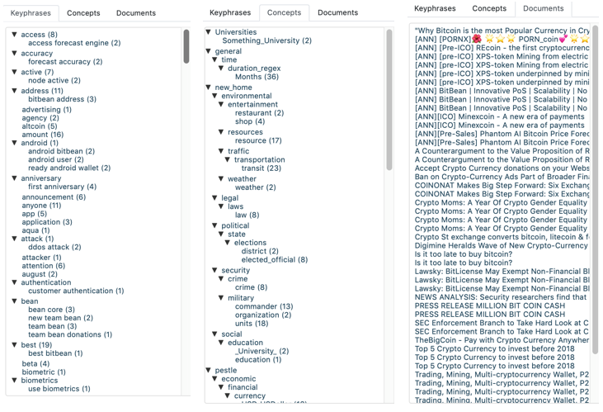

*Figure 73: Data Set Index Summary Options Example*

To interact with the results, the user selects the desired entry in the left-hand listing (e.g., parrot anafi) and the associated result will be loaded in the right-hand column (see Figure 74). If there are multiple documents for that result, such that multiple documents had the keyphrase “parrot anafi,” the user will see a hyperlinked-listing of documents to choose from first.   
  
*Note: The number in parentheses next to the keyphrases or concepts listing is the number of documents matching those results.*

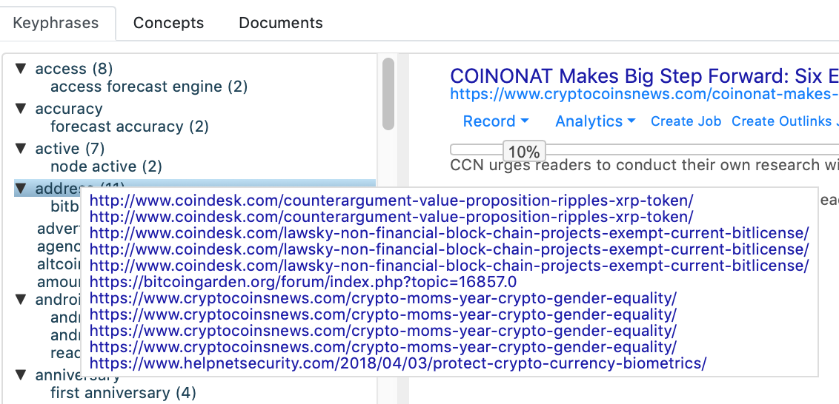

*Figure 74: Document Index Results Example*

### Holdings Search Overview

The Holdings Search page provides the user a means to query any/all retrieved materials from within the Domain that have been brought in and stored in the OSKE data holdings. The Holdings Search is differentiated from the Discovery Sessions Search in that the Holdings Search only searches against any material that have been previously retrieved and stored through recurring jobs or Discovery Sessions; whereas, the Discovery Sessions Search only searches against materials retrieved from a live search on the Internet (using the appropriate source handler).

The Holdings Search is useful for longer-term research projects where jobs have been created and bulk data analysis is required. This type of query for information can find related materials to a given topic that may be tangentially related, and wouldn’t be constrained to a set limit of the top *X* number of results provided by a simple Discovery Sessions Search.   
  
*Note: Remember, a recurring job can crawl out from a seed page’s outlinks a user-defined number of steps, pulling in much more information that a one-off search. This is only available, however, if jobs have been created and have been running for a period of time to build the corpus of data.*

#### Holdings Search Interface

The Holdings Search interface is comprised of two sections, a Query pane and a Search Results pane (see Figure 75).

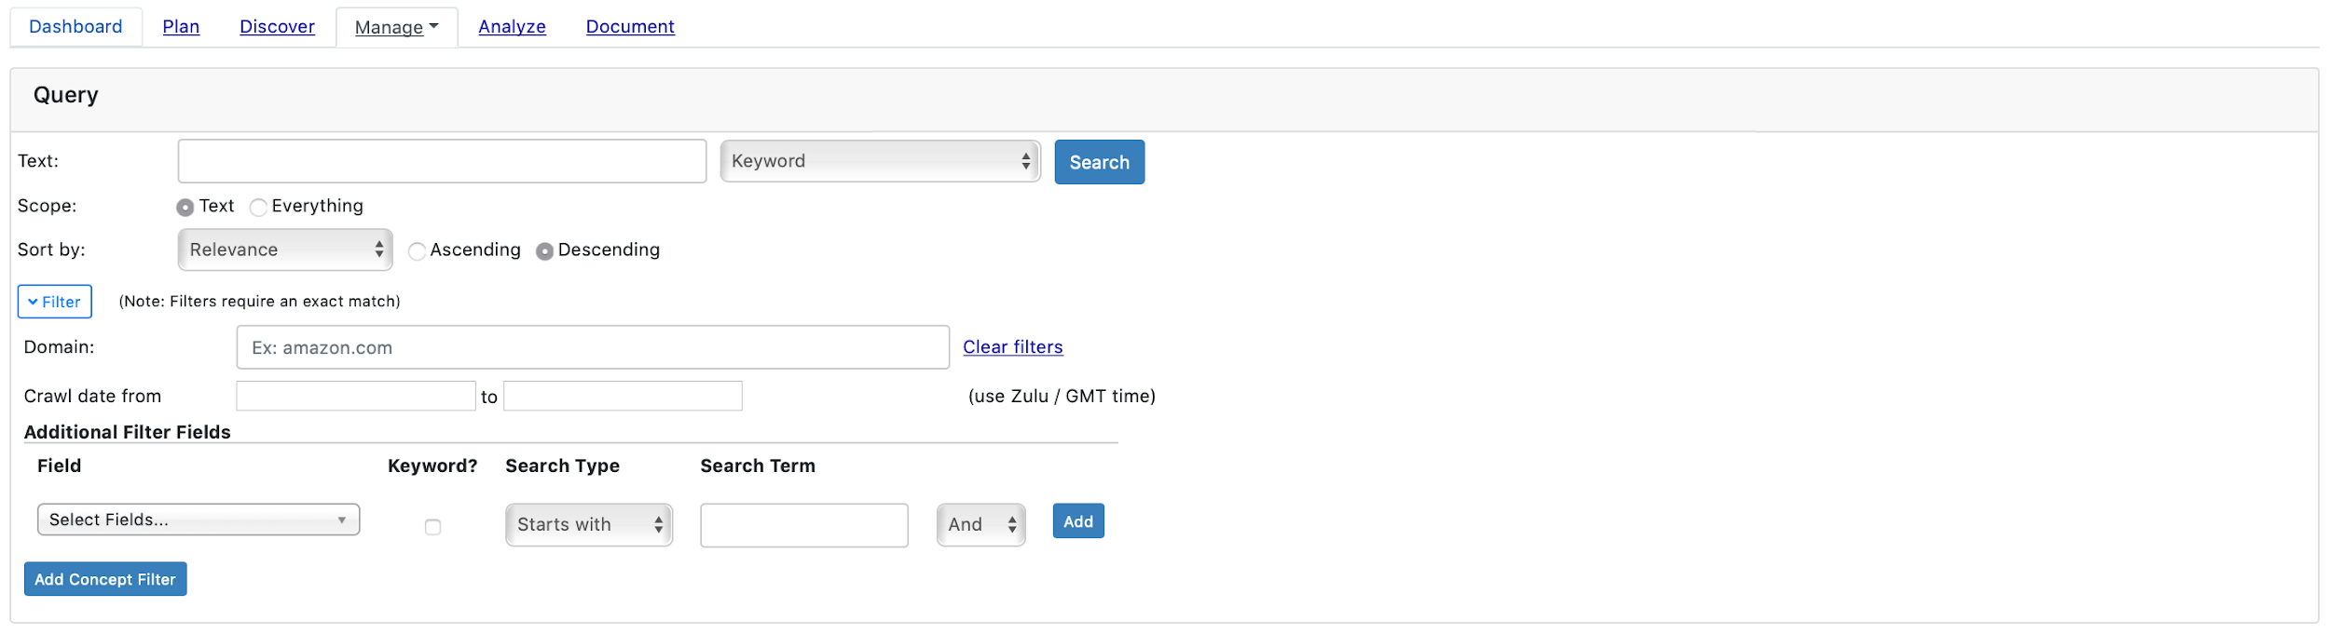

*Figure 75: Holdings Search Interface with Expanded Filters Portion*

Within the Query form, the user can input/modify the following elements:

* Text - the text for which the user wants to search the OSKE holdings; the user can define how they would like for that text to be handled, as either a Keyword, REGEX, or Exact Phrase; default logic is OR’d for keywords
* Scope - toggle to define what to search within each record of the holdings; default is set to Text (the body of text only), but can be changed to Everything (which enables also searching through header and metadata for each record); searching Everything will increase query times
* Sort By - determines the ordering of search results retrieved; user-defined as ascending or descending for Relevance (default, based off of keyword scoring); Crawled Timestamp (when it was retrieved by OSKE); Published Date (when the material was originally published, if available); Text Length (number of characters); or Title (alphabetized listing of titles)
* Filters - optional parameters to restrict results retrieved to user-defined criteria; options include:
  + Domain - restricts results to only specific domains (e.g., amazon.com)
  + Crawl Date From - allows user to define a time window by which to restrict results using OSKE’s Crawled Timestamp that is appended to each record after retrieval; uses Zulu/GMT time in the YYYY-MM-DD HH:MM:SS format (e.g.,2018-09-19 09:00:35); calendar selector appears when clicking in the box to facilitate input dates/times
* Additional Filter Fields - allows user to define additional filter using any available OSKE metadata field or concept field
  + - Add Concept Filter - provides an interactive graphic of concepts from which to select and add directly to filter; user can Shift-Click on any wedge within the graphic to automatically add to filter (e.g., pestle.legal in example shown in Figure 76 and Figure 77 below)

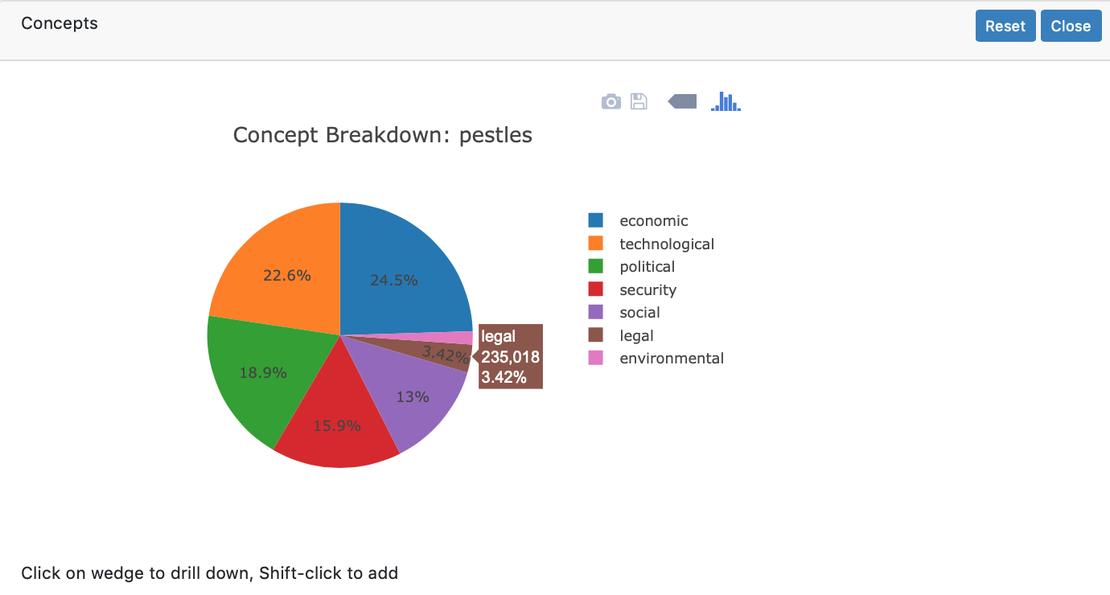

*Figure 76: Add Concept Filter Dialog; Shift-Click on "legal” Creates Filtered Search*

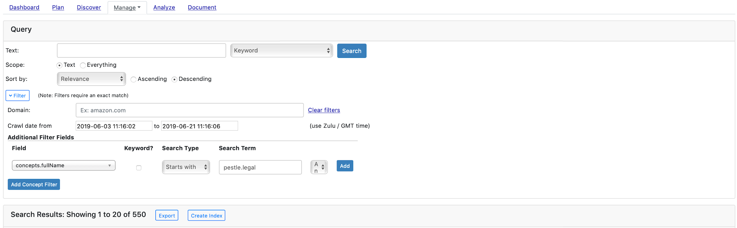

*Figure 77: Search Holding Example with Filters Employed (2,386 to 95 results)*

#### Submitting a New Holdings Search and Interacting with Results

After completing the Query form, the user will click the Submit button and be presented with the Search Results (see Figure 78). Within the Search Results pane, the user has the same Records, Analytics, Inline Job Creation, and Inline Text Summarization menu options as the Discovery Sessions Search Results view (see Discover section above for full details on each option). Additionally, the user can Export, Create a Document Index, and save records to Document Buckets from this view.

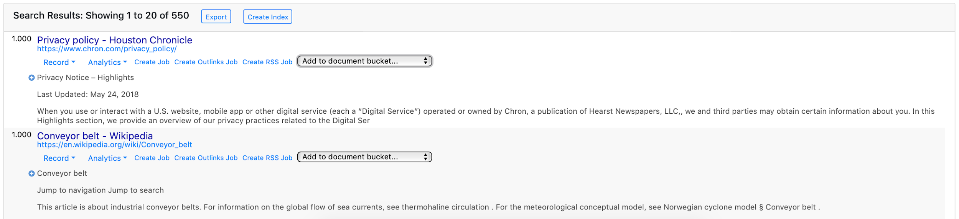

*Figure 78: Holdings Search Results Interface*

#### Creating a New Document Index from Holdings Search

The user can elect to create a New Document Index from a Holdings Search using the appropriate link. Upon clicking the link, the user will be presented with a Create New Document Index dialog (see Figure 79) where they can input the name for the index as well as the number of documents to include in the index.   
  
*Note: Document indexes can only support between 1 and 1,000 results. If the number of results is more than 1,000, the user will have to restrict the index to the first 1000 listed.*

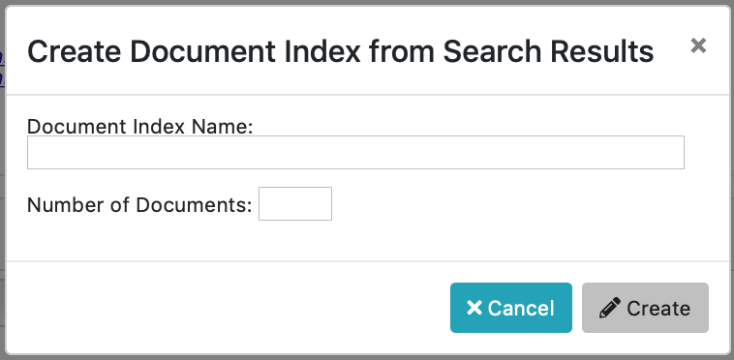

*Figure 79: Create Document Index Dialog*

Upon submitting, the user will be presented a notification of successful completion (see Figure 80). The user can then navigate to the Document Indexes page to view results.

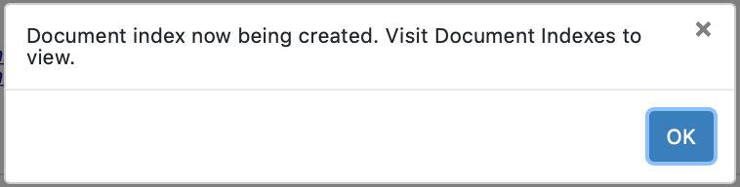

*Figure 80: Document Index Creation Completion Dialog*

### Search Alerts Overview

The Search Alerts page provides the user the opportunity to create recurring searches and be provided alerts on any new results automatically. For example, if a user is interested in news on Bitcoin, the user can establish an alert on the term “*bitcoin*” and they will be alerted any time a new result is available within the search criteria assigned. This functionality offers users a means to automatically monitor for new information pertaining to a topic of interest, utilizing any of the source handlers available within the OSKE platform.   
  
*Note: Search Alerts can also be viewed on the* *Dashboard* *page.*

#### Search Alerts Interface

The Search Alerts page provides a table listing of existing search alerts for the user (see Figure 81). If there are no existing Search Alerts, the user will see “No search alerts available.” Within the table, information on the Name, Configuration, Owner, Schedule, Last Run, Next Run, and Status for each alert is provided. The Status column will show waiting (i.e., active and on schedule), paused (i.e., on hold), running (i.e., currently retrieving), or errored (i.e., configuration incorrect and needs to be addressed).

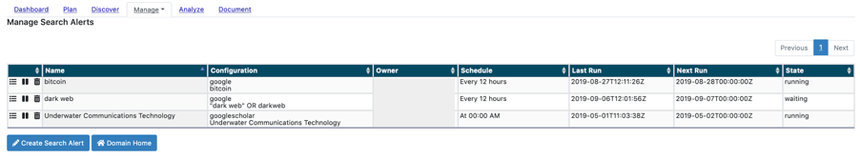

*Figure 81: Search Alerts Interface*

In the left-hand column, the user is presented with the action icons to view notifications, pause the search alert, or delete the search alert. The user can view any search alert notifications by clicking on the list icon. The user can manually pause and restart the search alert by clicking on the pause icon. The user can delete the search alert by clicking on the trash can icon.

To create a new search alert, the user can click on the Create Search Alert button below the table. Upon clicking the Create Search Alert button, the user will be presented the Create Search Alert dialog (see Figure 82).

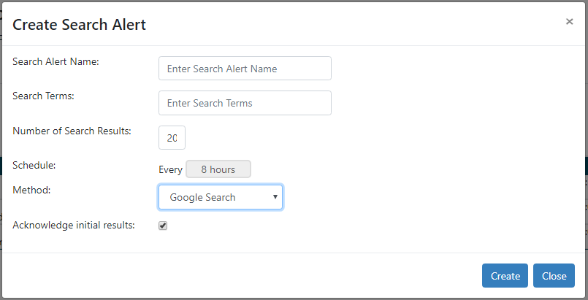

*Figure 82: Create Search Alert Dialog*

The Create Search Alert dialog is comprised of the following elements:

* Search Alert Name - user defined name for alert
* Search Terms - keywords and/or keyphrases to be searched
* Number of Search Results - the depth/number of search results to compare for new entries on each search; defaults to top 20 results
* Schedule - the frequency with which to conduct searches for new entries; defaults to every 8 hours
* Method - the source handler to use for the search
* Acknowledge initial results - user-defined entry for clearing alerts from the Dashboard view; defaults to on; toggling off will clear results on each session.

### Structural Extraction Overview

In addition to providing default annotators for extracting semantic information (e.g., addresses, events) from web pages where authors explicitly place that information in specialized tags (see [schema.org](http://schema.org/) and [microformats.org](http://microformats.org/)), the OSKE platform provides a Structural Extraction Annotator that allows users to extract records from HTML pages based upon the page structure. Users define extraction records based upon [CSS Selectors](https://developer.mozilla.org/en-US/docs/Web/CSS/CSS_Selectors) (<https://developer.mozilla.org/en-US/docs/Web/CSS/CSS_Selectors>) to bring out specific content, such as a title or article text. The extracted content can be further refined through the use of REGEX.   
  
*Note:* [*jSoup selector syntax*](https://jsoup.org/cookbook/extracting-data/selector-syntax) *(*[*https://jsoup.org/cookbook/extracting-data/selector-syntax*](https://jsoup.org/cookbook/extracting-data/selector-syntax)*) is used for the CSS selector.*

The structural extraction records are defined at the OSKE Domain level as the HTML page structure is independent of a retrieval job. Additionally, by having a separate application area, users can test the structural extraction process.

#### Structural Extraction Interface

The Structural Extraction page (see Figure 83) allows for the user to create new structural annotation records. From here, the user can import and test REGEX to extract content from pages of interest.

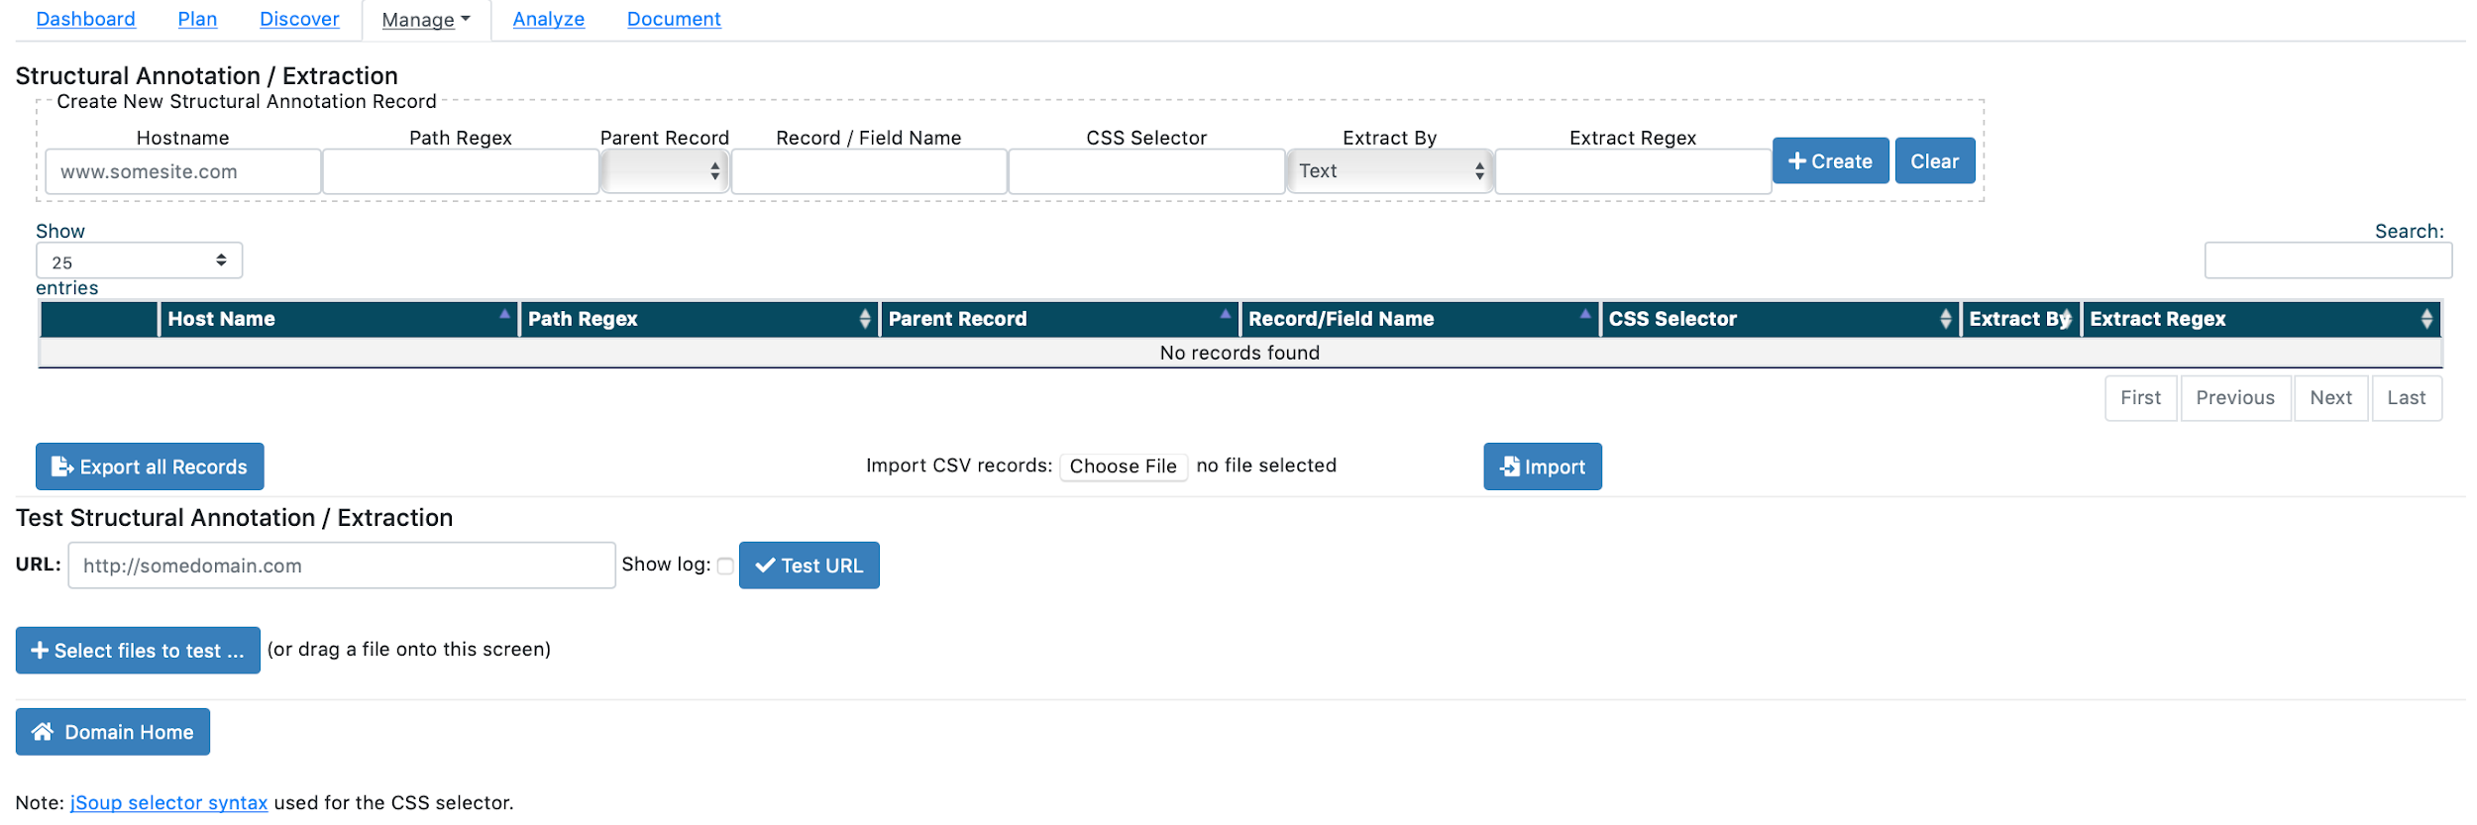

*Figure 83: Structural Extraction Interface*

#### Example - Single Record on Page

A Craigslist detailed list page or a Reuters news article are examples where generally a single record exists on a page. For example, the following [Reuters story](http://www.reuters.com/article/us-uber-britain-playbook/uber-reviving-old-tactic-is-backed-by-m%20ore-than-500000-in-london-row-idUSKCN1BY0IZ) ([http://www.reuters.com/article/us-uber-britain-playbook/uber-reviving-old-tactic-is-backed-by-m](http://www.reuters.com/article/us-uber-britain-playbook/uber-reviving-old-tactic-is-backed-by-more-than-500000-in-london-row-idUSKCN1BY0IZ) [ore-than-500000-in-london-row-idUSKCN1BY0IZ](http://www.reuters.com/article/us-uber-britain-playbook/uber-reviving-old-tactic-is-backed-by-more-than-500000-in-london-row-idUSKCN1BY0IZ)):

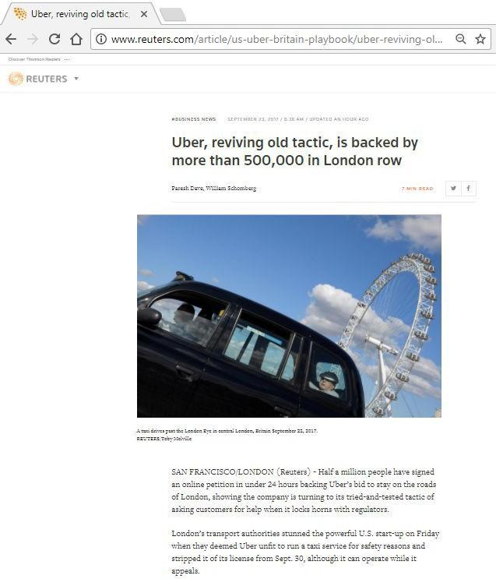

*Figure 84: Reuters Story Example for Structural Extraction*

Within the screenshot, the user can see specific parts of the story that can be extracted and processed, including: title, authors, article, text, images, and published date.

To see this closer and examine the parts, within the user’s browser, they can right click on a part of the web page, and select Inspect from the browser’s menu options. Here they can view the HTML source for that content/structure. Inspecting the page title (see Figure 85), shows this source:

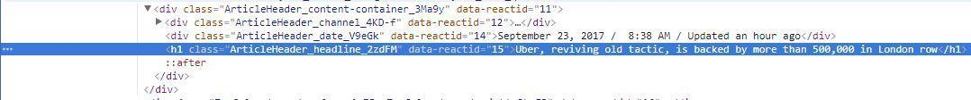

*Figure 85: Page Source Information Example*

Examining the HTML tag ("h1") and the class "ArticleHeader_headline-2zdFM", the user can create a CSS selector and extract out the article title. In this situation, they will want to use "h1[class^=ArticleHeader_headline]" to find the h1 HMTL tag that has an attribute called "class" starting with "ArticleHeader_headline".

#### Example - Multiple Records on Page

Often a web site will have multiple records on a single page. With OSKE, users can define a "record" that identifies part of the page that forms each record and then define subfields within that record. For example (as shown in Figure 86), craigslist.org has multiple listings on this page:

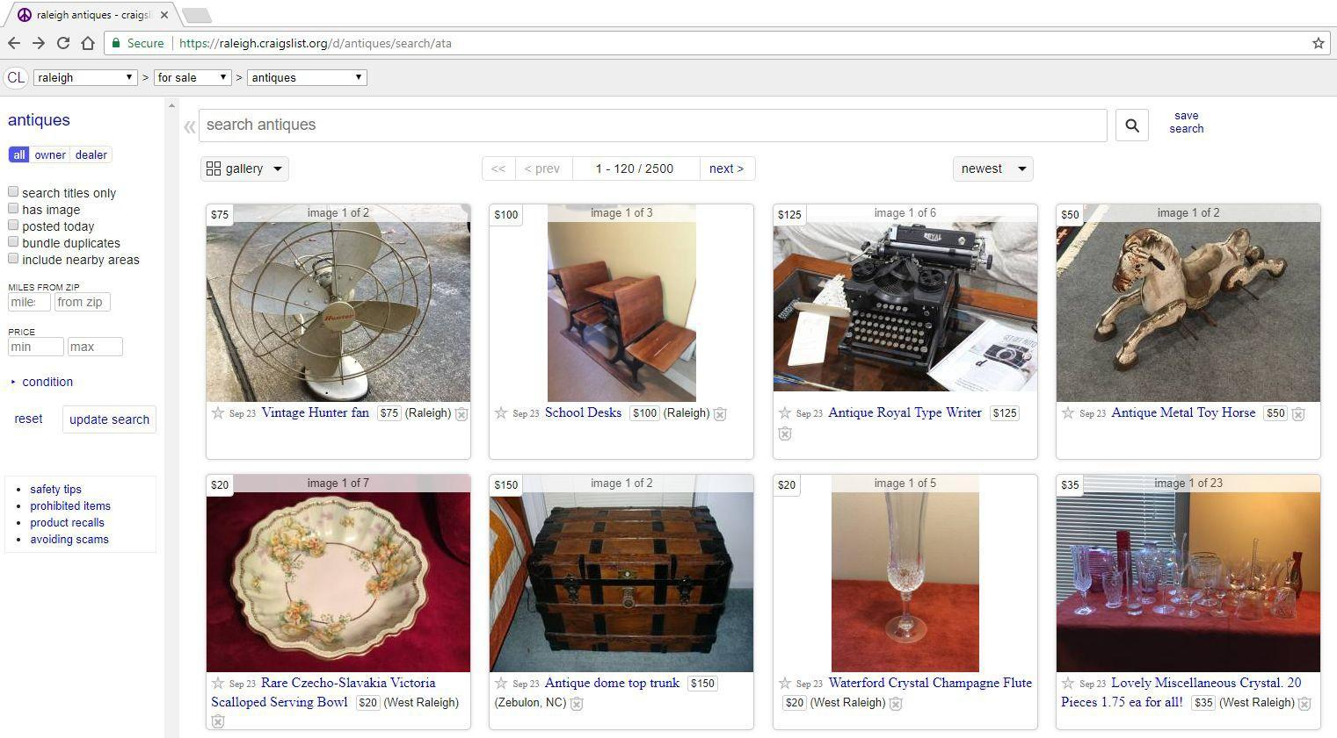

*Figure 86: Craigslist Listing Example for Structural Extraction*

For each one of those boxes, the user can identify a price, posting date, a title, and location. Inspecting the HTML source (see Figure 87), they will see the following structure:

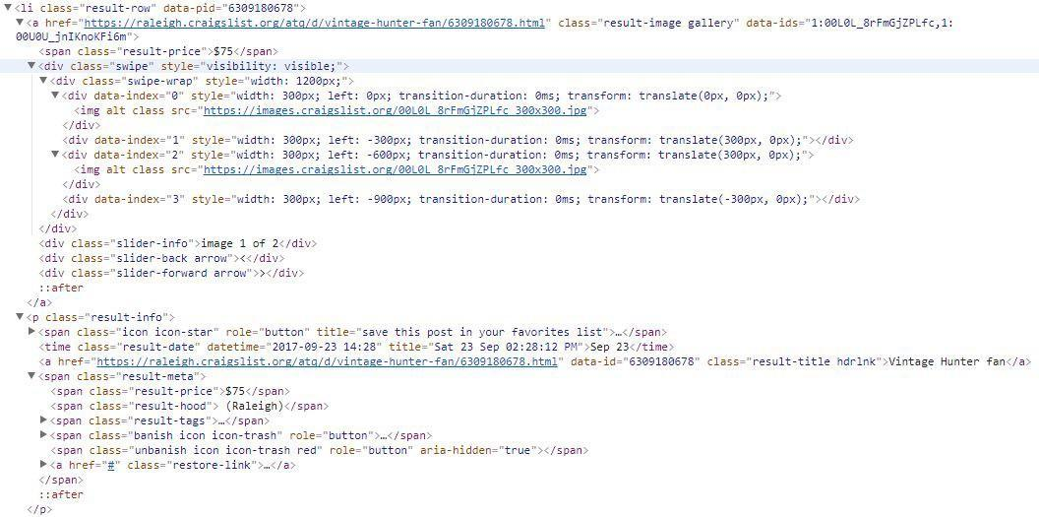

*Figure 87: Page Source Information Example*

The user can then use "ul.rows li.result-row" as the CSS selector that defines each one of the records (see Figure 88).

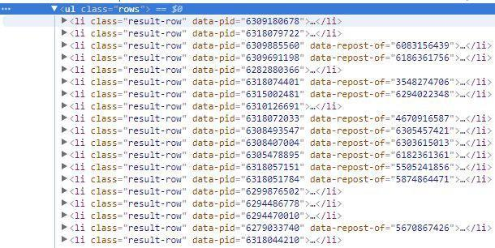

*Figure 88: Page Source CSS Selector Example*

Running this on a craigslist listing page will produce something similar to:

{ "listing": [

{

"publishedTime": ["2017-09-23 15:00"],

"price": ["$55"],

"location": ["Holly Springs"],

"title": ["FURNITURE REPAIR and Press Caning replacement seat"]

},{

"publishedTime": ["2017-09-23 14:56"],

"price": ["$400"],

"location": ["Raleigh"],

"title": ["Pagoda mirror"]

}, ....

]

}

#### HTML Content and Regular Expressions

Sometimes, users will need to extract out IDs or other values from the HTML source. In this situation, the user can use a combination of the HTML source code and REGEX to extract out the information. Looking at the Reuters news story example above, there are two images on this page. While most websites use the "<img>" tag to present images, Reuters utilizes a "<div>" tag with a background image. Examining the HTML page source, the user will find:

<div class="LazyImage_image_1KsYy LazyImage_fallback_2kFne"

style="background-image:url(//s1.reutersmedia.net/resources/r/?m=02&amp;d=20170923&amp;t=2&amp

;i=1202624705&amp;r=LYNXNPED8M0GA&amp;w=20);background-position:center center;" data-reactid="67"></div>

However, to only get the URL value, the user will need to also combine this with REGEX. With REGEX, the user can either extract the entire expression that matches or they can use a group to identify the part of the regular expression. In the div tag above, the image URL is within "url(" and ")". This can be expressed as url\(.*\)". Using this, the user will get the following results:

{

"article": [

{

"image": [ "url(//s2.reutersmedia.net/resources/r/?m=02&amp;d=20170923&amp;t=2&amp;i=1202624704&amp;r=LYN XNPED8M0GC&amp;w=20)",

"url(//s2.reutersmedia.net/resources/r/?m=02&amp;d=20170923&amp;t=2&amp;i=1202624704&amp;r=LYN XNPED8M0GC&amp;w=20)",

"url(//s1.reutersmedia.net/resources/r/?m=02&amp;d=20170923&amp;t=2&amp;i=1202624705&amp;r=LYN XNPED8M0GA&amp;w=20)",

"url(//s1.reutersmedia.net/resources/r/?m=02&amp;d=20170923&amp;t=2&amp;i=1202624705&amp;r=LYN XNPED8M0GA&amp;w=20)",

"url(//s2.reutersmedia.net/resources/r/?m=02&amp;d=20170923&amp;t=2&amp;i=1202624708&amp;r=LYN XNPED8M0GB&amp;w=20)",

"url(//s2.reutersmedia.net/resources/r/?m=02&amp;d=20170923&amp;t=2&amp;i=1202624708&amp;r=LYN XNPED8M0GB&amp;w=20)"

],

"text": [

"SAN FRANCISCO/LONDON (Reuters)

As they do not need the "url(//" in the result, they can refine the regular expression to define a "capture group" to limit the value: url\(//(.*)\). The parenthesis "(" and ")" defines this area "captured".

{

"article": [

{

"image": [ "s2.reutersmedia.net/resources/r/?m=02&amp;d=20170923&amp;t=2&amp;i=1202624704&amp;r=LYNXNPED8 M0GC&amp;w=20", "s2.reutersmedia.net/resources/r/?m=02&amp;d=20170923&amp;t=2&amp;i=1202624704&amp;r=LYNXNPED8 M0GC&amp;w=20", "s1.reutersmedia.net/resources/r/?m=02&amp;d=20170923&amp;t=2&amp;i=1202624705&amp;r=LYNXNPED8 M0GA&amp;w=20", "s1.reutersmedia.net/resources/r/?m=02&amp;d=20170923&amp;t=2&amp;i=1202624705&amp;r=LYNXNPED8 M0GA&amp;w=20", "s2.reutersmedia.net/resources/r/?m=02&amp;d=20170923&amp;t=2&amp;i=1202624708&amp;r=LYNXNPED8 M0GB&amp;w=20", "s2.reutersmedia.net/resources/r/?m=02&amp;d=20170923&amp;t=2&amp;i=1202624708&amp;r=LYNXNPED8 M0GB&amp;w=20"

],

"text": [

"SAN FRANCISCO/LONDON (Reuters)

If they decode the "&ampl" in the URL, they end up with a value such as "[http://s2.reutersmedia.net/resources/r/?m=02&d=20170923&t=2&i=1202624704&r=LYNXNPE](http://s2.reutersmedia.net/resources/r/?m=02&amp;d=20170923&amp;t=2&amp;i=1202624704&amp;r=LYNXNPED8M0GC&amp;w=20) [D8M0GC&w=20](http://s2.reutersmedia.net/resources/r/?m=02&amp;d=20170923&amp;t=2&amp;i=1202624704&amp;r=LYNXNPED8M0GC&amp;w=20)". Seeing that result in a browser, they end up with a tiny thumbnail. They can then refine the URL to exclude "w=20". url\(//(.*)\&amp;w=20\)

### Jobs Overview

An essential component of the OSKE platform and conducting longer-term research is the ability to set up and manage recurring crawls (i.e., jobs) to routinely gather material. This component allows the user to build a corpus of material over time relevant to their project/topic of interest, and have that information readily available to conduct post-retrieval, bulk analytics, supporting trend analysis and discovery.

The user can create any number of crawling job configurations which allow for highly-customized and tuned open source data retrieval. Each job can be configured to run at user-defined intervals (CRON-style to allow for monthly, weekly, daily, hourly). Each job will leverage one of the source handlers to retrieve resources such as: web pages, RSS feeds, and web searches (using one of several implemented search engines providers) to access content, including text and additional hyperlinks (along with the hypertext markup and JavaScript) associated with each page. The hypertext is parsed to attempt to remove the layers of formatting from each page and, ultimately, get to the unstructured text within it and store this information in OSKE’s holdings. The pages, along with additional metadata is stored in JSON format. Hyperlinks found in the content may then be used to start additional page retrievals, based on the job configuration.

The OSKE job configuration options allow for things like: limiting to a specific domain, controlling extent of retrievals, limiting the size of individual page retrieval, limiting the number of pages in a retrieval, and even adding a delay between subsequent page retrievals within an OSKE job.

The OSKE job configuration also includes the option of using simple REGEX statements to determine relevance to keep or drop individual pages or the ability to extract only specific text based upon parameters in the job configuration.

#### Manage Jobs Interface

The Manage Jobs interface provides the user with a summarized listing of all existing recurring jobs (see Figure 89). If there are no existing jobs in the Domain, the user will see *“No active jobs available.”* From this interface, the user can create a new job, view/edit an existing job, view a specific job’s history, view a specific jobs visited pages, schedule all errored jobs, and export all job configurations.

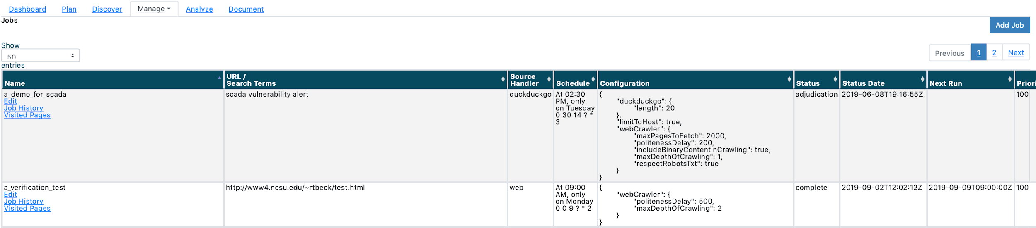

*Figure 89: Jobs Interface*

A summary of details is provided for each entry in the table (see Figure 90), providing the user with a quick view of the Name of the job; the seed URL or keywords used for the job; the source handler used for the job; the schedule by which the recurring job is run automatically; the configuration syntax used for the job; the current status of the job; the status date/time; the next scheduled run date/time; the priority of the job; the email of the owner for the job; and, the classification. Each column in the table is sortable ascending/descending, with the default ascending alphabetically on the Name column.

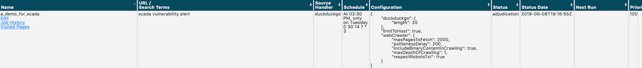

*Figure 90: Job Entry Example*

The Status column will show the state of the job, including:

* Complete - the job has completed execution, is on schedule, and is awaiting the next scheduled run time
* Draft - the job has been created, but it has not been approved/adjudicated and is not active; if a previously approved/adjudicated job is edited, it will return to this state; jobs do not run in this state
* Errored - the job is in a hold state due to an execution error and will not be processed; this state requires user attention to troubleshoot and remedy the error prior to being eligible to run again
* Hold - the job is in a hold/paused state and will not be run until reactivated
* Inactive - used to mark a job as not active with no need to execute the job in the future; requires system administrator action to move out of this state
* Processing - the job is currently being executed; processing rules are be being run, pages are being retrieved, parsed, and stored
* Ready - the job has been approved/adjudicated and is ready to be executed and is waiting for execution thread (may be a new job or a previous job, which frequency delay time has yet to happen)
* Stopping - user selects “stop” for a processing job; the job enters this state until the collection process has been terminated; once the associated collection process is terminated, the job will go to the hold state

At the bottom of the table, there are several navigation options (see Figure 91). The user can quickly navigate back to the Domain Dashboard homepage by clicking the Domain Home button. The user can quickly re-run any jobs currently showing in an “Errored” state by clicking the Schedule All Errored Jobs button. The user can also export all job configurations to a file within the shared directory by clicking the Export Job Configurations button.



*Figure 91: Manage Jobs Navigation Options*

#### View/Edit an Existing Job

Using the Edit link under the respective Job Name, the user will be presented with the Edit Job form (see Figure 92). From here, the user can view, edit, and manage their specific job.   
  
*Note: Currently, all users in the domain can view/edit/delete any job listed.*

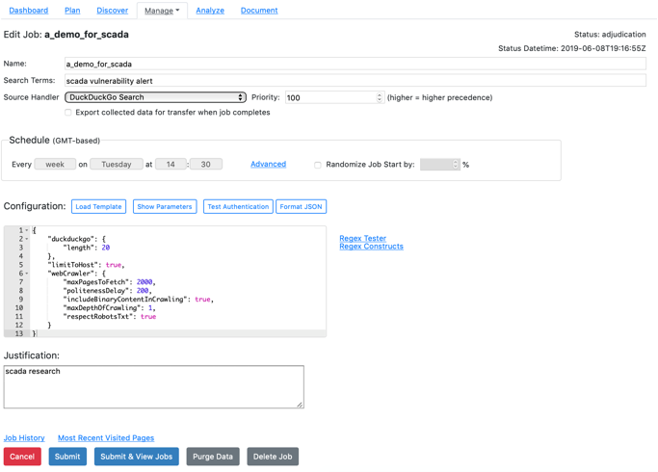

*Figure 92: Edit Jobs Form Example*

The Edit Job form is comprised of the following elements: (depending upon the source handler, the Search Term and URL fields may not be visible)

* Name - user-defined name of the job; no spaces allowed
* Search Terms - depending on the source handler, this will be the keywords to search
* URL - start URL for web crawls or the location of an RSS Feed.
* Source Handler - the source handler used for crawling
* Priority - the priority given to a job for running within the cache; values accepted from 1 to 100, with higher values being higher priority; defaults to 100
* Export data - toggle to automatically export collected data to a file for easy transfer upon job completion
* Schedule - user-defined frequency for crawl; guided option (default) shows the user a drop-down selection of values to complete the *“Every * on * at *”* format; clicking on Advanced will allow the user to use specific syntax (e.g., 0 30 14 ? * 3) using CRON[13] expressions.
* Randomize Job Start by - when toggled on, the input percent will be used to randomize when the job will be run; for example, if the selected schedule is every Sunday at 14:30, an offset of 10% (given 168 hours in a week) would randomize the start/re-query time somewhere between approximately Saturday at 2200 and Monday at 0600 each iteration
* Configuration - shows specific syntax to be used in an editable text box
* Load Template - provides the user a default, editable template for configuration
* Show Parameters - provides a link to the parameter listing and criteria for the chosen Source Handler
* Test Form Authentication - tests the form authentication
* Format JSON - formats the JSON
* REGEX Tester and REGEX Constructs - provides reference links to test REGEX prior to submission
* Justification - user input field justifying the need to conduct job
* Classification - classification for the job and retrieved results; fixed to UNCLASSIFIED

At the bottom of the form (see Figure 93), the user can cancel any edits without saving and return to the Manage Jobs interface; submit any edits to an adjudicator for adjudication and approval and remain on the edit form; submit any edits to an adjudicator for adjudication and approval and return to the Manage Jobs interface; save the edits in draft status as a new job; place the job in a “Hold” status (i.e., pause the job from actively running); run the job immediately (i.e., outside of the next scheduled run date/time); or, resume the schedule (i.e., restart a held job).



*Figure 93: Edit Jobs Form Options*

After any edits, the user will need to click the Submit or Submit & View Jobs buttons to apply changes and resubmit the job to an adjudicator.   
  
*Note: All edits will require adjudicator approval prior to becoming active.*

Additionally, using the respective links from this page, the user can visit the Job History for the current Job or view the Most Recent Visited Pages for the current Job.

### Job History

Clicking on the Job History link will present the user with the Job History page (see Figure 94). The Job History page provides a status and associated comments for each previous iterative run of the selected job. This page allows a user to view performance metrics on specific jobs, such as indicating potential issues through increased processing times (e.g., 20+ hour completion time in the example below when average was 4 hours).

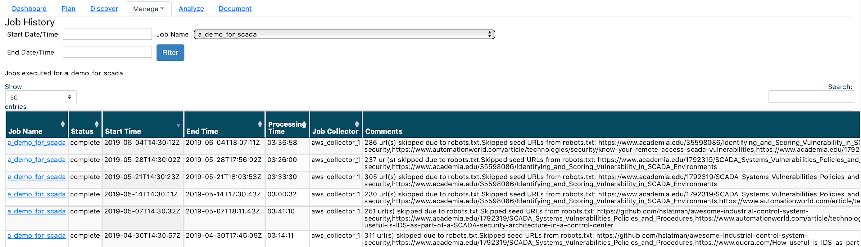

*Figure 94: Job History Interface Example*

The Visited Pages page also allows the user to manually select a time period and/or specific job to filter results. Using the options at the top of the page (see Figure 95), the user can input a specific Start and End Date/Time and/or Job Name to retrieve metrics tailored to their interests.



*Figure 95: Job History Filter Options*

### Most Recent Visited Pages

Clicking on the Most Recent Visited Pages link from the Edit Jobs form will provide the user with the most recently crawled pages associated with that job (see Figure 96).

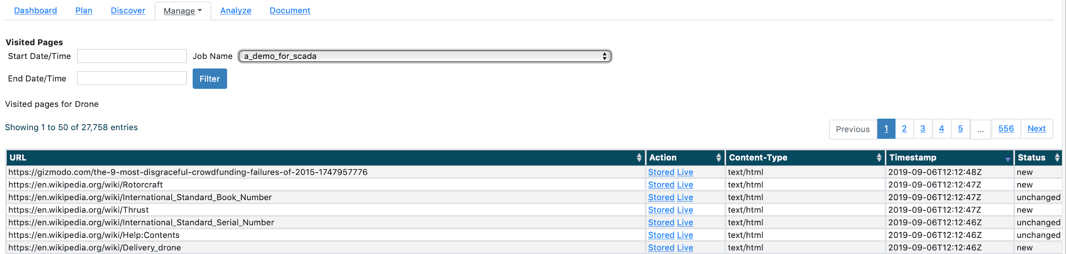

*Figure 96: Most Recent Visited Pages Example*

The Visited Pages listing provides information on the URL, Content Type, Timestamp, Status, and Classification of the retrieved page.   
  
*Note: Details on Status provided in* *Manage Jobs Interface* *section.*

Additionally, under the Actions column, the user has the ability to either view the page as it was stored in OSKE’s holdings or conduct a live query of the site using the URL in a new browser window. The Stored copy rips out all page text and strips formatting (see Figure 97 for comparison).

*Note: The Live link will visit the page directly, outside of the OSKE platform.*

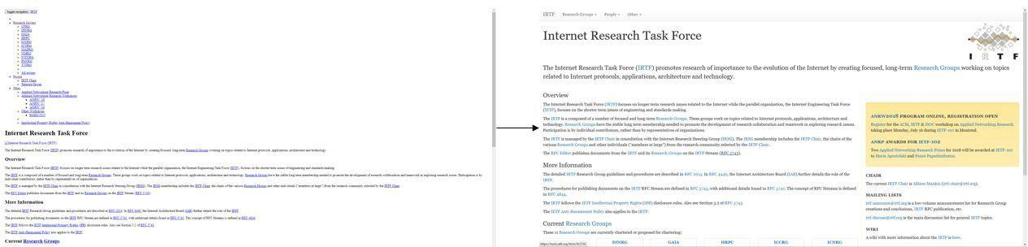

*Figure 97: Stored Copy (Left) Compared to Live Version (Right)*

The Visited Pages page also allows the user to manually select a time period and/or specific job to filter results. Using the options at the top of the page (see Figure 98), the user can input a specific Start and End Date/Time and/or Job Name to retrieve metrics tailored to their interests.

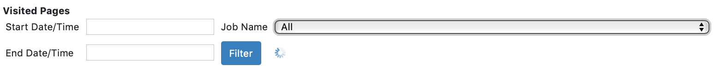

*Figure 98: Visited Pages Filter Options*

### Add a New Job

To initiate a new job, the user can select the Add Job button, on the top right-hand side of the Manage Jobs interface (see Figure 99).

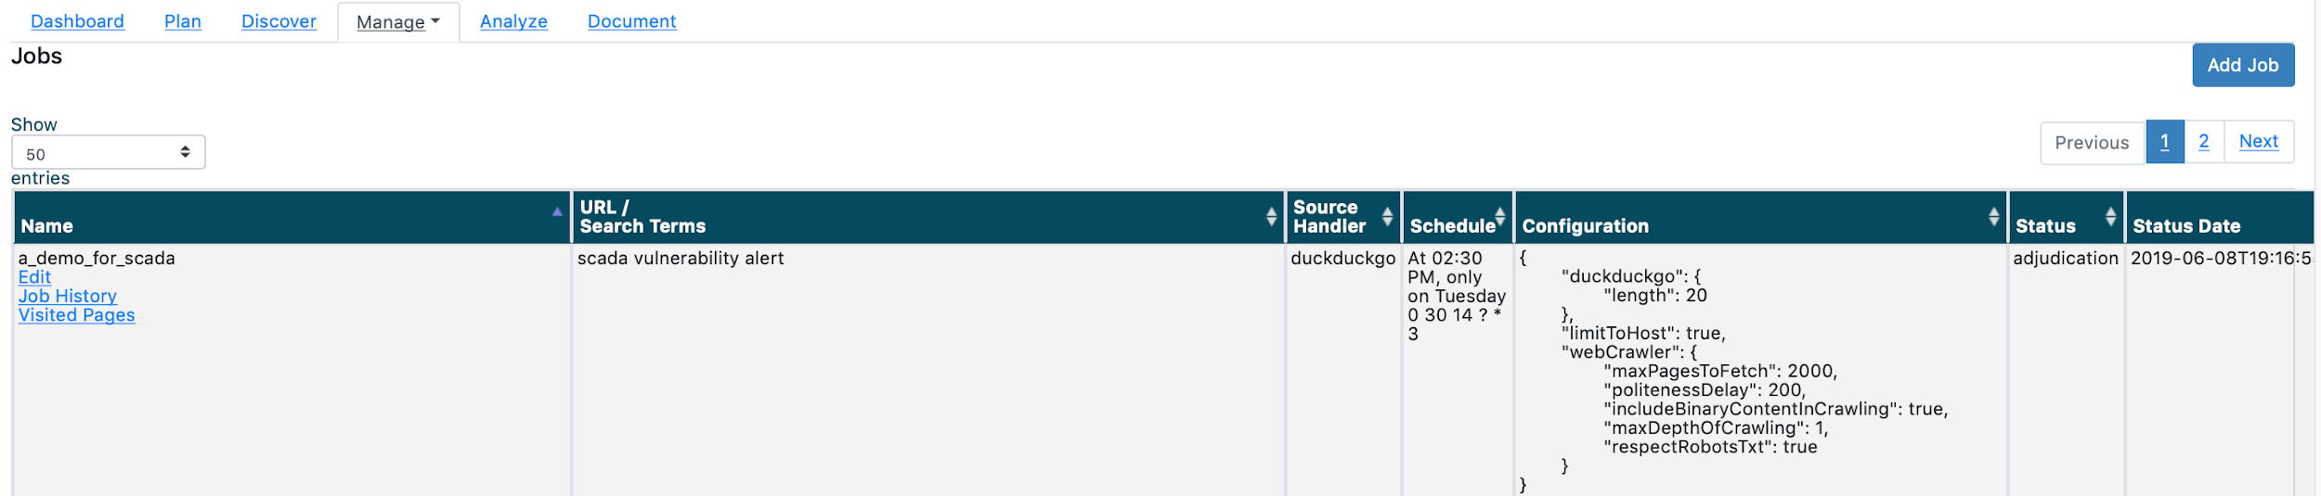

*Figure 99: Manage Jobs Interface; Add Job Button*

Upon clicking the Add Job button, the user will be presented with the New Job form (see Figure 100).

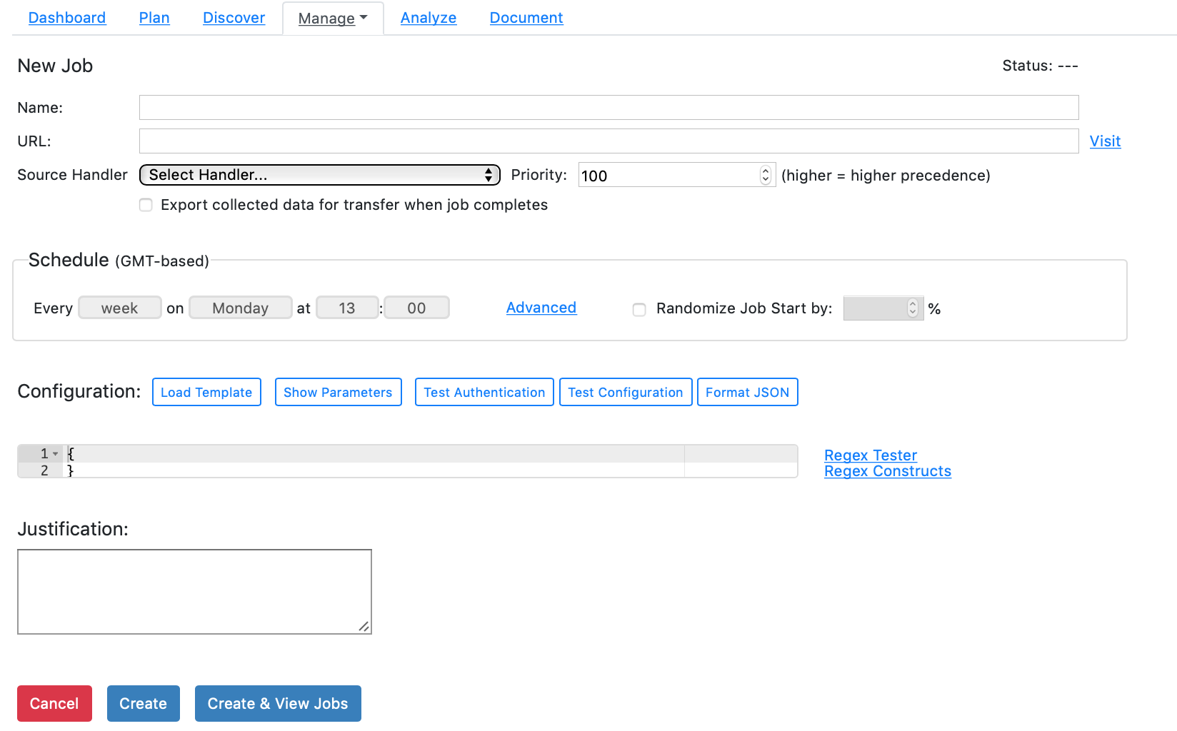

*Figure 100: Add New Job Interface*

The New Job form is comprised of the following elements:

* Name - user defined name for the job to be created; no spaces permitted
* URL/Search Terms - keywords or URLs to be searched; the name of this field will vary with the source handler selected; for some handlers, the user will input a URL, for others, they will enter keywords
* Source Handler - the desired processing source handler to be used for retrieval
* Priority - the priority given to a job for running within the cache; values accepted from 1 to 100, with higher values being higher priority; defaults to 100
* Schedule - user-defined frequency for crawl; guided option (default) shows the user a drop-down selection of values to complete the *“Every * on * at *”* format; clicking on Advanced will allow the user to use specific syntax (i.e., 0 30 14 ? * 3)
* Configuration - shows specific syntax to be used in an editable text box
* Load Template - provides the user a default, editable template for configuration
* Show Parameters - provides a link to the parameter listing and criteria for the chosen Source Handler
* Test Form Authentication - tests the form authentication
* Format JSON - formats the JSON
* REGEX Tester and REGEX Constructs - provides reference links to test REGEX prior to submission
* Justification - user input field justifying the need to conduct job
* Classification - classification for the job and retrieved results; defaults to UNCLASSIFIED

After selecting a Source Handler, clicking the “Load Template” button will provide a template with all the configuration options for that handler to customize the job to retrieve the relevant data of that domain. This is the best way to explore the full extent of options available. There is also a “Show Parameters” button which will open another web page with details on the available parameters for that source handler.

If errors exist in the configuration, details of the error are visible on the top part of the page in red. If a job is successful, there will be a pop up confirming the new job, and it will be visible on the Manage Jobs page.

At the bottom of the form (see Figure 101), the user can cancel any edits without saving and return to the Manage Jobs interface; create the job (which saves edits and places job in draft status) and remain on the edit form; or, create the job (which save edits and places job in draft status) and return to the Manage Jobs interface.



*Figure 101: Add Job Form Action Buttons*

After any edits, the user will need to click the *Create* or *Create & View* Jobs buttons to apply changes. The user will still have to submit the job after creation, in order to send to an adjudicator for approval and prior to the job becoming active.

To quickly walk through the job creation flow (see diagram in Figure 102 for graphical representation), when a new job is created (or an existing job is edited), that job gets a status of “Draft”, and will not be executed. The user will then submit the job from the Edit Job form, to submit the job for review. This initiates a manual review process for OSKE users with the Adjudicator role, who will receive an email when a new job is submitted. When the adjudicators log into the OSKE main menu, they will see a link at the top with a link to a list of un-reviewed jobs where they can approve (state changes to “Ready”) or deny (state changes to “Hold”).   
  
Every five minutes, the OSKE server will look for jobs ready to execute based on their scheduled run time. If a job thread is available, “Ready” jobs will be executed, and changed to the “Processing” state. Job run times can vary from minutes to days depending on the configuration (badly configured jobs may never end). However, when a job is finished, the state changes from “Processing” to “Complete” and the frequency counter resets.   
  
If the OSKE server detects an execution error, a “Processing” job can change to the “Errored” state, which requires user attention to remedy. If a job is no longer needed, it can be set to an “Inactive” state by a system administrator.

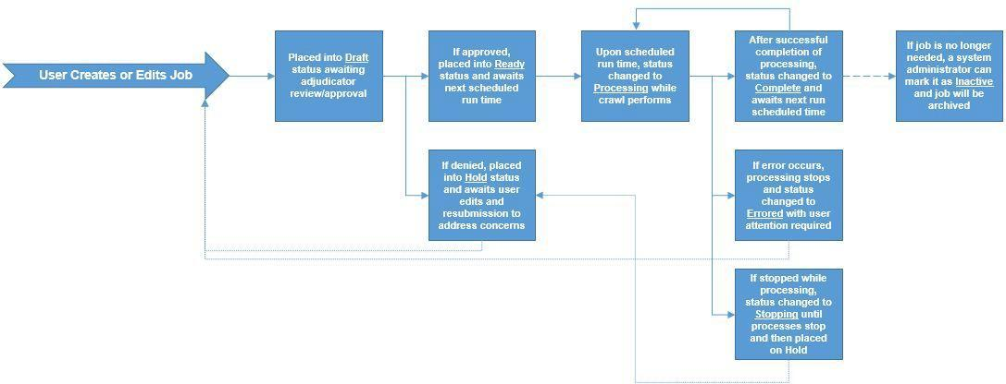

*Figure 102: Job Creation Process Schematic Diagram*

### Advanced Collector View Overview

The Advanced Collector View provides quick access to system health and job status metrics as well as information on source handler parameters for those users that are more collector-focused and routinely building and managing recurring jobs. This view is intended to show the latest retrieval activity for the respective domain, enabling the user to spot any recurring job issues quickly.

#### Advanced Collector View Interface Overview

The Advanced Collector View interface presents the user with a listing of the Most Recent Jobs and the Most Recent Visited Pages (see Figure 103). Additionally, the interface provides the user quick access to upload new files and reference materials detailing all parameters for the available source handlers.

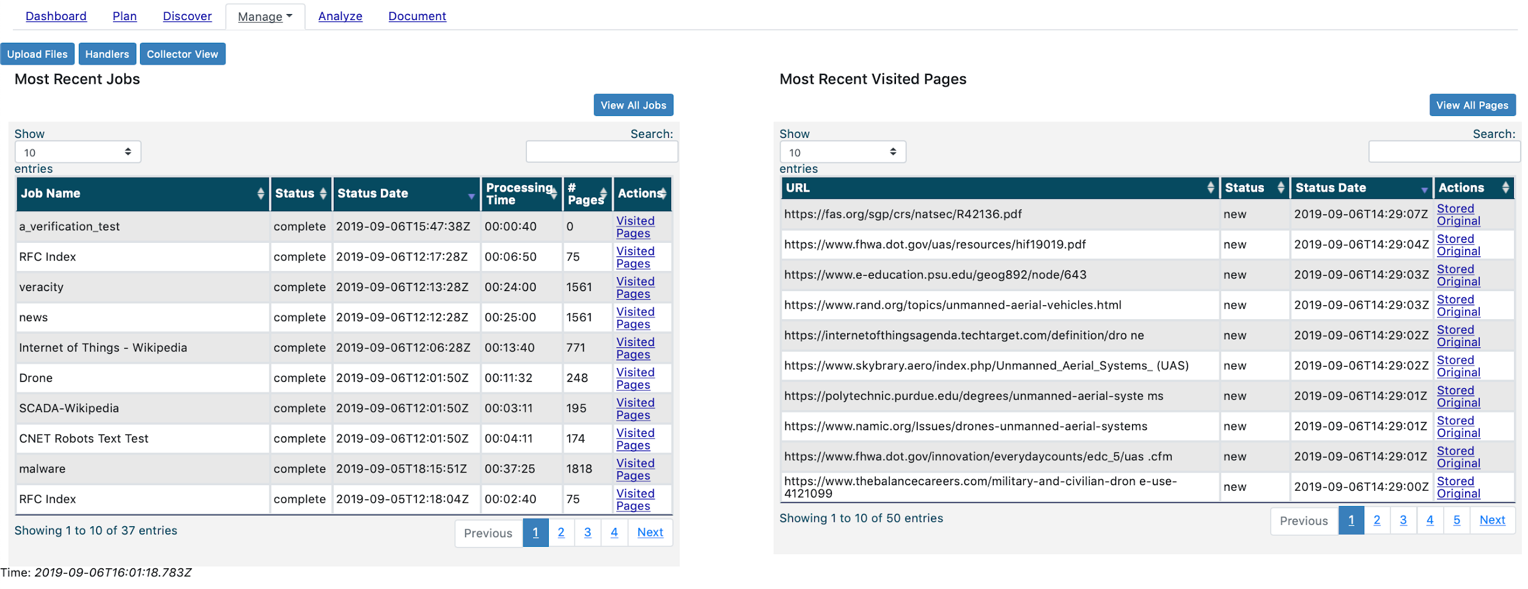

*Figure 103: Advanced Collector View Interface Example*

#### Most Recent Jobs Table

The Most Recent Jobs table displays status for all the recurring jobs in the domain. The listing provides information on the Job Name, Status, Status Date, Processing Time, and Number of Pages Retrieved. The listing is sorted, by default, descending (from last run) on the Status Date, showing the most recent at the top of the list.

Under the Actions column, a user can view the retrieval metrics for each respective job by clicking the Visited Pages link. The user will then be presented with the Visited Pages interface (see section below for more detail).

#### Most Recent Visited Pages Table

The Most Recent Visited Pages table displays status for the most recently-retrieved and stored pages from all recurring jobs currently running. The listing provides information on the URL, Status, and Status Date. The listing is sorted, by default, descending (from retrieval) on the Status Date.

The Status column will show the state of the page stored in OSKE’s holdings, including:

* Irrelevant - indicates that there is a conditional store (usually a REGEX) in a job configuration and based on the retrieved page content, the conditions were not satisfied, there was no value in the page, and it was not stored
* New - the page was newly-added to the holdings; the page was either not previously visited or was modified from a previously stored version
* Othersource - the source came from a different source than the seed
* Unchanged - the page was previously stored and contained no modifications from the previous version

Additionally, under the Actions column, the user has the ability to either view the page as it was stored in OSKE’s holdings or conduct a live query of the site using the URL to see the page in a new browser window (see Figure 104). The stored copy presents the page as is - as such this means that certain URLs and links to resources for stylesheets and images may not be correct.   
  
*Note: The Original link will visit the page directly, outside of the OSKE platform - you are directly accessing that page in this situation.*



*Figure 104: Stored Copy (Left) Compared to Live Version (Right)*

For a more in-depth view of the visited pages, the user can choose to work directly from the Visited Pages interface by clicking the View All Pages button.

#### Visited Pages Interface

Upon clicking the View All Pages button, or the Visited Pages link from the Most Recent Jobs table, the user will be presented with a listing of all the pages retrieved by all recurring jobs (see Figure 105).   
  
*Note: Clicking the Visited Pages link from the Most Recent Jobs table will automatically filter the results to the respective job; whereas, the View All Pages will provide a listing across all jobs submitted.*



*Figure 105: Visited Pages Interface Example*

The Visited Pages listing provides information on the URL, Content Type, Timestamp, Status, and Classification of the retrieved page.   
  
*Note: Details on Status provided in* *Manage Jobs Interface* *section.*

Additionally, under the Actions column, the user has the ability to either view the page as it was stored in OSKE’s holdings or conduct a live query of the site using the URL in a new browser window (see Figure 106).   
  
*Note: The Live link will visit the page directly, outside of the OSKE platform - you are directly accessing that page in this situation.*



*Figure 106: Stored Copy (Left) Compared to Live Version (Right)*

The Visited Pages page also allows the user to manually select a time period and/or specific job to filter results. Using the options at the top of the page (see Figure 107), the user can input a specific Start and End Date/Time and/or Job Name to retrieve metrics tailored to their interests.



*Figure 107: Visited Pages Filter Options*

Upload Files

The Advanced Collector View also provides the user the ability to directly upload files into OSKE’s holdings through the Upload Files button. Upon clicking the button, the user can select the file to be uploaded from their local system, or drag-and-drop the file into the interface (see Figure 108). Users can upload files (including archives such as zip and tar files) that already have without needing to explicitly retrieve from another source.

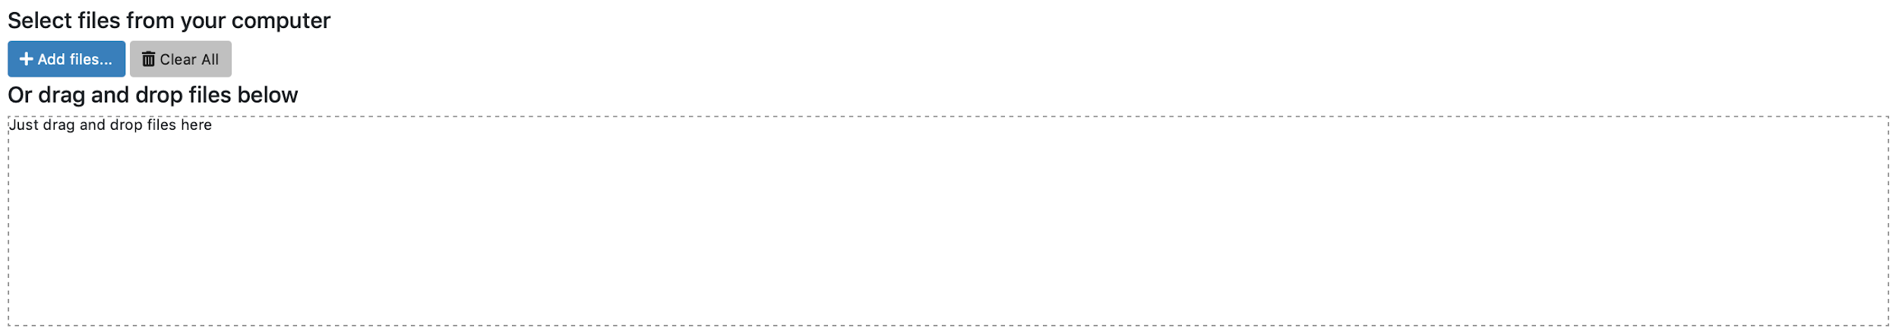

*Figure 108: File Upload Interface Example*

#### Handler Parameters and Interface

Lastly, the Advance Collector View provides the user direct access to references on the various configurable parameters for all the source and document handlers available as well as the annotators available. Upon clicking the Handlers button, the user is presented the Handlers interface (see Figure 109). From here, the user can view the name and brief description of the various handlers and annotators implemented.

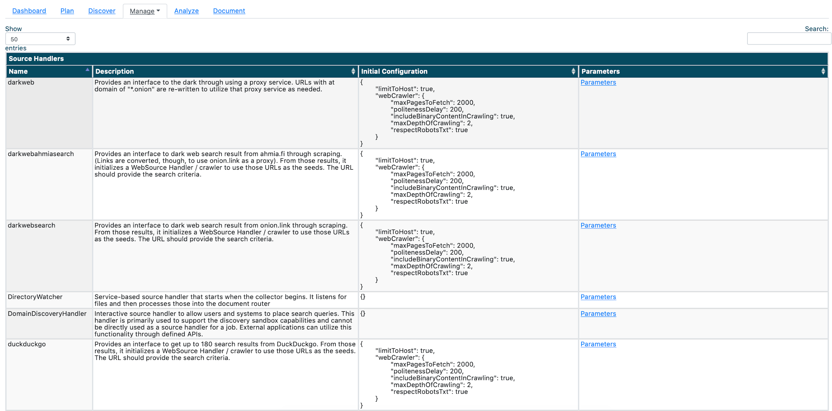

*Figure 109: Source Handler Listing*

The Source Handlers are listed first, and provide an Initial Configuration as well as a hyperlinked-reference to any configurable parameters (accessed through the Parameters link under the parameters column – see Figure 110).

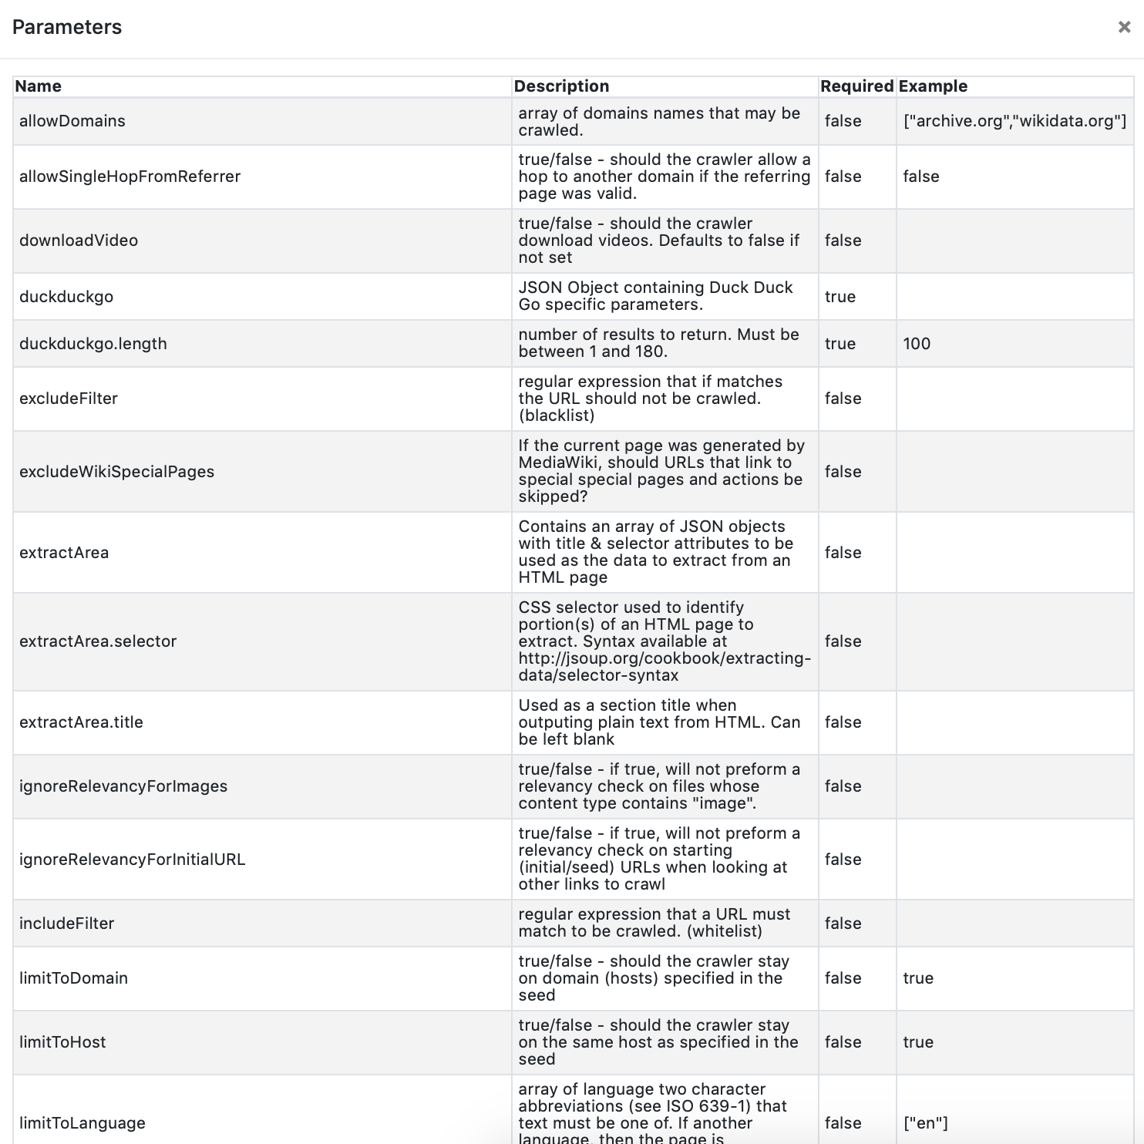

*Figure 110: Source Handler Parameters Example (for DuckDuckGo Handler)*

The Source Handlers currently implemented are:

* darkweb - provides an interface to the dark through using a proxy service. URLs with at domain of "*.onion" are re-written to utilize that proxy service as needed
* darkwebahmiasearch - provides an interface to dark web search result from ahmia.fi through scraping. (Links are converted, though, to use onion.link as a proxy); from those results, it initializes a WebSource Handler/crawler to use those URLs as the seeds; the URL should provide the search criteria
* darkwebcabsearch - provides an interface to dark web search result from onion.cab through crawling; links are converted, though, to use onion.link as a proxy; from those results, it initializes a WebSource Handler/crawler to use those URLs as the seeds; the URL should provide the search criteria
* darkwebsearch - provides an interface to dark web search result from onion.link through crawling; from those results, it initializes a WebSource Handler/crawler to use those URLs as the seeds; the URL should provide the search criteria
* DirectoryWatcher - service-based source handler that starts when the collector begins; it listens for files and then processes those into the document router
* DomainDiscoveryHandler - interactive source handler to allow users and systems to place search queries; this handler is primarily used to support the discovery session capabilities and cannot be directly used as a source handler for a job; external applications can utilize this functionality through defined APIs
* DuckDuckGo - provides an interface to get up to 180 search results from DuckDuckGo; from those results, it initializes a WebSource Handler/crawler to use those URLs as the seeds; the URL should provide the search criteria
* Email - provides an interface to use emails in a IMAP server account as a data source
* federatedAcademicSearch - provides an interface to get search results from Google Scholar and Microsoft Academic; search results are round-robin from each of the underlying handlers; from those results, it initializes a WebSource Handler/crawler to use those URLs as the seeds; the URL should provide the search criteria
* federatedSearch - provides an interface to get search results from DuckDuckGo and google; search results are round-robin from each of the underlying handlers; from those results, it initializes a WebSource Handler/crawler to use those URLs as the seeds; the URL should provide the search criteria
* feed - processes URLs from a feed (RSS, ATOM, etc.); the handler first queries the feed to get the list of the URLs; from that, it initializes a WebSource Handler/crawler to use those URLs as the seeds
* forum - provides an interface to systematically crawl a forum-board based site
* Google - provides an interface to web search result from Google through crawling; from those results, it initializes a WebSource Handler/crawler to use those URLs as the seeds; the URL should provide the search criteria
* googlescholar - provides an interface to web search result from Google Scholar through crawling; from those results, it initializes a WebSource Handler/crawler to use those URLs as the seeds; the URL should provide the search criteria
* microsoftacademic - provides an interface to web search result from MicrosoftAcademic through crawling; from those results, it initializes a WebSource Handler/crawler to use those URLs as the seeds; the URL should provide the search criteria
* pastebinsearch - provides an interface to search pastebin.com and similar sites through crawling (<https://inteltechniques.com/osint/menu.pastebins.html>); from those results, it initializes a WebSource Handler/crawler to use those URLs as the seeds; the URL should provide the search criteria
* qwant - provides an interface to web and news API feed provided by Qwant; from those results, it initializes a WebSource Handler/crawler to use those URLs as the seeds; the URL should provide the search criteria
* vbulletin - provides an interface to systematically crawl a vBulletin-board based site
* video - provides an interface to download videos from the Internet; the URL should provide the link to the specified video
* web - the web source crawler is the primary crawler for crawling web sites
* weblist - the Web List Handler functions the same as normal "web" handler ("Web Crawler"), except that an array of URLs is used as the seed for a web crawl rather than a specific URL

The Document Handlers are listed after the Source Handlers and provide additional detail on the handlers, including the Name, Processing Order, MIME Type, Document Domain (if specific), and Description (see Figure 111).

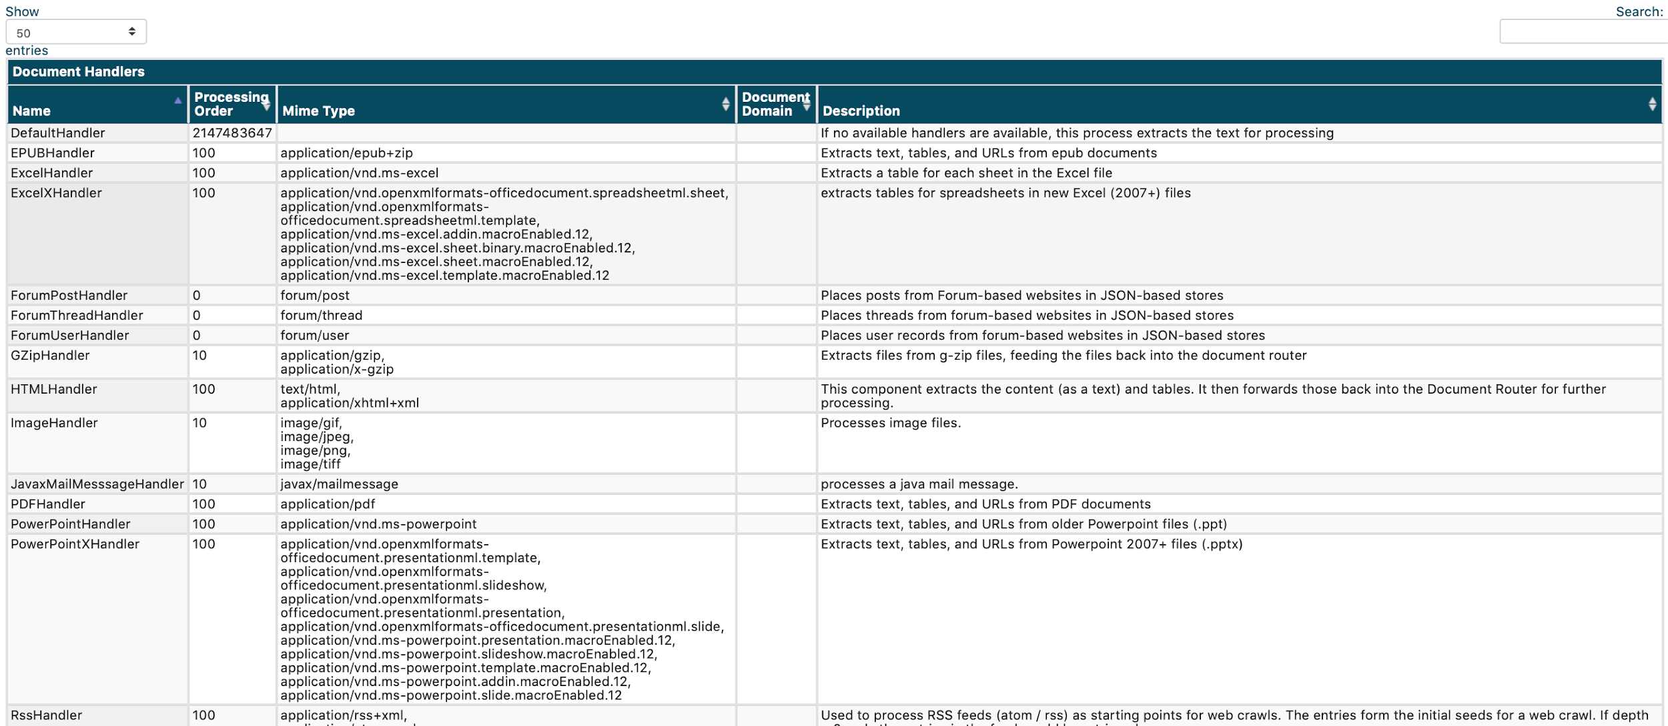

*Figure 111: Document Handler Listing*

The current Document Handlers implemented are:

* DefaultHandler - if no available handlers are available, this process extracts the text for processing
* ExcelHandler - extracts a table for each sheet in the Excel file
* ExcelXHandler - extracts tables for spreadsheets in new Excel (2007+) files
* ForumPostHandler -places posts from Forum-based websites in JSON-based stores
* ForumThreadHandler - places threads from forum-based websites in JSON-based stores
* ForumUserHandler - places user records from forum-based websites in JSON-based stores
* GZipHandler - extracts files from g-zip files, feeding the files back into the document router
* HTMLHandler - this component extracts the content (as a text) and tables; it then forwards those back into the Document Router for further processing
* ImageHandler - processes image files
* JavaxMailMesssageHandler - processes a java mail message
* PDFHandler - extracts text, tables, and URLs from PDF documents
* PowerPointHandler - extracts text, tables, and URLs from older Powerpoint files (.ppt)
* PowerPointXHandler - extracts text, tables, and URLs from Powerpoint 2007+ files (.pptx)
* RssHandler - used to process RSS feeds (atom / rss) as starting points for web crawls; the entries form the initial seeds for a web crawl; if depth = 0, only the entries in the feed would be retrieved
* TableHandler - places information in tables into the graph database
* TARHandler - extracts files from TAR files, feeding the files back into the document router
* TextHandler - performs any direct processing for text data; primary this established the extracted text portion of the record
* URLHandler - processes URLs by feeding them back into the current webcrawler for processing
* WordDocHandler - extracts text, tables, and URLs from older Microsoft Word documents
* WordDocXHandler - extracts text, tables, and URLs from new Microsoft Word documents
* ZipHandler - extracts files from zip files, feeding the files back into the document router

Lastly, details on the Annotators are listed (see Figure 112), to include the Name, Code, Description, MIME Type, Execution Point, and Priority.

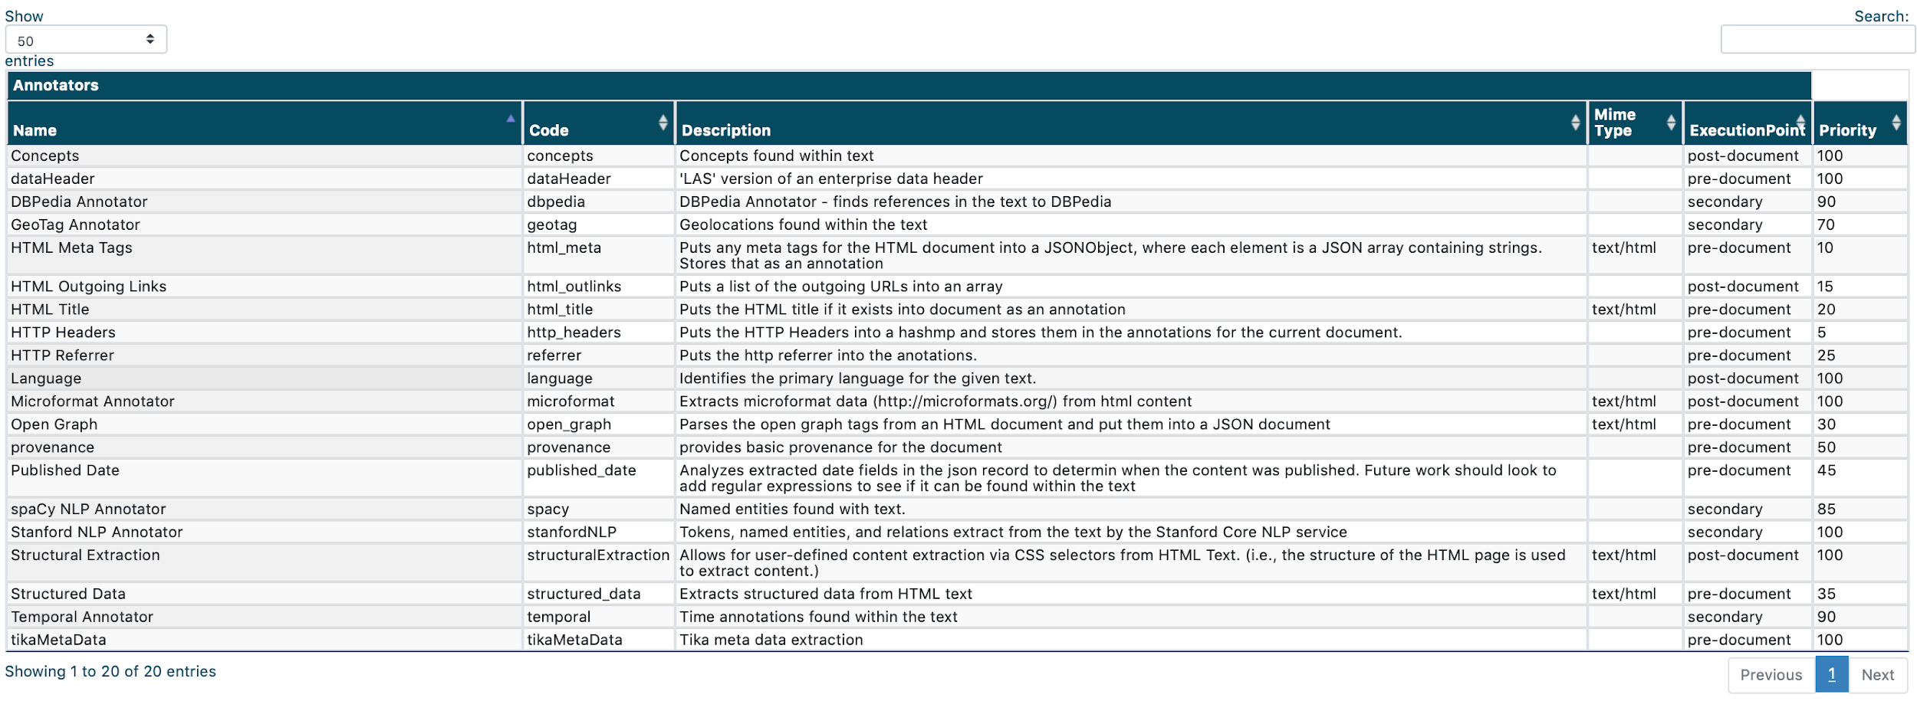

*Figure 112: Annotators Listing*

The current Annotators implemented are:

* Concepts - annotate all concept dictionary matches within page text, adds those concept names and locations to the page object
* dataHeader - annotates a LAS enterprise data header to the page object
* DBPedia Annotator - finds references in the text to DBpedia
* GeoTag Annotator - annotates named entity matches within page text (using Clavin service), adds matched names and geo coordinates to the page object
* HTML Meta Tags - puts any meta tags for the HTML document into a JSONObject, where each element is a JSON array containing strings. Stores that as an annotation
* HTML Outgoing Links - puts a list of the outgoing URLs into an array
* HTML Title - puts the HTML title if it exists into document as an annotation
* HTTP Headers - puts the HTTP Headers into a hashmap and stores them in the annotations for the current document
* HTTP Referrer - puts the http referrer into the annotations
* Language - identifies the primary language for the given text.
* Microformat Annotator - extracts microformat data ([http://microformats.org](http://microformats.org/)) from HTML content
* Open Graph - parses the open graph tags from an HTML document and put them into a JSON document
* Provenance - annotates information on how, when, and from where the page was retrieved
* Published Date - analyzes extracted date fields in the JSON record to determine when the content was published; future work should look to add regular expressions to see if it can be found within the text
* spaCy NLP Annotator - named entities found with text
* Stanford NLP Annotator - tokens, named entities, and relations extract from the text by the Stanford Core NLP service
* Structural Extraction - allows for user-defined content extraction via CSS selectors from HTML Text. (i.e., the structure of the HTML page is used to extract content)
* Structured Data - extracts structured data from HTML text
* Temporal Annotator - time annotations found within the text
* tikaMetaData - adds tika output as additional metadata

## Analyze

The Analyze phase of the workflow affords users the opportunity to gain high-level perspective and summarize across their research holdings, looking for trends and patterns. OSKE enables a user’s post-query analysis by providing several different means to visualize and filter the information available. The Analyze interface (see Figure 113) provides a quick snapshot of summary statistics across the user’s stored holdings. Additionally, the interface offers the user multiple options for visualizing their results.

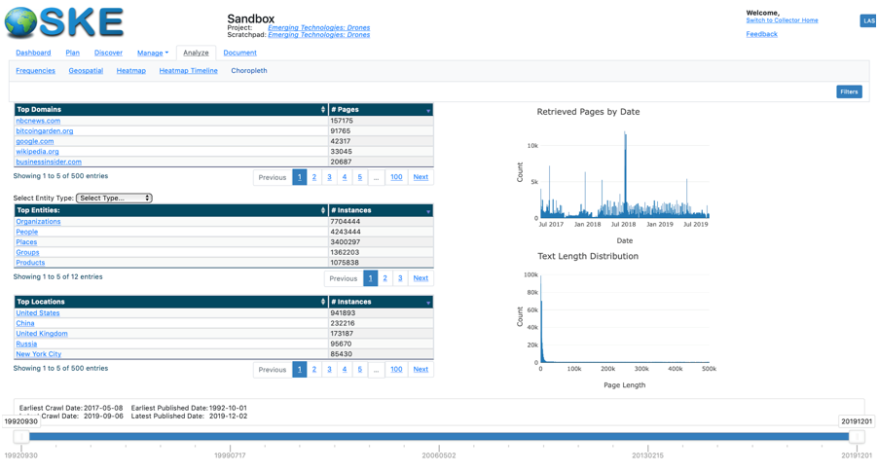

*Figure 113: OSKE Analyze Page Interface Example*

Features within the Analyze interface draw from the ideas set forth from Ben Shneiderman’s work (<https://www.cs.umd.edu/~ben/papers/Shneiderman1996eyes.pdf>). In particular, the filtering capabilities employed follow a hierarchy of abstraction. More tasks and refinements of these tasks would be a natural next step in expanding the result set(s) that users are presented. The levels of abstraction include:

1. Overview: gain an overview of the entire collection
2. Zoom : zoom in on items of interest
3. Filter: filter out uninteresting items
4. Details-on-Demand: select an item or group and get
5. Relate: view relationships among items
6. History: keep a history of actions to support undo
7. Extract: allow extraction of sub-collections and of the details, when needed

OSKE’s Analyze interface focuses on providing a simple way to enable the first four levels, providing the user an overview of data holdings in the Analyze page interface; providing options to select and zoom within the resultant tables and graphs within the visualizations; create robust filters to minimize noise (as highlighted in the Filter dialog covered later); and, engage in Details-on-Demand when applying user-defined criteria and filters to retrieve and act upon the results. The remaining levels of abstraction are provided through capabilities within other sections of OSKE, namely the Search Results pane covered in the Discover section.

### Analyze Overview

The main portion of the Analyze interface provides the user with high-level summaries for Top Domains, Top Entities, Top Locations, Count of Retrieved Pages, and Count for Page Lengths. These summaries are pulled from the Annotators and metrics gathered during the data storage processes. Statistics on the timeframe spanning the user’s data holdings are provided at the bottom of the interface, including the earliest and latest retrieval and published dates. The provided timeline slider enables a user to further filter the summary tables and graphics provided to specific user-defined parameters, if so desired. The results are dynamically updated in the tables and graphs (see Figure 114) as the user modifies the start/stop points on the timeline.

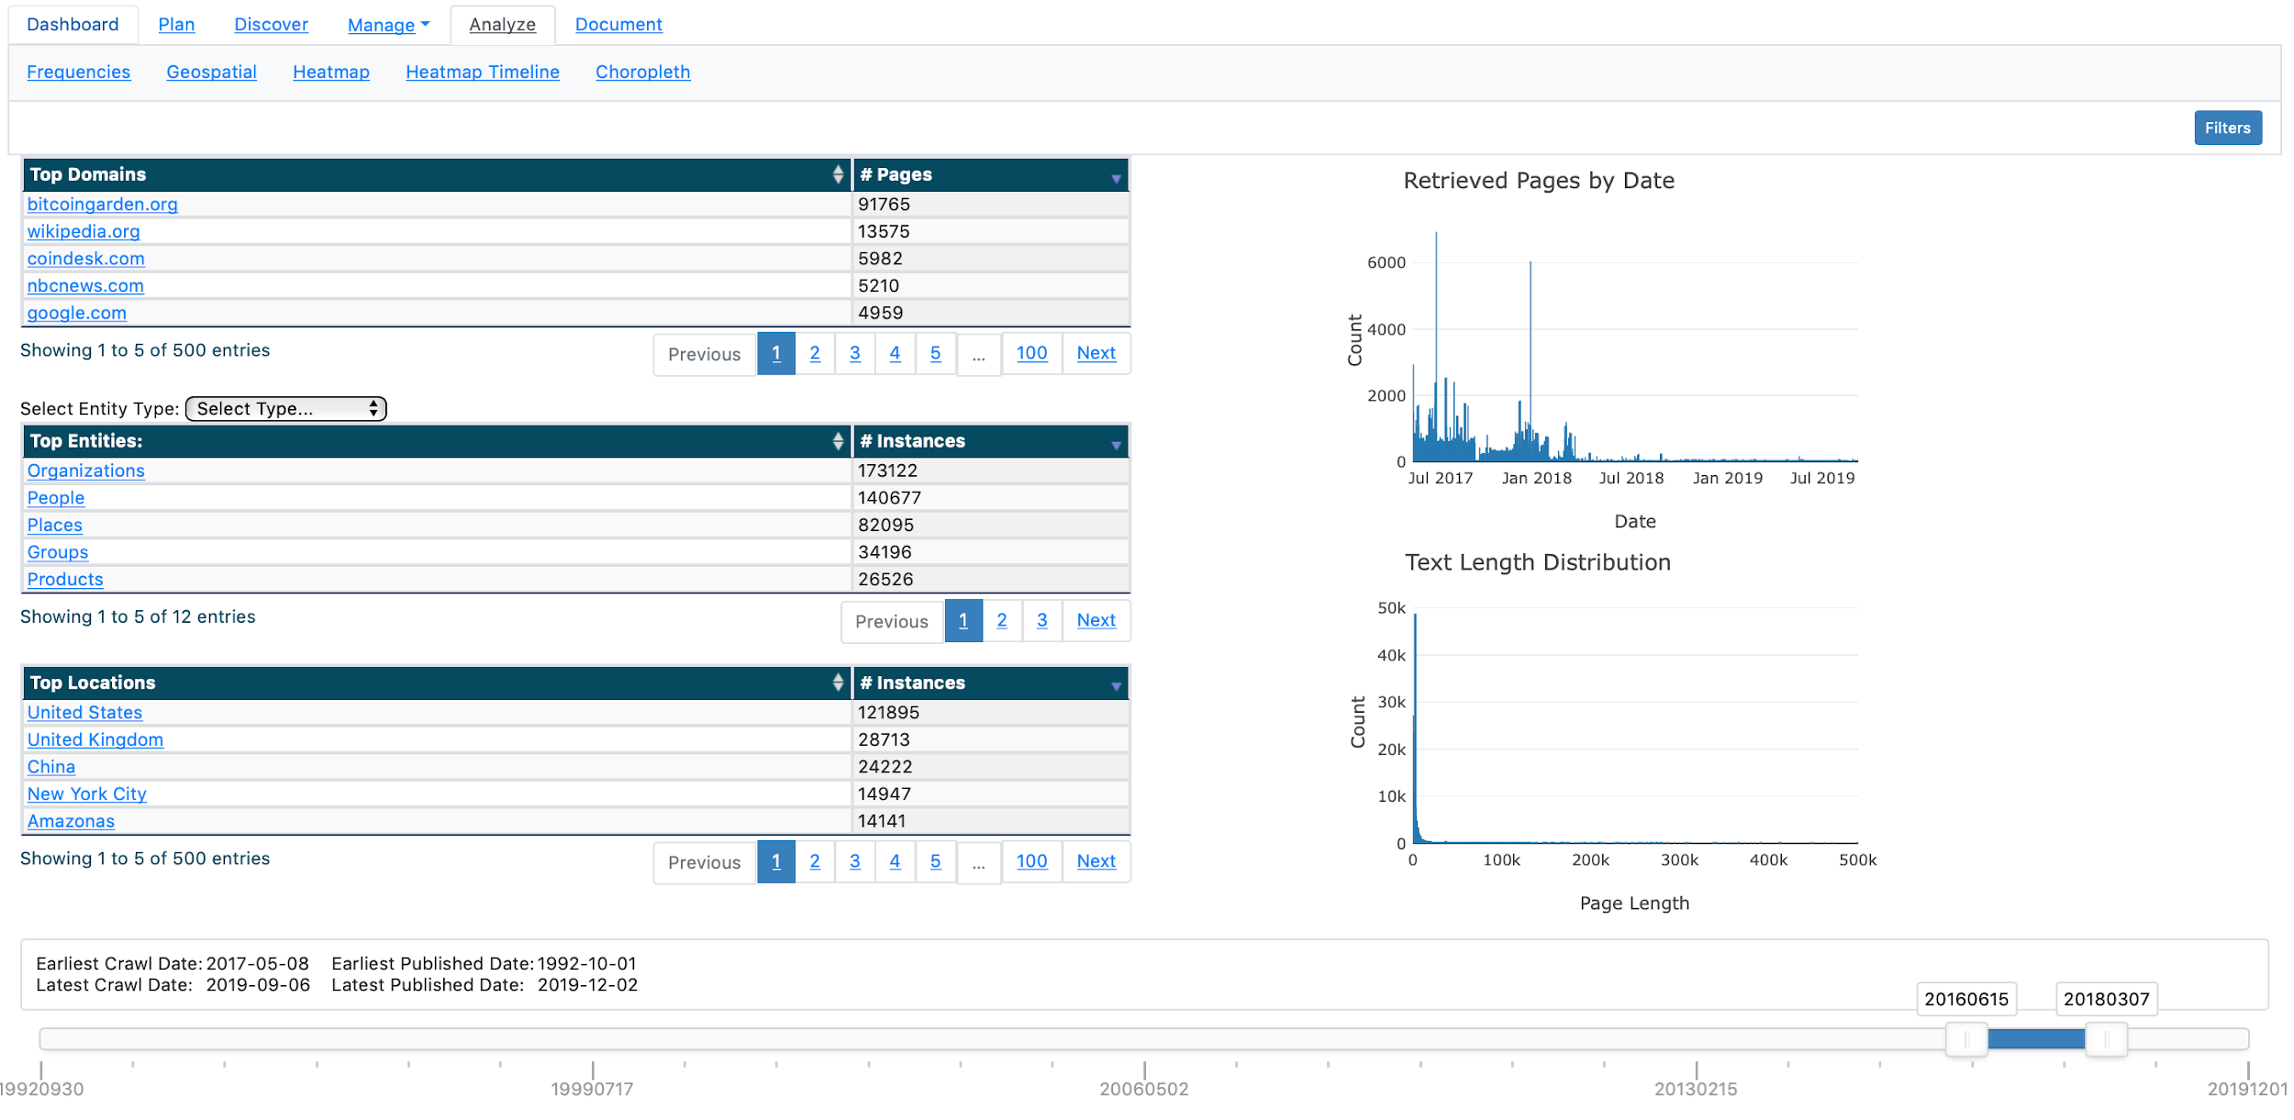

*Figure 114: Example of Modified Statistics in Tables Using Timeline Slider*

Just above the summary tables and graphs, the Analyze interface also offers the user the option to visualize and summarize their data holdings in additional ways, including Frequencies, Geospatial, Heatmap, Heatmap Timeline, and Choropleth.

The Analyze interface also offers a powerful filtering dialog interface that allows for dynamically interacting with the entirety of data holdings and creating complex queries using simple selections (see Figure 115). Users can open the Filter dialog by clicking on the Filters button.

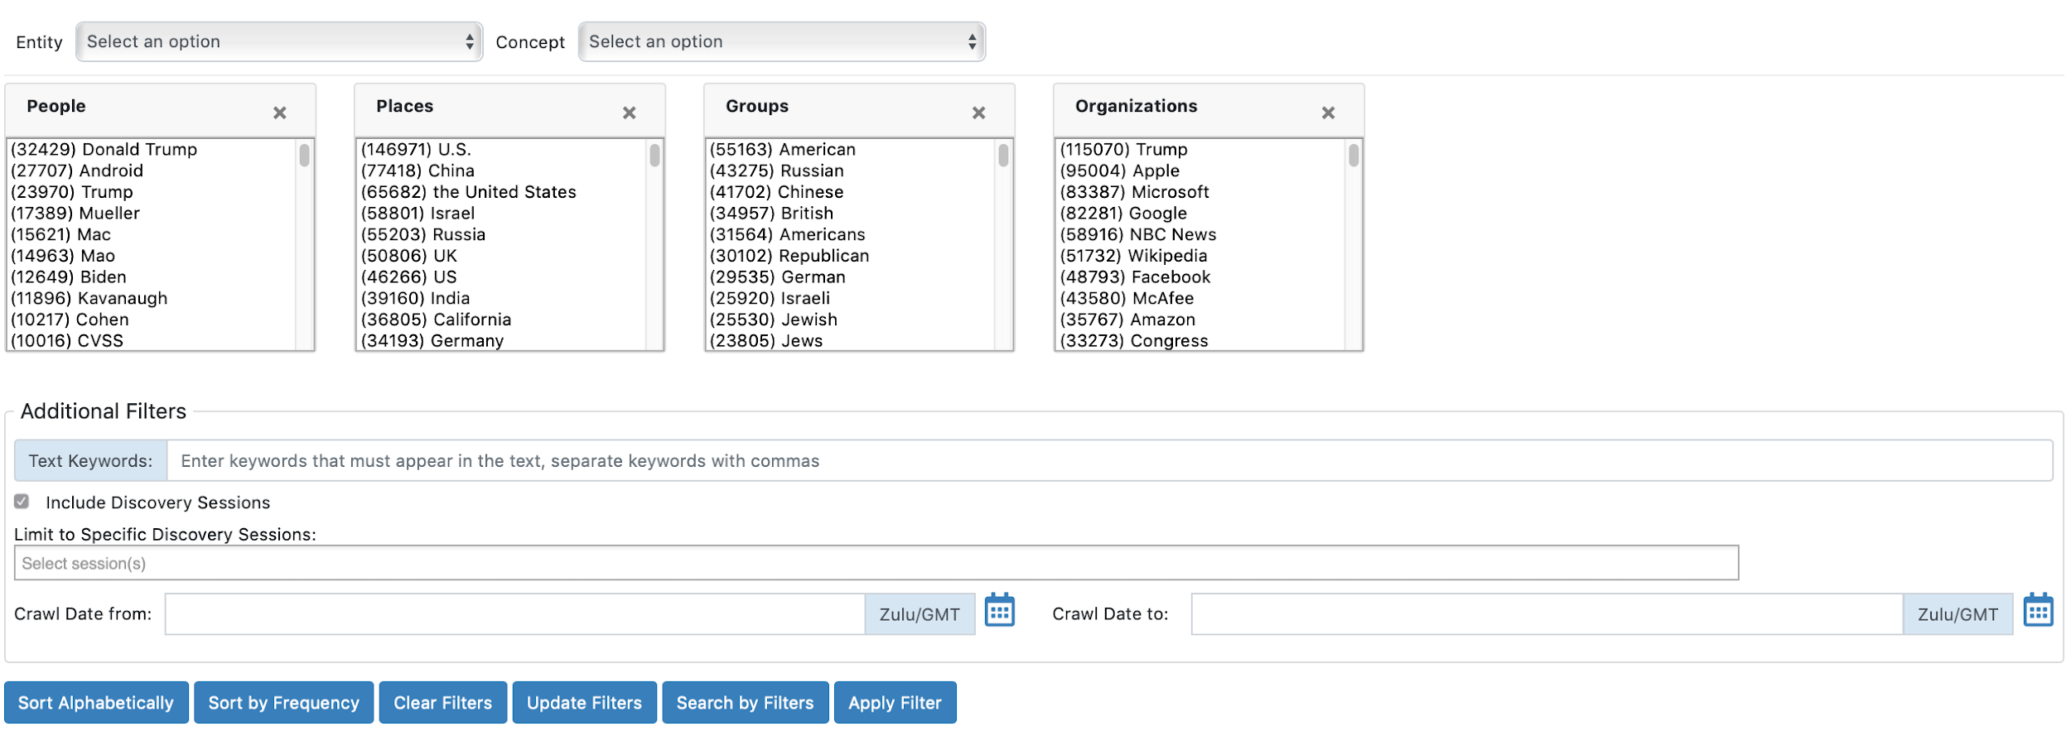

*Figure 115: Filter Dialog within Analyze Interface*

To utilize the Filter dialog, users can select one or more entries from the respective tables to build a filter.   
  
*Note: Shift- and Command-click gestures will allow you to select multiple entries within each table.*   
  
Users can select entries from one or more tables at once, allowing for simple or complex filter generation. The Filter dialog defaults to show the user entities extracted by the annotators for People, Places, Groups, and Organizations. Users can manually add additional entities and/or concepts using the provided drop-down menus. Users can also manually remove/delete any entities or concepts display by clicking on the “X” for the respective table. Once the desired entries are selected, the user can click the Update Filters button to dynamically update the counts shown.

The counts displayed reflect the number of times that entity/concept were noted in the data holdings. By selecting one entry and clicking the Update Filters button, the resultant counts will then show the number of times each entry is shown in the filtered results based off the initial selection criteria. To remove filters and reset the statistics back to the entirety of the data holdings, the user can click the Clear Filters button. Options within the Filter dialog also exist to sort entries within the tables alphabetically or by frequency of occurrence (default).

To retrieve the data holdings records matching the specified filter criteria, the user can click on the Search by Filters button. The results will be presented in a Results pane in a new browser window. From there, the user can interact with the records as described in the Manage > Holdings Search section.

The Additional Filters section of the interface provides the user further refinement opportunities by allowing for the addition of specified keywords, the inclusion or exclusion of all or specific discovery session results, and the ability to restrict by time parameters. The additional keywords option gives the user the ability to add specific terms that may not be captured by an annotator or concept dictionary entry. Inclusion or exclusion of discovery sessions can allow users to focus solely on data retrieved and stored as part of jobs, as discovery sessions may be unrelated to key research questions under specific plans.

### View/Edit a Different Analysis Visualization

To view/edit a new visualization/summary, the user can click on the name of the visualization. Upon clicking on the name of the visualization, the respective interface will appear allowing the user to further tailor the summary. Different visualizations and summaries offer the user different perspectives and could, possibly, highlight previously-unknown features and trends within the data set(s). To foster this discovery, OSKE enables the user to act upon the entirety of their data holdings and summarize by specific methods, including summarizing based on word frequencies, geospatial references, heatmap comparisons, heatmap comparisons with additional timeline filters, and choropleth.

#### Frequencies

The Frequencies visualization offers users the ability to summarize data holdings by the most frequently noted terms (see Figure 116). Using the drop-down selection menu, the interface allows the user to select any field created by the spaCy annotator or concept dictionary to use as the chosen summary. The user can then apply an optional specified number to the y-axis results.   
  
*Note: Leaving the optional value field blank will return up to the top 20 results.*   
  
Users can then specify the type of display format; either a Bar Chart or Date Histogram. Once selected, the user clicks the Chart button to create the display. Users can iterate multiple charts by making changes and clicking the Chart button again. An example of the Bar Chart and Date Histogram based on Events is provided in the figure below. The user can clear all charts by clicking the Clear All Charts button.  
  
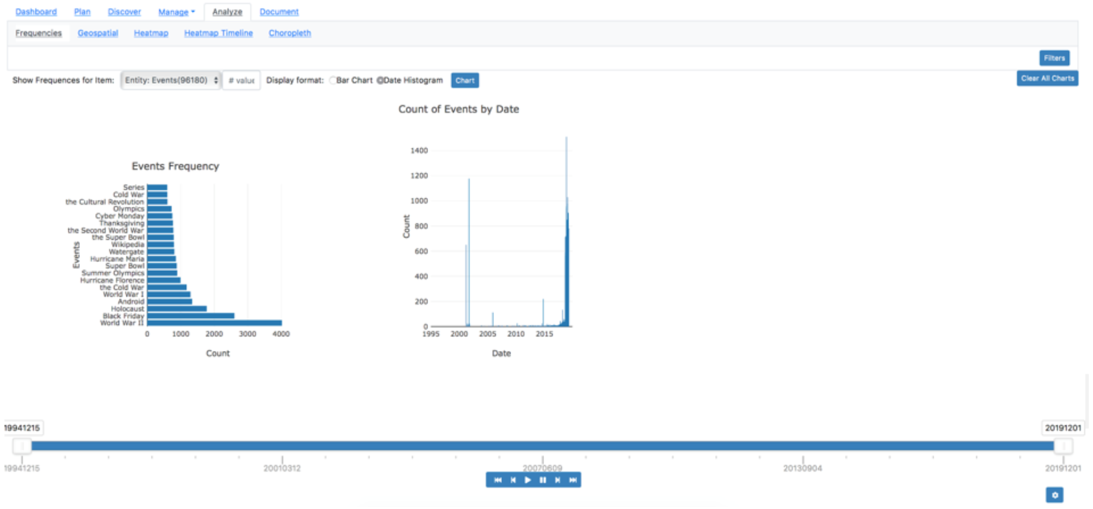

*Figure 116: Example of Frequencies Interface*

The Bar Chart provides a listing of the top results by count across the entirety of data holdings. The Date Histogram will provide a count of results based on publication date.  
  
Geospatial

The Geospatial visualization offers users the ability to display and navigate all geographic references noted in the data holdings on a map (see Figure 117). Geospatial references are extracted during processing. The underlying map utilizes OpenStreetMap and open-source gazetteers. The geolocation is based off of the level of specificity of the extracted location (i.e., region, city, country). Results are aggregated to clusters at lower zoom levels and will become individual references once zoomed to the appropriate levels. Users can use the provided map navigation to zoom, double-click within the map, or use appropriate mouse gestures/cursor wheel to control zoom levels.  
  
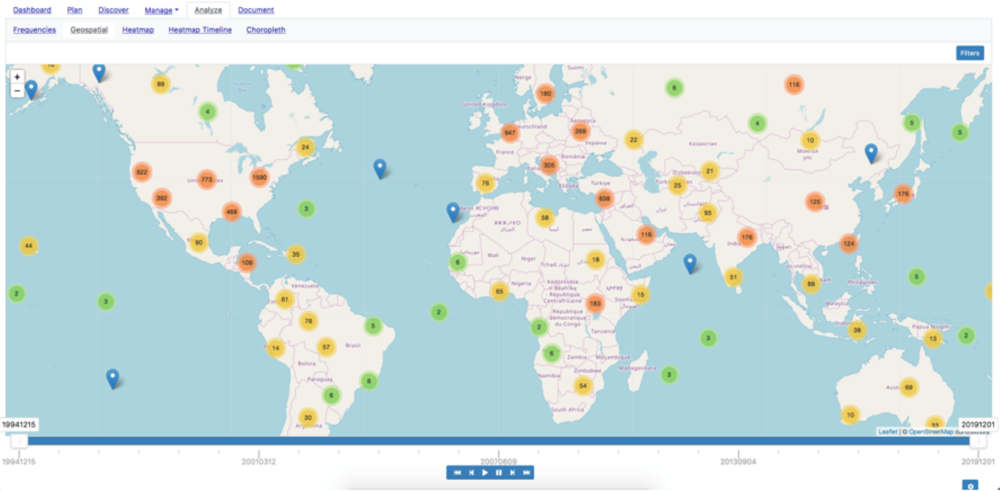

*Figure 117: Example of Geospatial Interface*

Upon clicking on the individual pin on the map, the user will be provided with a snippet of the resulting source document from the holdings (see Figure 118). A user can then interact with the result as they could in the Results pane of the Discover interface, including using analytics, creating jobs, and adding results to document buckets.  
  
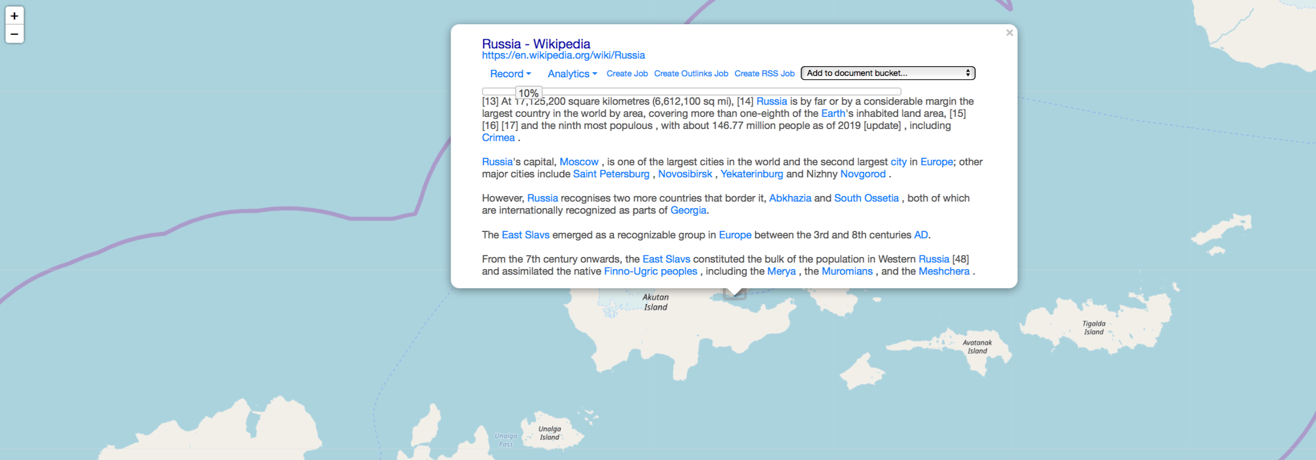

*Figure 118: Example of Individual Result in Geospatial Interface*

#### Heatmap

The Heatmap visualization offers users the ability to generate a custom heatmap based off of user-defined X-axis and Y-axis attributes (see Figure 119). This visualization enables the user to discover trends among disparate pieces of information. The heatmap will depict the count of co-occurrences between the selected X-axis and Y-axis attributes.

To create a co-occurrence heatmap, the user selects attributes from the respective X-axis and Y-axis drop-down menus. Optional values can be set to limit the number of entries displayed on each axis independently. *Note: Leaving the set values blank will return a default top 20 results.* Once the user has selected the desired attributes, clicking the View button will generate the heatmap. Higher co-occurrence values will show in more intense colorways. In the example below, the co-occurrence of “Donald Trump” and “Watergate” appeared 230 times in the data holdings.   
  
*Note: This could have been in one document or across multiple documents. To get a sense of trending over time, user can employ the timeline feature or the Heatmap Timeline visualization.*Clicking on the entry will conduct a query against the data holdings and open a new page with the results. From there, the user can further filter the query, as covered in the Manage > Holdings Search section.  
  
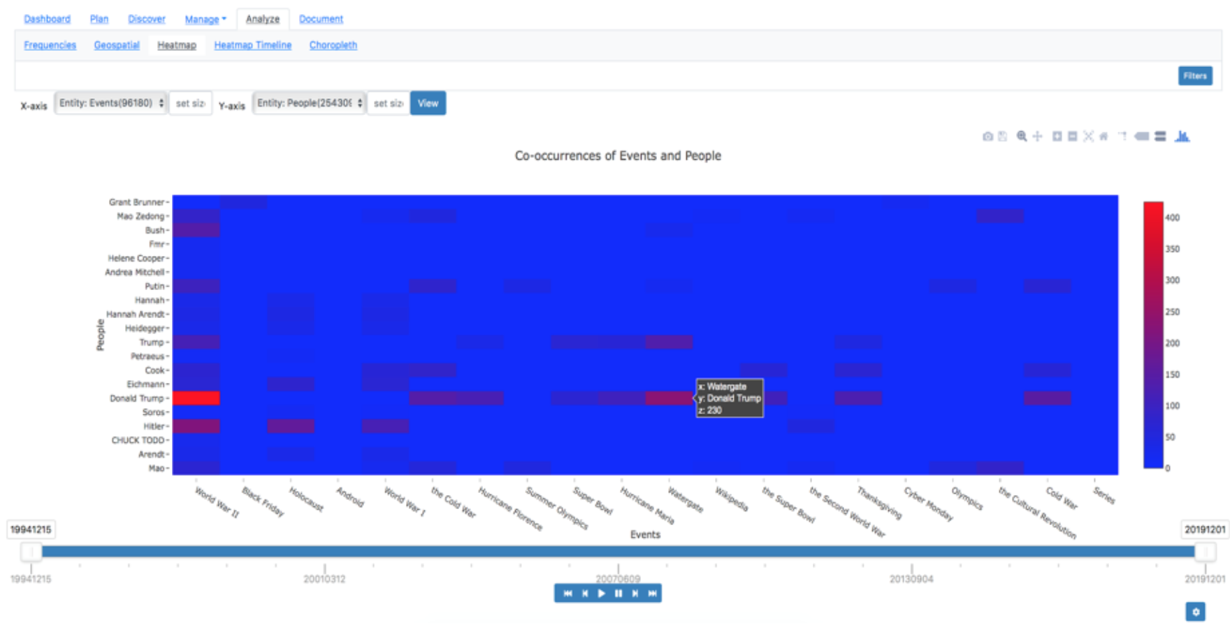

*Figure 119: Example of Heatmap Interface*

Users can create a graphic from the heatmap, save the heatmap, zoom and pan within the heatmap, and various other functions through the menu available when hovering within the heatmap interface (see Figure 120).  
  


*Figure 120: Heatmap Options Menu*

#### Heatmap Timeline

The Heatmap Timeline visualization expands upon the idea of the Heatmap visualization, providing the user the ability to see trends in occurrences of a single attribute over time (see Figure 121). In this fashion, a user can see the rise and fall of attributes throughout the timeframe of the data holdings. The values will show the frequency of the chosen attribute based on the publication dates of the data holdings.

To create a Heatmap Timeline, the user selects the desired Timeframe granularity (i.e., by Month or Week) as well as the attribute for the Item (i.e., X-axis) from the drop-down menu. An option value for the number of X-axis values to display can also be set. Once the user has selected the desired attributes, clicking the View button will generate the heatmap. Higher co-occurrence values will show in more intense colorways. In the example below, there was a spike in occurrence of “World War II” in materials retrieved and stored in the data holdings from September 2018 to March 2019. Clicking on the entry will conduct a query against the data holdings and open a new page with the results. From there, the user can further filter the query, as covered in the Manage > Holdings Search section.  
  
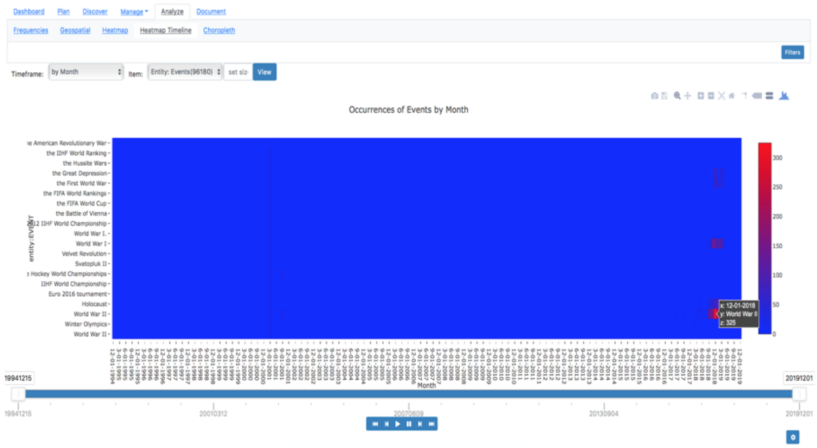

*Figure 121: Example of Heatmap Timeline Interface*

Users can create a graphic from the heatmap, save the heatmap, zoom and pan within the heatmap, and various other functions through the menu available when hovering within the heatmap interface (see Figure 122).  
  


*Figure 122: Heatmap Timeline Options Menu*

#### Choropleth

A choropleth map is a thematic map in which areas are shaded or patterned in proportion to the measurement of the statistical variable being displayed on the map, such as population density or per-capita income (see Figure 123). As such, it offers the user the ability to quickly visualize the distribution of holdings based on publication country.

The Choropleth visualization can be used by the user to quickly filter data holdings by publication country. By hovering over the countries on the map, the user can see a count of the documents in the holdings. Clicking on the country will conduct a query against the data holdings and open a new page with the results. From there, the user can further filter the query, as covered in the Manage > Holdings Search section.  
  
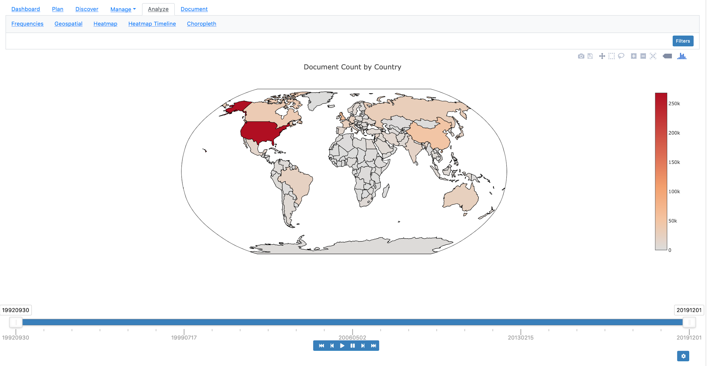

*Figure 123: Example of Choropleth Interface*

## Document

The Document phase of the workflow enables a user to capture and export knowledge that addresses their analytic tasks and research questions. In order to facilitate the capture of relevant findings and sources, the OSKE platform offers an internal note-taking capability with the Document page (see Figure 124). The Document page provides the user with the ability to input, save, edit, and output their research findings using an internal Scratchpad feature, which replicates a simple text editor. The Document page is comprised of a Scratchpads and Scratchpad Details pane.

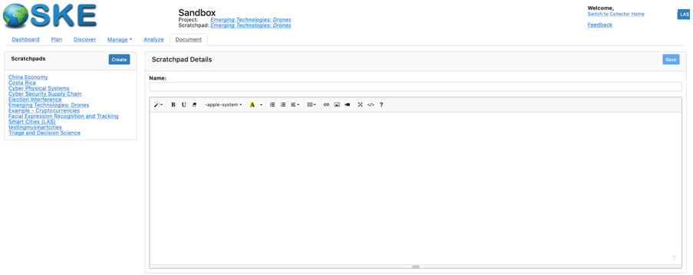

*Figure 124: OSKE Document Page Interface*

### Document Overview

The Document page displays all current scratchpads (i.e., editable text field for taking notes) within the respective domain within the Scratchpads pane. If there are no existing scratchpads available, the user will see *“No active scratchpads”* in the display. Likewise, if no existing scratchpads are available and/or selected, the user will see *“No document is currently selected or set as active”* in the Scratchpad Details pane (as seen above in Figure 124).   
  
*Note: All users within the domain can view/edit any scratchpad. There are currently no project-level restrictions in place.*

### View/Edit an Existing Scratchpad

To view/edit the details of an existing scratchpad, the user can click on the name of the scratchpad. Upon clicking on the name of the scratchpad, a Scratchpad Details pane will appear with the relevant details (see Figure 125 for example clicking on the *Emerging Technologies: Drone* scratchpad).

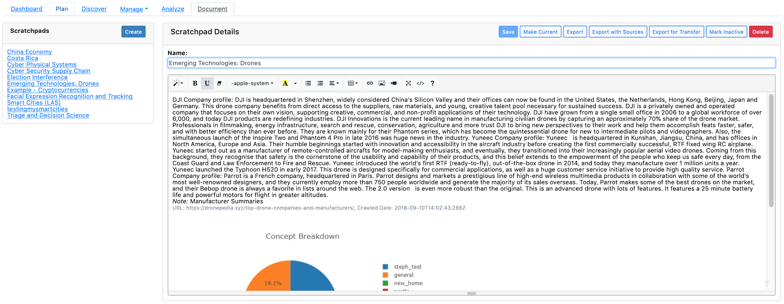

*Figure 125: OSKE Scratchpad Details Example*

From an existing Scratchpad Details pane, using the appropriate buttons, the user can also set the selected scratchpad as their current scratchpad; save any edits to the scratchpad; export the scratchpad as a Microsoft Word (.doc) file; mark the scratchpad as inactive/complete; or, delete the scratchpad entirely.   
  
*Note: There is no undo button for any edit or deletion. All users within the domain can view/edit/delete any scratchpad listed.*

Marking a scratchpad as the current scratchpad will enable any notes (i.e., highlight and send to scratchpad feature) to be saved automatically to that designated scratchpad by default. The user can change the current setting for active scratchpad at any time by clicking the scratchpad name in the Navigational element in the top-middle of the OSKE interface, selecting the scratchpad desired from the Scratchpads pane, and marking it as the Current Scratchpad in the Scratchpad Details pane (see Figure 126).



*Figure 126: Setting the Current Scratchpad Procedure*

Users can also toggle a scratchpad as Active/Inactive, using the respective toggle button, should they complete a research project or need to place one on hold. This option allows a user to archive the scratchpad details for future use and offers the ability to remove older scratchpads from the active project directory. When a scratchpad is set to inactive, a new button is included in the Scratchpads pane that toggles between *All Scratchpads* and *Active Scratchpads Only*. When All Scratchpads is selected, any inactive scratchpad(s) will be shown in italics (see “testingmysmartcities” project in Figure 127 below for example of an inactive project). When Active Scratchpads Only is selected, any inactive scratchpad(s) will be hidden for view (see Figure 128).

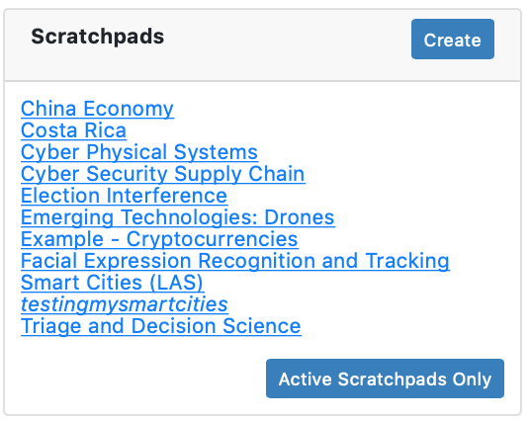

*Figure 127: Example of All Scratchpads Selection, Displaying Inactive Scratchpad*

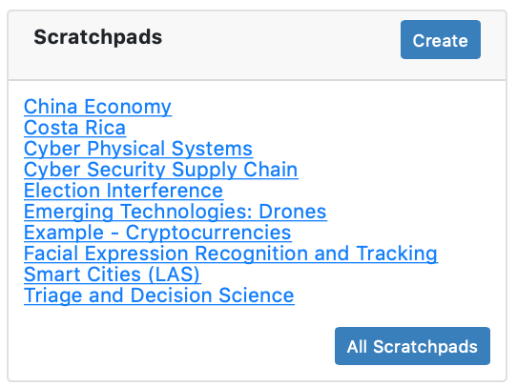

*Figure 128: Example of Active Scratchpads Only Selection, Hiding Inactive Scratchpad*

### Initiating a New Scratchpad

To initiate a new scratchpad, the user can click on the Create button in the Scratchpads pane. The user can then directly input and edit any relevant details concerning their new research project in the blank scratchpad form (see Figure 129).

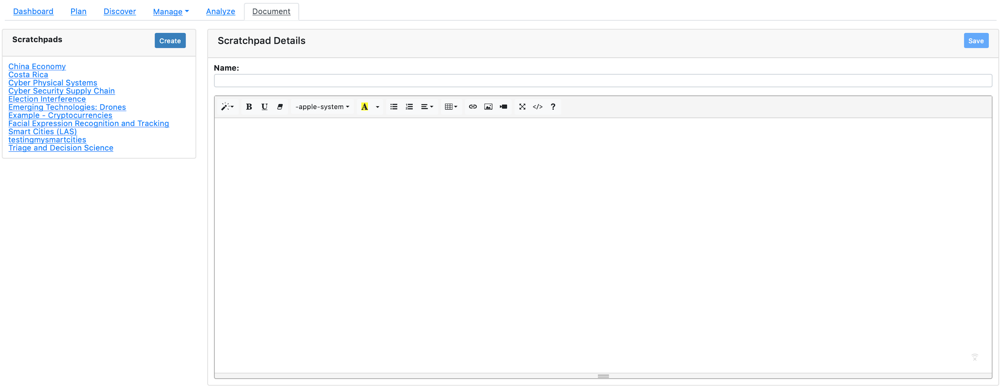

*Figure 129: OSKE Scratchpad Entry Form Example*

Users have all the common features associated with a text editor at their disposal within the scratchpad editor (see Figure 130), including font style and sizing, layout controls, table creation, ability to link multimedia, and more. User can also copy-paste from outside sources into their scratchpad through the system clipboard.



*Figure 130: Scratchpad Text Editor Options Menu*

Once complete, the user clicks the Save button to save changes and add the scratchpad to the Scratchpads pane. Upon clicking the Save button, the user will be notified of a successful save by a temporary alert in the bottom left-hand portion of the screen (see Figure 131).   
  
*Note: Any changes made will be lost if the user navigates away from the scratchpad without clicking the Save button. There is no autosave feature.*

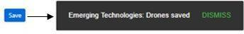

*Figure 131: Example Notification Alert of Successful Save*

#### Export Scratchpad Feature

To facilitate the transfer of information to other programs, OSKE allows the user to export scratchpads in a variety of ways (see Figure 132). When ready to export, the user can select the Export button to export the current scratchpad to a Microsoft Word file. Alternatively, the user can select the Export with Sources button to create a .zip file or the Export for Transfer button to create a .zip file in the server location.



*Figure 132: Scratchpad Menu Options*

#### Copy-Paste to Scratchpad Feature

Additionally, to facilitate faster and more efficient note-taking, OSKE allows a user to highlight text from within the Search Results pane of the Discover section and send those notes (including a user-defined note and corresponding URL citation) directly to the current scratchpad. The user simply highlights the text to be captured with their mouse, and OSKE will provide a pop-up alert that shows the text to be copied to the scratchpad and allows the user to make an appended note why they are saving the text (i.e., what research question does this source address). Example shown in Figure 133 below:

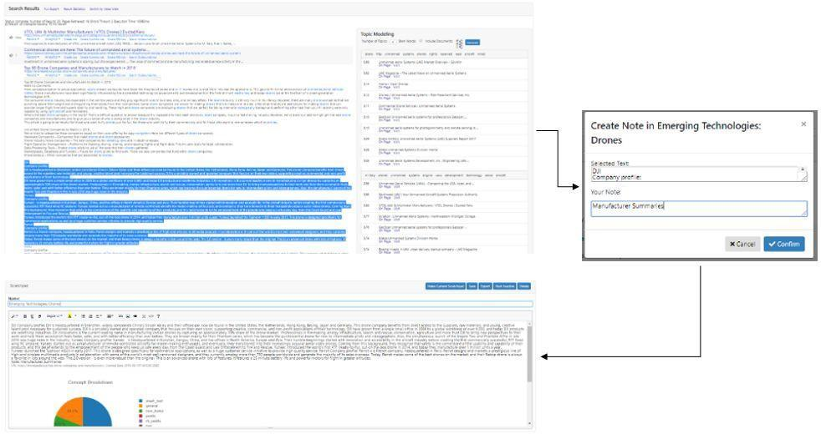

*Figure 133: Copy to Scratchpad Feature Example*

# Analysis Tools Overview

OSKE was developed to be a framework for open source research. The main value of OSKE is to retrieve and filter large volumes of very precise open source data for specific domains. This “big data” can be exported to follow on tools for analysis and extraction of enrichment data as well as for research purposes to evaluate “big data” tools and techniques.

OSKE does integrate some tools into the framework. This includes ElasticSearch and Kibana for indexing and visualization, the Voyant word cloud visualization, and an LAS knowledge graph research effort. Additional documentation is available for external tools including LAS Text Summarization Tool, PNNL’s Knowledge Graph, the Voyant Tool, IBM Watson, and SAS Tools.

## Elasticsearch

See details at <https://www.elastic.co/products/elasticsearch>.

## Kibana

See details at <https://www.elastic.co/products/kibana>.

## Voyant Word Cloud

See details at [https://voyant-tools.org](https://voyant-tools.org/).



# Appendix

Additional technical details on OSKE are provided in the following appendix pages.

## Collector Job Examples

Below are several examples of various collector jobs:

|  |  |  |
| --- | --- | --- |
| Handler Freq | URL and Job Intent | Configuration |
| Feed 360 | <http://rss.cnn.com/rss/cnn_tech.rss>  Job looks at CNN’s Technology RSS feed four times a day, only at cnn.com domain  Only store files that have words “quadcopter”, “drone”, “drones”, “uav”, “uavs”, uas”, or “unmanned” Only crawl a depth one beyond seed URL Abide by website robot.txt rule | { "allowSingleHopFromReferrer": "false", "relevantRegExp":  "quadcopter|drone|drones|uav|uavs|uas|unmanned", "webCrawler": {  "maxDepthOfCrawling": 1, "respectRobotsTxt": "true" }  } |
| Web 1440 | [http://www.interdrone.com/news](http://myfirstdrone.com/)/  This job looks at interdrone website news pages once a day, only look at domain interdrone.com. Only crawl one depth beyond seed URL  Abide by website robots.txt rules. | {  "limitToDomain": true, "webCrawler": {  "maxDepthOfCrawling": 1, "respectRobotsTxt": "true"  }  } |
| Web 10080 | <http://www.amazon.com/s/?node=1160808001> 1&page={p:%d[1-100]}  This job looks at the amazon hobby drone web page once a week.  Extract the areas as specified by “selector” and output them with the text “title” in the resulting OSKE record.  Crawl is allowed to use initial extracted links that are one hop from amazon.com.  Page must contain word “drone” or “quadcopter”.  Crawls delay 20 seconds between page retrievals, are limited to depth of one, and adhere to the Robots.txt rules. | { "extractArea": [  { "selector": "#productTitle", "title": "Title" },  { "selector": "#feature-bullets", "title": "" },  { "selector": "#prodDetails", "title": "Details" },  { "selector": "#productDescription", "title": "Description" },  { "selector": "#detail-bullets", "title": "Details - Bullets" },  { "selector": "#aplus-product-description_feature_div", "title": "Manufacturer Info" },  { "selector": "#aplusProductDescription", "title": "Manufacturer Info" },  { "selector": "#technical-specs_feature_div", "title": "Technical Specifications" },  { "selector": ".kmd-section-container", "title": "Amazon Specific" },  { "selector": "#bookDescription_feature_div", "title": "Book Description" } ],  "allowSingleHopFromReferrer": true, "relevantRegExp": "drone|quadcopter", "limitToDomain": true,  "webCrawler": { "politenessDelay": 20000,  "maxDepthOfCrawling": 1, “respectRobotsTxt”: true }  } |

## OSKE Job Configuration Parameters

Below are examples of source handler parameters:

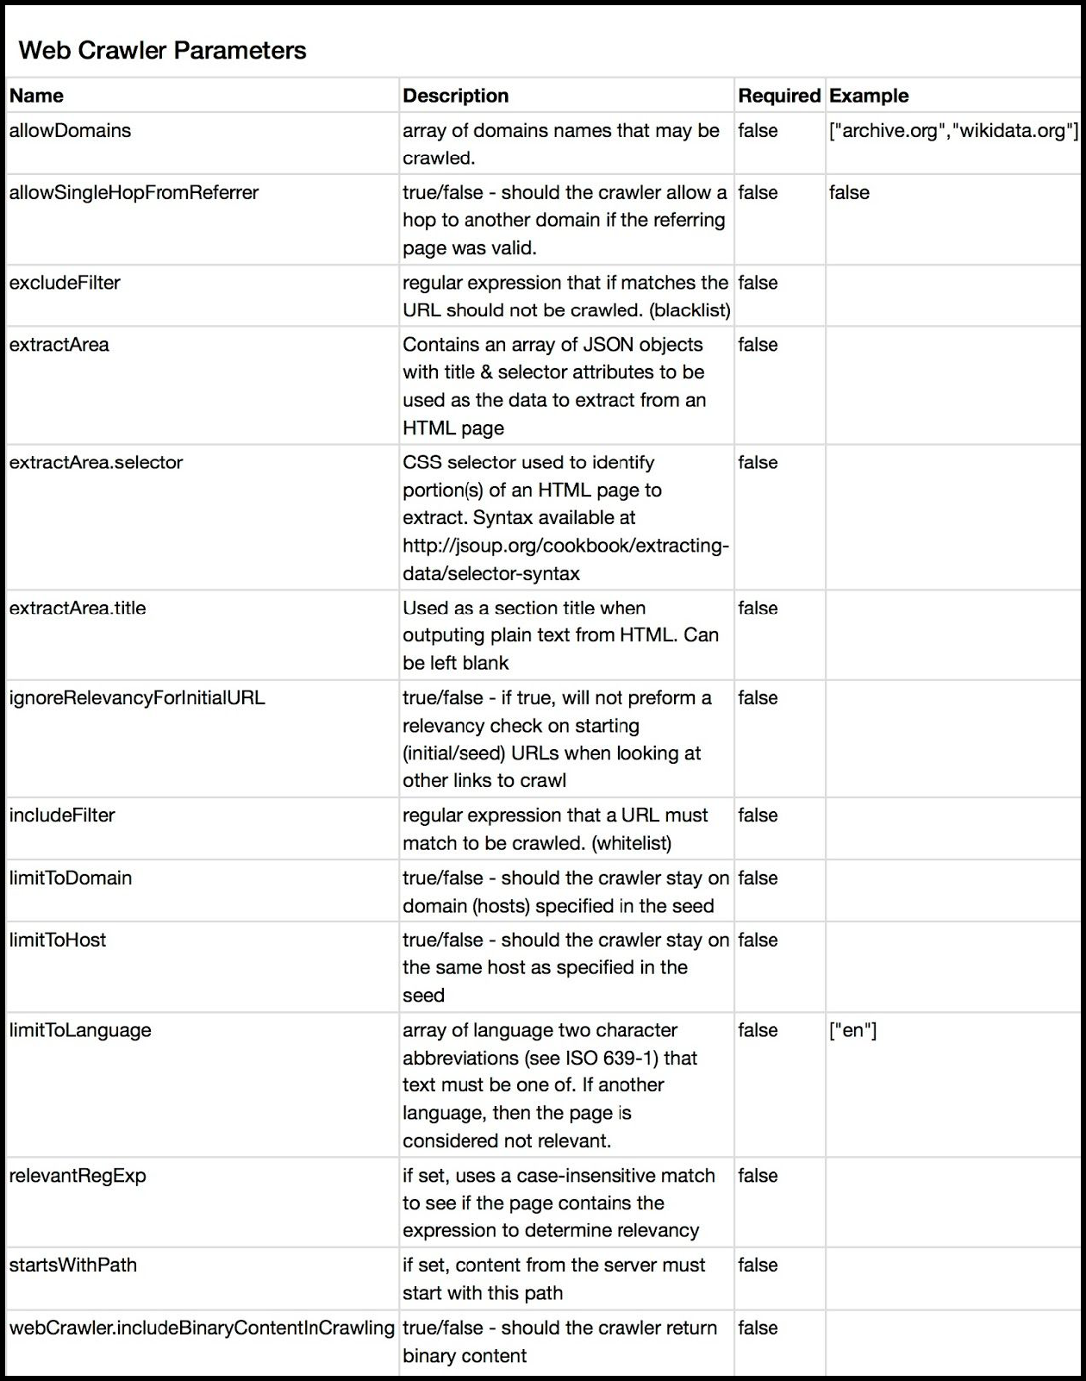

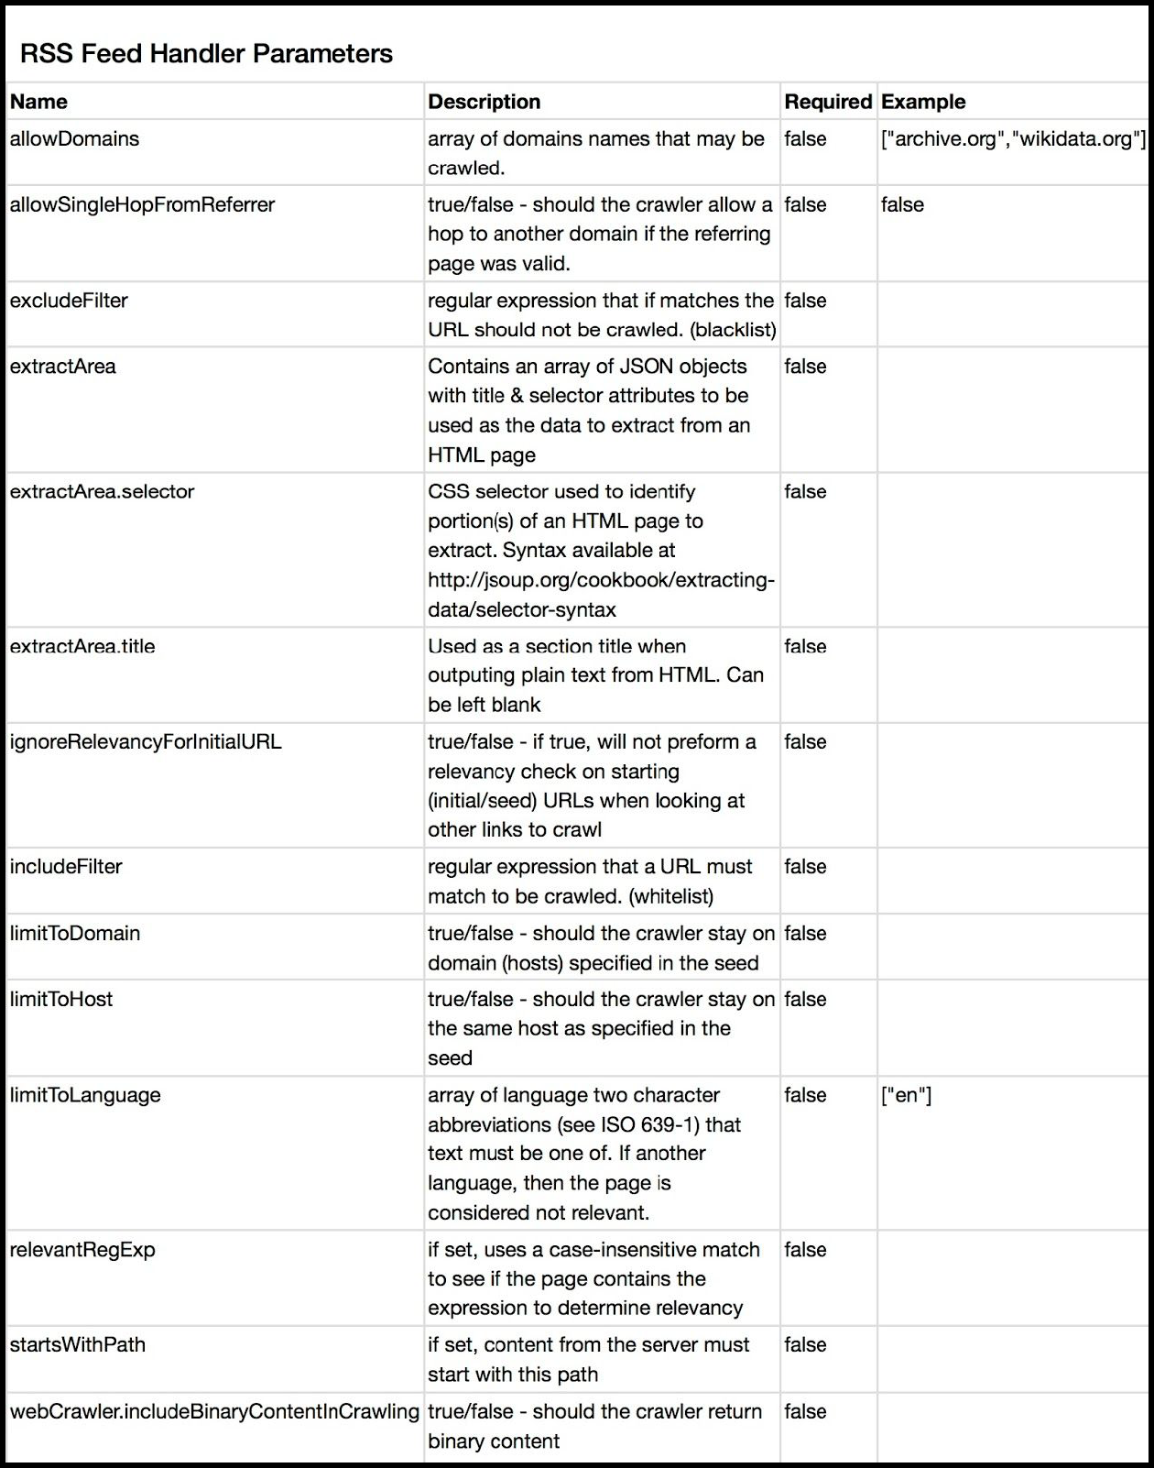

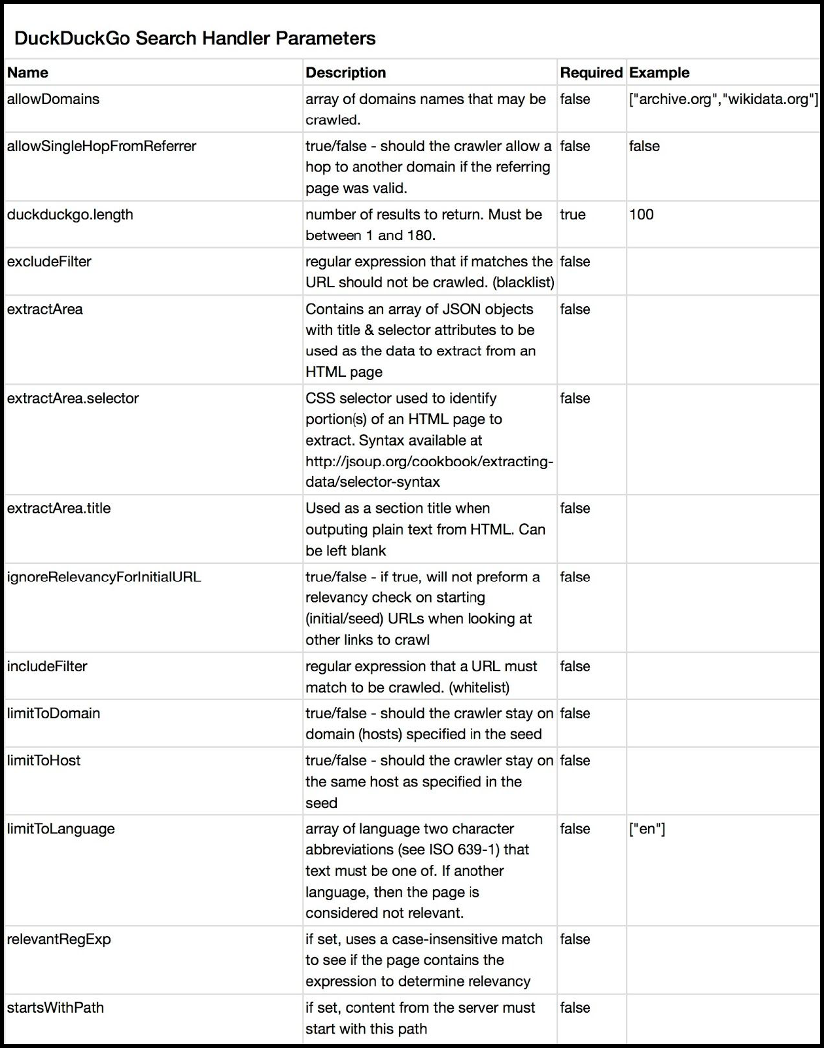

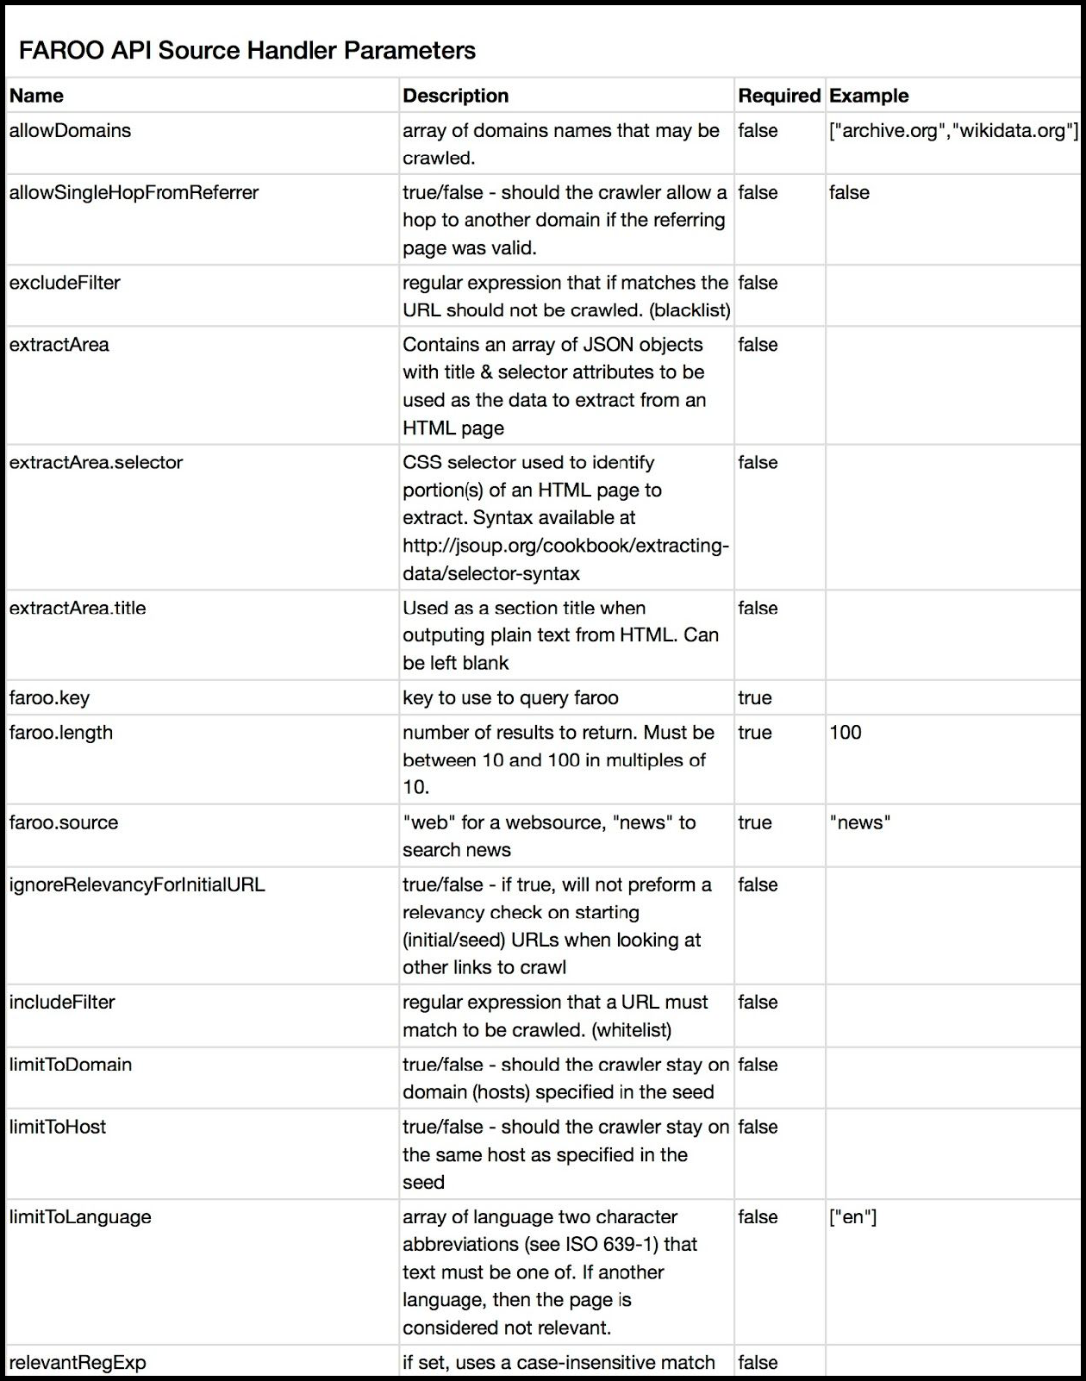

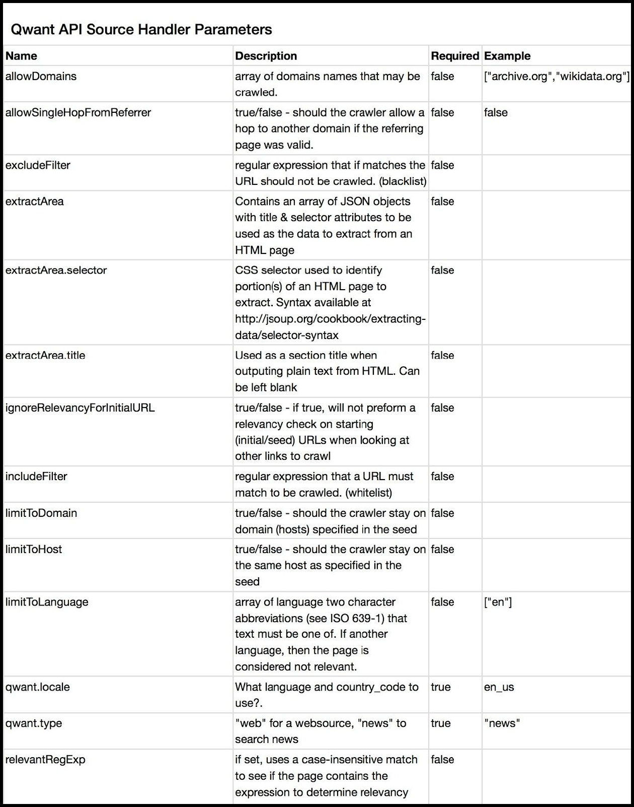

## JSON Output Example

Below is a JSON element that depicts a single web page retrieval. This is how OSKE stores retrieved pages and also one format in which filtered results are exported from OSKE (the other being comma separated variables). If more than one page is to be exported, they are combined into a single JSON object. This example page was retrieved from the “interdrone.com” OSKE web retrieval job and was retrieved from the OSKE search using the terms “*drone*” AND “*photography*” AND “*legal*”.

{

"_index": "drones_normal", "_type": "web",

"_id": "00000154-5dbf-8e35-0a11-010400080c30",

"_score": 0.3624637, "_source": {

"crawled_dt": "2016-04-28T16:41:55.581Z",

"source_uuid": "00000154-5dbf-8e35-0a11-010400080c30", "raw_data_length": 70396,

"dataHeader": { "ExternalSecurity": {

"noticeList": {

},

"access": { "ownerProducer": "USA",

"classification": "U//FOUO", "requires": {

"accessIndividual": [

]

}

}

},

"icid": "las://OSKEDrones/00000154-5dbf-8e35-0a11-010400080c30", "DataItemCreateDateTime": "2016-04-28T16:41:55.581Z", "responsibleEntity": {

"country": "USA",ots "organization": "LAS"

},

"usAgency": "urn:us:gov:ic:nsa:las"

},

"html_meta": {

"X-UA-Compatible": "IE=edge,chrome=1",

"twitter:title": "Qualcomm gets deeper into the drone industry", "twitter:card": "summary",

"viewport_": "width=device-width, initial-scale=1, maximum-scale=1, user-scalable=no", "twitter:domain": "[www.interdrone.com](http://www.interdrone.com/)",

"viewport": "width=device-width, initial-scale=1", "author": "Christina Mulligan",

"twitter:description": "Qualcomm secures permission from the FAA to test its drones

out",

"description": "Qualcomm secures permission from the FAA to test its drones out", "generator": "HubSpot",

"twitter:image:src":

"<http://cdn2.hubspot.net/hubfs/369936/images/0426.interdrone-qualcomm.jpeg#keepProtocol>"

},

"text_length": 5417,

"html_title": "Qualcomm gets deeper into the drone industry",

"url": "<http://www.interdrone.com/news/qualcomm-gets-deeper-into-the-drone-industry>", "open_graph": {

"og:image": [

"<http://cdn2.hubspot.net/hubfs/369936/images/0426.interdrone-qualcomm.jpeg#keepProtocol>"

],

"og:type": [ "article"

],

"og:title": [

"Qualcomm gets deeper into the drone industry"

],

"og:description": [

"Qualcomm secures permission from the FAA to test its drones out"

]

},

"referrer": "<http://www.interdrone.com/news>", "provenance": {

"configuration": { "limitToDomain": true, "webCrawler": {

"maxDepthOfCrawling": 1, "respectRobotsTxt": "true"

}

},

"collectorVersion": "20160407.11", "label": "LAS: Drones",

"job": {

"name": "InterDrone News",

"id": "00000153-f7c5-6638-0a11-0c0100000002",

"url": "<http://www.interdrone.com/news>"

}

},

"http_headers": {

"Access-Control-Allow-Credentials": "false", "X-HS-Content-Id": "4111758433",

"Connection": "keep-alive", "Vary": "Accept-Encoding", "Expires": "2016-04-28T15:41:55Z",

"Date": "2016-04-28T16:41:55Z",

"Content-Type": "text/html;charset=UTF-8"

},

"html_outlinks": [

"<http://cdn2.hubspot.net/hub/-1/hub_generated/style_manager/1431123893544/hubspot_default/sh> ared/responsive/layout.min.css",

"<http://cdn2.hubspot.net/hub/369936/file-1138218594-png/EVENTS_ASSETS/SPTECHCON/images/BZPro> duction-logo.png?t=1461861547853",

"<http://cdn2.hubspot.net/hub/369936/file-1472308998-css/EVENTS_ASSETS/GGDEVCON/ResponsiveMen> u/responsivemobilemenu.css?t=1461861547853",

"[http://cdn2.hubspot.net/hub/369936/file-1811420640-ico/EVENTS_ASSETS/INTERDRONE/InterDrone.](http://cdn2.hubspot.net/hub/369936/file-1811420640-ico/EVENTS_ASSETS/INTERDRONE/InterDrone) ico?t=1461861547853",

"<http://cdn2.hubspot.net/hub/369936/file-1919454186-png/EVENTS_ASSETS/INTERDRONE/Images/Inte> rDrone-header_Left.png?t=1461861547853&width=540",

"<http://cdn2.hubspot.net/hub/369936/file-2387394486-gif/EVENTS_ASSETS/INTERDRONE/Images/Inte> rDrone-LOGO_150px.gif?t=1461861547853",

"<http://cdn2.hubspot.net/hub/369936/hub_generated/style_manager/1397487076330/custom/page/cs> s/setup-style.min.css",

"<http://cdn2.hubspot.net/hub/369936/hub_generated/style_manager/1420346572700/custom/styles/> default/hs_default_custom_style.min.css",

"<http://cdn2.hubspot.net/hub/369936/hubfs/EVENTS_ASSETS/Shared/Social/GPlus48x48.png?t=14618> 61547853&width=48",

"<http://cdn2.hubspot.net/hub/369936/hubfs/EVENTS_ASSETS/Shared/Social/facebook48x48.png?t=14> 61861547853&width=48",

"<http://cdn2.hubspot.net/hub/369936/hubfs/EVENTS_ASSETS/Shared/Social/instagram48x48.png?t=1> 461861547853&width=48",

"<http://cdn2.hubspot.net/hub/369936/hubfs/EVENTS_ASSETS/Shared/Social/linkedin48x48.png?t=14> 61861547853&width=48",

"<http://cdn2.hubspot.net/hub/369936/hubfs/EVENTS_ASSETS/Shared/Social/twitter48x48.png?t=146> 1861547853&width=48",

"<http://cdn2.hubspot.net/hub/369936/hubfs/images/0426.interdrone-qualcomm.jpeg?t=14618615478> 53&width=489",

"<http://cdn2.hubspot.net/hubfs/369936/EVENTS_ASSETS/INTERDRONE/Documents/InterDrone2016Prosp> ectus.pdf?t=1461861547853",

"<http://cdn2.hubspot.net/hubfs/369936/EVENTS_ASSETS/INTERDRONE/Images/Buttons/sidebar_ID_gra> phic.jpg?t=1461861547853",

"<http://fonts.googleapis.com/css?family=Rokkitt%3A400%2C700>", "<http://gplus.to/InterDrone>", "<http://resources.sdtimes.com/andevnews>", "<http://resources.sdtimes.com/interdronenews>", "<http://resources.sdtimes.com/newsonmonday>", "<http://resources.sdtimes.com/sptechreport>",

"<http://static.hsstatic.net/content_shared_assets/static-1.4002/css/public_common.css>", "<http://www.andevcon.com/>",

"<http://www.bzmedia.com/>", "<http://www.bzmedia.com/contactus.html>", "<http://www.bzmedia.com/history.html>", "<http://www.bzmedia.com/privacy.html>", "<http://www.dronedealerexpo.com/>", "<http://www.googletagmanager.com/ns.html?id=GTM-NJJQVZ>", "<http://www.interdrone.com/>", "<http://www.interdrone.com/beware-of-scams>", "<http://www.interdrone.com/callforspeakers>", "<http://www.interdrone.com/codeofconduct>", "<http://www.interdrone.com/exhibitors>", "<http://www.interdrone.com/mediapartners>", "<http://www.interdrone.com/news>",

"<http://www.interdrone.com/news/algorithm-controls-team-of-drones>", "<http://www.interdrone.com/news/author/christina-mulligan>",

"<http://www.interdrone.com/news/bz-media-announces-interdrone-for-commercial-drone-industry>"

,

"<http://www.interdrone.com/news/call-for-speakers-open-for-north-americas-largest-commercial>

-drone-show",

"<http://www.interdrone.com/news/drone-business-conference-added-to-interdrone-las-vegas>", "<http://www.interdrone.com/news/drones-take-on-biofuels>",

"<http://www.interdrone.com/news/interdrone-and-ctia-partner-to-create-las-vegas-megashows>

"<http://www.interdrone.com/news/interdrone-announces-the-interdrone-film-festival>",

"<http://www.interdrone.com/news/leading-women-join-interdrone-for-special-drone-networking-l> unch",

"<http://www.interdrone.com/news/new-battery-solution-aims-to-extend-drone-flight-life>", "<http://www.interdrone.com/news/qualcomm-gets-deeper-into-the-drone-industry>", "<http://www.interdrone.com/news/rss.xml>", "<http://www.interdrone.com/news/topic/3d-robotcs>", "<http://www.interdrone.com/news/topic/3d-robotics>", "<http://www.interdrone.com/news/topic/3dr>", "<http://www.interdrone.com/news/topic/aei-labs>", "<http://www.interdrone.com/news/topic/aerial-video>", "<http://www.interdrone.com/news/topic/airmap>", "<http://www.interdrone.com/news/topic/airware>", "<http://www.interdrone.com/news/topic/amazon>", "<http://www.interdrone.com/news/topic/andrew-tridgell>", "<http://www.interdrone.com/news/topic/arpa-e>", "<http://www.interdrone.com/news/topic/ascending-technology>", "<http://www.interdrone.com/news/topic/att>", "<http://www.interdrone.com/news/topic/australia-post>", "<http://www.interdrone.com/news/topic/autodesk>", "<http://www.interdrone.com/news/topic/auvsi>", "<http://www.interdrone.com/news/topic/batteries>", "<http://www.interdrone.com/news/topic/chris-anderson>", "<http://www.interdrone.com/news/topic/commercial-drones>", "<http://www.interdrone.com/news/topic/complier-enterprise>", "<http://www.interdrone.com/news/topic/consumer-drones>", "<http://www.interdrone.com/news/topic/csail>", "<http://www.interdrone.com/news/topic/d-nas>", "<http://www.interdrone.com/news/topic/darpa>", "<http://www.interdrone.com/news/topic/dji>", "<http://www.interdrone.com/news/topic/drone-america>", "<http://www.interdrone.com/news/topic/drone-analyst>", "<http://www.interdrone.com/news/topic/drone-development>", "<http://www.interdrone.com/news/topic/drone-distribution>", "<http://www.interdrone.com/news/topic/drone-highways>", "<http://www.interdrone.com/news/topic/drone-manufacturers-alliance>", "<http://www.interdrone.com/news/topic/drone-mapping>", "<http://www.interdrone.com/news/topic/drone-registration>", "<http://www.interdrone.com/news/topic/drone-regulation>", "<http://www.interdrone.com/news/topic/drone-restrictions>", "<http://www.interdrone.com/news/topic/drone-traffic>", "<http://www.interdrone.com/news/topic/drone-videography>", "<http://www.interdrone.com/news/topic/drone-volt>", "<http://www.interdrone.com/news/topic/dronecode>", "<http://www.interdrone.com/news/topic/dronedeploy>", "<http://www.interdrone.com/news/topic/drones>", "<http://www.interdrone.com/news/topic/eena>", "<http://www.interdrone.com/news/topic/environmental-monitoring>", "<http://www.interdrone.com/news/topic/exemptions>", "<http://www.interdrone.com/news/topic/faa>", "<http://www.interdrone.com/news/topic/faa-regulations>", "<http://www.interdrone.com/news/topic/facebook>", "<http://www.interdrone.com/news/topic/fast-lightweight-autonomy>", "<http://www.interdrone.com/news/topic/first-responders>", "<http://www.interdrone.com/news/topic/flir-systems>", "<http://www.interdrone.com/news/topic/flirtey>", "<http://www.interdrone.com/news/topic/ford>", "<http://www.interdrone.com/news/topic/geofencing>", "<http://www.interdrone.com/news/topic/georgia>", "<http://www.interdrone.com/news/topic/google>", "<http://www.interdrone.com/news/topic/gopro>", "<http://www.interdrone.com/news/topic/intel>", "<http://www.interdrone.com/news/topic/interdrone>",

"<http://www.interdrone.com/news/topic/internet-of-things>", "<http://www.interdrone.com/news/topic/investment>", "<http://www.interdrone.com/news/topic/ioe>", "<http://www.interdrone.com/news/topic/journalism>", "<http://www.interdrone.com/news/topic/karma>", "<http://www.interdrone.com/news/topic/kokam>", "<http://www.interdrone.com/news/topic/lindbergh-foundation>", "<http://www.interdrone.com/news/topic/lufthansa>", "<http://www.interdrone.com/news/topic/measure>", "<http://www.interdrone.com/news/topic/micro-four-thirds-camera>", "<http://www.interdrone.com/news/topic/mit>", "<http://www.interdrone.com/news/topic/movidius>", "<http://www.interdrone.com/news/topic/naasic>", "<http://www.interdrone.com/news/topic/nasa>", "<http://www.interdrone.com/news/topic/near-earth-autonomy>", "<http://www.interdrone.com/news/topic/nextgen-air-transportation-system>", "<http://www.interdrone.com/news/topic/object-avoidance>", "<http://www.interdrone.com/news/topic/osrf>", "<http://www.interdrone.com/news/topic/parrot>", "<http://www.interdrone.com/news/topic/phantom>", "<http://www.interdrone.com/news/topic/precisionhawk>", "<http://www.interdrone.com/news/topic/prime-air>", "<http://www.interdrone.com/news/topic/professional-drones>", "<http://www.interdrone.com/news/topic/qualcomm>", "<http://www.interdrone.com/news/topic/robot-operating-system>", "<http://www.interdrone.com/news/topic/ros>", "<http://www.interdrone.com/news/topic/security>", "<http://www.interdrone.com/news/topic/skyward>", "<http://www.interdrone.com/news/topic/small-uav-coalition>", "<http://www.interdrone.com/news/topic/sony>", "<http://www.interdrone.com/news/topic/swarms>", "<http://www.interdrone.com/news/topic/venture-capital>", "<http://www.interdrone.com/news/topic/washington-d-c>", "<http://www.interdrone.com/news/topic/wildlife-conservation>", "<http://www.interdrone.com/news/topic/women-in-drones>", "<http://www.interdrone.com/news/topic/xenosky>", "<http://www.interdrone.com/news/topic/yamaha>", "<http://www.interdrone.com/news/topic/yuneec>", "<http://www.interdrone.com/registrationdetails>", "<http://www.sdtimes.com/>",

"<http://www.sptechcon.com/>",

"<http://www.wearablestechcon.com/>", "https://instagram.com/interdroneexpo", "https://twitter.com/InterDroneExpo", "https://twitter.com/share", "https://[www.facebook.com/pages/InterDrone/1676269215932233](http://www.facebook.com/pages/InterDrone/1676269215932233)",

"https://[www.linkedin.com/groups/Commercial-Drone-Network-UAS-UAV-6794254](http://www.linkedin.com/groups/Commercial-Drone-Network-UAS-UAV-6794254)"

],

"mime_type": "text/html", "domain": "interdrone.com", "structured_data": {

"items": [

{

"type": [ ""

],

"properties": { "stylesheet": [

],

"nofollow": [

],

"og:image": [

"<http://cdn2.hubspot.net/hubfs/369936/images/0426.interdrone-qualcomm.jpeg#keepProtocol>"

],

"og:type": [ "article"

],

"og:title": [

"Qualcomm gets deeper into the drone industry"

],

"shortcut icon": [

],

"alternate": [

],

"canonical": [

],

"og:description": [

"Qualcomm secures permission from the FAA to test its drones out"

]

}

}

]

},

"text": "Venue Speakers Exhibiting Partners

News About Us

Register Now!

Qualcomm gets deeper into the drone industry Christina Mulligan

Tweet

Apr 26, 2016 3:38:12 PM

Qualcomm, a company known for its wireless technologies, is looking to expand its reach from powering smartphones, wearable devices, and other mobile devices to powering drones. The company first announced its Snapdragon Flight drone platform in September 2015, and just recently it announced it received a Federal Aviation Administration certificate of authorization (COA) to further expand its drone research.

“Drones are essentially flying cameras enabling a broad range of applications to enhance everyday life such as aerial photography and videography, sports, filming, public safety, inspections, search and rescue, agriculture, delivery, real estate, and many other applications, so the ability to shoot in 4K is a must-have feature,” said Hugo Swart, director of product management at Qualcomm. “Snapdragon Flight is designed to provide drone developers and OEMs with an advanced platform to allow more innovative designs, faster development, and lower price points for 4K drones.”

According to Swart, the company’s interest in the drone industry aligns with its mission to accelerate the Internet of Things. Qualcomm has been looking to help reduce the time it takes to develop and deliver IoT products by providing customers with intelligent connectivity platforms and tools “that address the diverse requirements of distinct verticals,” and drones are expected to play a big part in that industry. “Drones [are] a fast-growing sector within the broader IoT space, and we see an opportunity to leverage our [system-on-chip] and integration expertise to bring significant advantages to customers using the Snapdragon Flight drone solutions,” he said.

The recently granted COA will be used to perform outdoor testing at the company’s San Diego facilities, and to accelerate the development of drones with Qualcomm Snapdragon processors. According to the company, drone manufacturers such as Tencent, ZEROTECH, Pegatron, Nine Eagles and Yuneec are planning to release drones based on Snapdragon. The goal of Qualcomm’s outdoor testing will be to refine and test the processor, and to increase drone operations with autonomous operation and reliable 4G/5G communications.

“The Consumer drone market is poised for growth, and Qualcomm will help drive it to the next level,” Swart said. “This grant of the COA is unique since the Qualcomm campus is located within highly restricted Class B airspace within a few miles of an airport with an operational air traffic control tower. The authorization allows the research team to

evaluate new technologies in a real-world urban environment—under tight controls at all times.”

Related Search Term(s):

Qualcomm

Thoughts? Leave a comment:

�Press Releases

InterDrone Film Festival Announced

Leading Women Join InterDrone for Special Drone Networking Lunch Drone Business Conference Added to InterDrone Las Vegas InterDrone, CTIA Partner to Create Las Vegas Mega-Show

BZ Media announces InterDrone for commercial drone industry

�Recent Posts

New battery solution aims to extend drone flight life Drones take on biofuels

Qualcomm gets deeper into the drone industry Algorithm controls team of drones

Call for Speakers Open for North America’s Largest Commercial Drone Show

�Posts by Topic Drones (36)

InterDrone (20)

DJI (19)

Drone Regulation (12)

Drone Development (10)

FAA (8)

FAA regulations (6)

Amazon (5)

commercial drones (5)

3D Robotics (4)

Aerial Video (4)

AirMap (4)

drone registration (3)

Dronecode (3)

Intel (3)

Airware (2)

DARPA (2)

Drone Manufacturers Alliance (2) Drone Mapping (2)

DroneDeploy (2)

Google (2)

GoPro (2)

MIT (2)

NASA, (2)

Skyward (2)

Women in Drones (2) Yuneec (2)

3D Robotcs (1)

3DR (1)

AEI Labs (1)

Andrew Tridgell (1)

ARPA-E (1)

Ascending Technology (1)

AT&T (1)

Australia Post (1)

Autodesk (1)

AUVSI (1)

batteries (1)

Chris Anderson (1)

Complier Enterprise (1)

consumer drones (1)

CSAIL (1)

D-NAS (1)

Drone America (1)

Drone Analyst (1)

Drone Distribution (1)

Drone highways (1)

drone restrictions (1)

drone traffic (1)

Drone Videography (1)

Drone Volt (1)

EENA (1)

environmental monitoring (1)

exemptions (1)

Facebook (1)

Fast Lightweight Autonomy (1) first responders (1)

FLIR Systems (1)

Flirtey (1)

Ford (1)

geofencing (1)

Georgia (1)

Internet of Things (1) investment (1)

IoE (1)

journalism (1)

Karma (1)

Kokam (1)

Lindbergh Foundation (1)

Lufthansa (1)

Measure (1)

Micro Four Thirds camera (1) Movidius (1)

NAASIC (1)

Near Earth Autonomy (1)

NextGen Air Transportation System (1) object avoidance (1)

OSRF (1)

Parrot (1)

Phantom, (1)

PrecisionHawk (1)

Prime Air (1)

professional drones (1)

Qualcomm (1)

Robot Operating System (1) ROS (1)

security (1)

Small UAV Coalition (1) Sony (1)

swarms (1)

venture capital (1)

Washington, D.C. (1)

Wildlife Conservation (1)

XenoSky (1)

Yamaha (1) see all

BZ Media • 631-421-4158

InterDrone? is a trademark of BZ Media LLC. About BZ Media

Legal & Privacy Policy Contact BZ Media INTERDRONE

Home Registration Venue

Call for Speakers Download the Prospectus Hosts

Code of Conduct

Beware of Scams - Warning to InterDrone Attendees! ABOUT BZ MEDIA

AnDevCon

Android Developer News Drone Dealer Expo InterDrone

SDTimes

SDTimes News on Monday SPTechCon

SPTechReport Wearables TechCon Keep Me Informed!

Sign up to receive updates about InterDrone ",

"hash": "XTMGTJZs9G3d8sPbKlQbfdey2l++xkrLgDCOcEVdRmI="

},

"highlight": {

"text": [ "Venue

Speakers Exhibiting Partners News

About Us Register Now!

Qualcomm gets deeper into the <em>drone</em> industry Christina Mulligan

Tweet

Apr 26, 2016 3:38:12 PM

Qualcomm, a company known for its wireless technologies, is looking to expand its reach from powering smartphones, wearable devices, and other mobile devices to powering drones. The company first announced its Snapdragon Flight <em>drone</em> platform"

1. OSKE is also referred to as OpenKE throughout the system and documentation.
2. Privacy-focused here refers to the fact that DuckDuckGo markets itself based on the fact that it does not store user search logs and our any user information. DuckDuckGo is billed as a more "anonymous" search engine to protect user privacy.
3. <http://tika.apache.org>
4. <https://github.com/kohlschutter/boilerpipe>
5. <https://www.elastic.co/products/elasticsearch>
6. <https://www.elastic.co/products/kibana>
7. <https://hadoop.apache.org/docs/r3.2.0/hadoop-project-dist/hadoop-hdfs/HdfsDesign.html>
8. <https://voyant-tools.org/>
9. <https://zeppelin.apache.org/>
10. <https://jupyter.org/>
11. The “support team” are the individuals assigned as “administrators” for the current domain within OSKE.
12. <https://www.aclweb.org/anthology/W04-3252>
13. <https://en.wikipedia.org/wiki/Cron>